Math 4 Honors Name_______________________________

Final Exam ReviewDate______________________________

1. Given , find the expression for *f’(x)* by definition.

2. Find the average rate of change in the function  over the interval .

3. Find the equation of the line tangent to the curve  at *x* = 2.

4. Find the derivative, , for each:

a.  b. 

c.  d. 

e.  f. 

OVER 🡪

Page 2

5. An open rectangular box with square base is to be made from 48 ft2 of material. What dimensions will result in a box with the largest possible volume?

6. Consider a rectangle of perimeter 12 inches. Form a cylinder by revolving this rectangle about one of its edges. What dimensions of the rectangle will result in a cylinder of maximum volume?

7. A rancher wants to construct two identical rectangular corrals using 200 ft of fencing. The

rancher decides to build them adjacent to each other, so they share fencing on one side. What dimensions should the rancher use to construct each corral so that together, they will enclose the largest possible area?

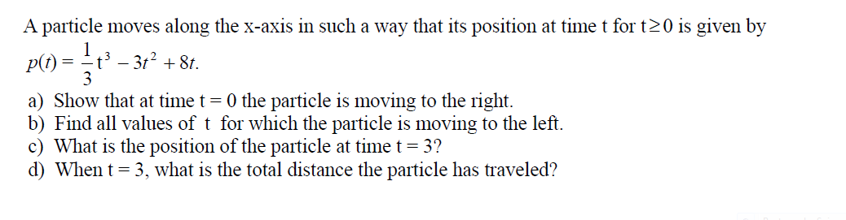

8.

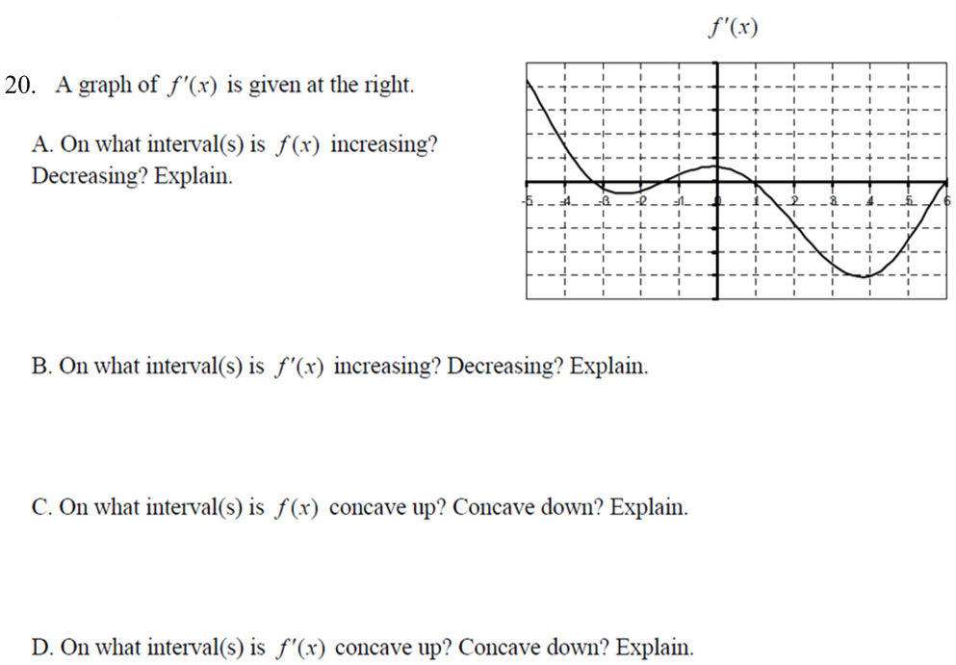 Page 3

9.

10. At the right is a graph of . Give the interval(s) or point(s) where  is negative, positive and zero.

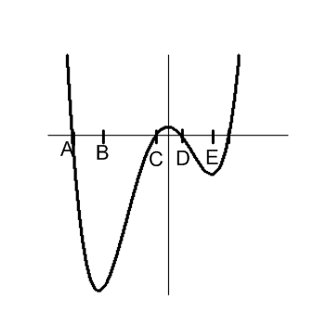

**Negative:**

**Positive:**

**Zero:**

OVER 🡪

Page 4

11. A particle moves on the *x-*axis (in units) such that its position at time *t* (in seconds) is given by

the function:



a. Determine the velocity & acceleration of the particle at time *t.*

b. For what values of *t* is the particle at rest?

c. For what values of *t* is the particle moving to the right? To the left?

d. What is the total distance it has traveled after 6 seconds?

e. What is the velocity when the acceleration is zero? Explain what your answer means in context.

f. Is the particle speeding up or slowing down when *t* = 4 seconds?

Page 5

12. Consider the equation 

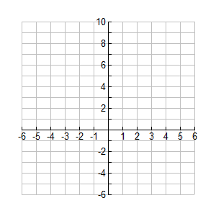

a. Determine the points where there are

maximums, minimums, or “flat spots”.

b. Find the coordinates of the maximums,

minimums, and “flat spots”

c. Determine the concavity of. Your answer should be intervals.

d. Find the coordinates of the inflection point(s) of.

e. Sketch the graph of based on the above information. Label all points you found above. DO NOT USE YOUR CALCULATOR!!

OVER 🡪

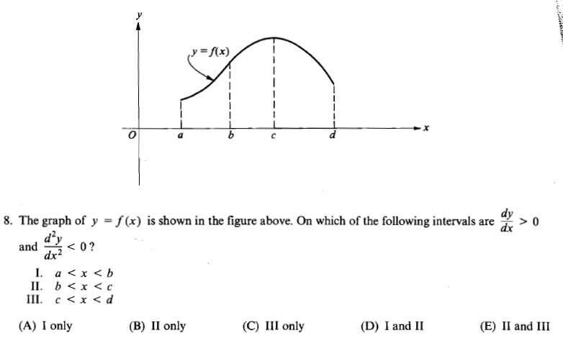 Page 6

13.



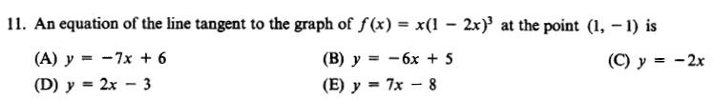

14.

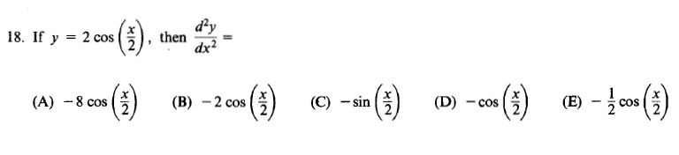

15.

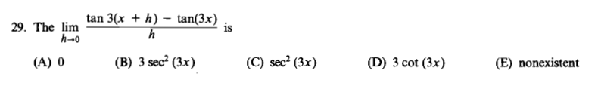

16.

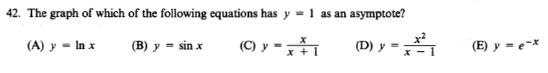 Page 7

17.

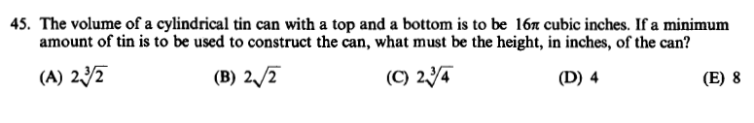

18.

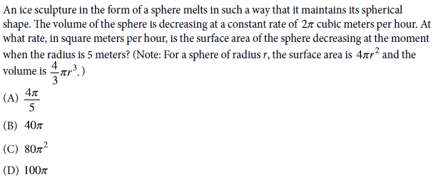

19.

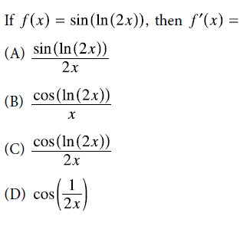

20.

OVER 🡪

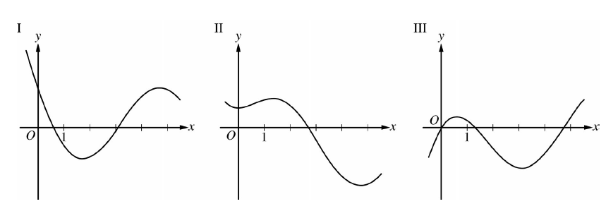 Page 8

21.

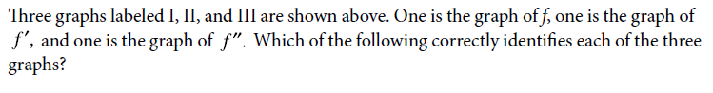

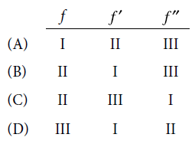

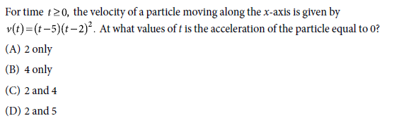

22.

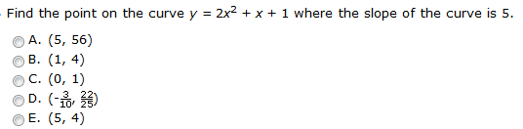

23.

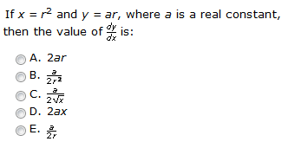

24.