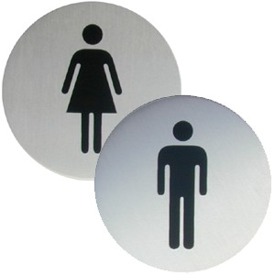

**Key Terms:**

* Sex – this is biologically founded. A human female has 2 X chromosomes and a human male has 1 X and 1 Y chromosome
* Gender - a socially constructed notion of what is feminine and what is masculine
* Gender Consistency – the realization (usually 4 or 5 and based upon genitalia) that gender does not change with age.
* Role – A set of expectations (norms) about a social position, defining how those in the position ought to behave
* Gender Role – a socially expected behavior for a male or a female
* Gender Role awareness – knowledge of what behavior is socially appropriate for each gender
* Gender Identity – one’s sense of being male or female
* Gender Typing – the acquisition of a particular masculine or feminine role
* Gender Stereotypes – oversimplified beliefs about characteristics that all men and women are presumed to have

**A Few Anecdotal Gender Differences**

* Compared to the average man the average woman has 70% more fat, possesses 40% less muscle and is 5 inches shorter
* Women enter puberty 2 yrs sooner
* Women are more likely to dream equally of men and women, to become sexually re-aroused after orgasm, smell faint odors, express emotions freely.
* Women are doubly vulnerable to depression and anxiety
* Women are 10 times greater risk for eating disorders
* Men are four times likely to be diagnosed with autism, color-blindness, hyperactivity, and antisocial personality disorder

**Gender Differences in Aggression**

* Men tend to behave more physically aggressive. This is found in various cultures are various ages. US male to female arrest ration for murder is 9 to 1.
* Men express more support for Iraq war. 51% Men vs. 34% of Women on Bush’s Iraq policy in 2005 Gallup poll

**Gender Differences in Social Power**

* Around the world people perceive men as more dominant forceful and independent
* Whether in juries or companies, leadership tends to go to males (Colarelli 2005)
* As leaders men are more directive and autocratic, while women are more democratic and elicit subordinates opinions (Engen 2005)
* When people interact men are more likely to offer opinions while women are more likely to express support. (Wood 1987)
* Men are more likely to talk assertively, to interrupt, to initiate touching, to smile less, and to stare (Hall 1987)
* Men hold 84% of the world’s political seats in 2005
* Gender differences in power lessen by middle age as men become more empathetic and women more assertive
* Men are more likely to hazard answers even when they don’t know. A phenomenon Giuliano calls the *male answer syndrome*

**Gender and Social Connectedness**

* The notion that we struggle to create our own identity (Erikson) is geared more to individualist males than relationship oriented women (Gilligan 1982, 1990)
* Women, Gilligan argues, are more concerned with “making connections.”
* Gender differences show early:
  + Boys play in large groups with an activity focus and little discussion
  + Girls play in smaller groups. Their play tends to be less competitive and they are more open to feedback then males
* Gender differences continue into adulthood
  + Women use conversation to explore relationships, men use it to communicate solutions (Tannen 1990)
  + New Zealand - From a sample of student emails, people guessed the writer’s gender 66% of the time (Males were less likely to disclose emotion, personal info, and to offer apologies) (Thomson 2001)
  + US - Women spend less time gaming and more time emailing when on computers (Crabtree 2002)
  + France - Women make 63% of phone calls. Women talking to women = 7.2 minutes. Men to men = 4.6. (Smoreda 2000)
  + Women purchase 85% of greeting cards
  + 90% of people report close relationship with mother while only 69% with their father (Hugick 1989)
  + While men enjoy doing activities side-by-side women enjoy talking face-to-face (Wright 1989)

**Nature**

* Up to seven weeks after conception you were anatomically identical until the X or Y chromosome from your father kicks in. If you are a male it flipped a switch triggering the development of testes and to produce testosterone.
* There is however, another key period for sexual development that falls during the fourth and fifth prenatal months. Here, due again to the presence of testosterone or female ovarian hormones, different brain wiring patterns emerge
* Male-Female differences exist
  + Frontal lobe areas involved in verbal fluency are reportedly thicker in women
  + Parietal cortex, a key area for space perception is thicker in men
  + Some gender differences in the hippocampus and amygdala could exist
* Glandular malfunctions or hormone injections can expose a female embryo to excess testosterone
  + Genetically female infants are born with masculine-appearing genitals, which can be corrected with surgery
  + Until puberty, these females tend to act more aggressive, dress and play in ways more typical of boys, and when given a choice of toys gravitate to male stereotypical toys.
  + While some become lesbians- most are heterosexual and the hormones do not reverse their gender identity they see themselves as girls.
  + Is this proof or since they may appear more boyish they are treated more like boys and thus nurture comes into play
* Genetic males who, despite normal testosterone levels, are born without penises or with very small ones
  + This happened to ‘Brenda’
  + Her parents made ‘him’ into a ‘her’ after a surgery
  + Parents raised ‘Brenda’ like a girl
  + Yet, ‘Brenda’ exhibited male like play and preferences
  + Had no attraction to boys
  + When parents told ‘Brenda’ the truth he immediately reverted to male and even eventually married, became a stepfather, but sadly committed suicide later in life

**Nurture**

* Are gender roles learned from your environment?
* The diversity of gender roles across culture and time seems to indicate that gender roles are not biologically determined
  + As we began the last century only New Zealand granted women the right to vote. As we ended it only one democracy – Kuwait – did not
  + In 1960 one in 30 entering law schools was a woman, now it is half.

**Gender Schema Theory**

- the theory that children learn from their cultures a concept of what it means to be male and female (social learning theory) AND that they adjust their behavior accordingly (cognitive appraisal.)

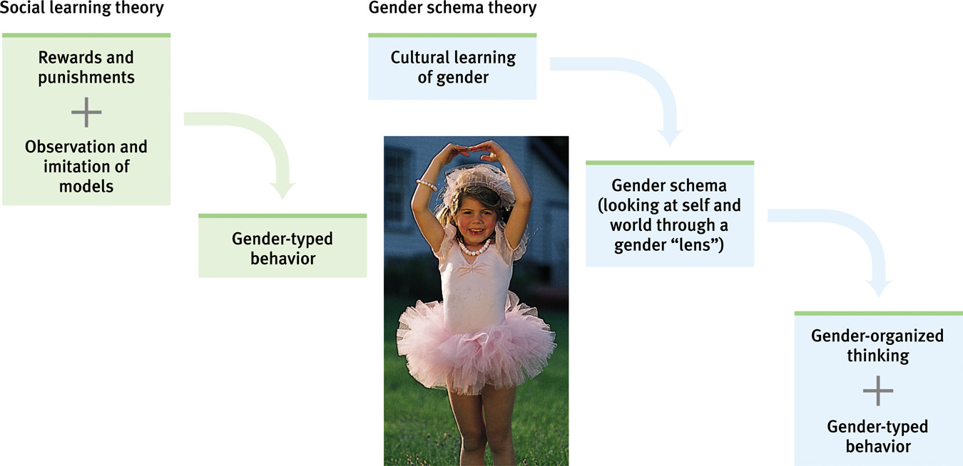

- Transformers vs. Babies

**Social Learning Theory**

- the theory that we social behavior (including gender roles) by observing, imitating and being reinforced/punished