AP Calculus AB Name ________________________________

Implicit Differentiation Madness! Date _____________________________

For each of the following equations, find using **implicit differentiation**.



1. 2.

***Challenge:***

3. Find the slope of 4.



OVER 🡪

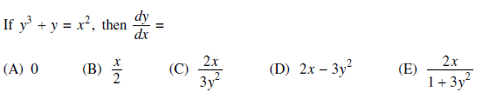5.

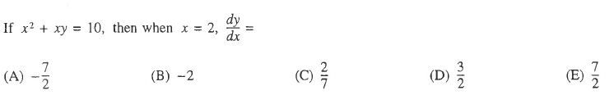

6.





7.