Math 4 Honors Name ___________________________
Intro to Unit 8 Date __________________________
***NO CALCULATOR***

Calculate the area between the curve and the x-axis over the interval of [-4, 10].
Show your work and/or explain your reasoning.

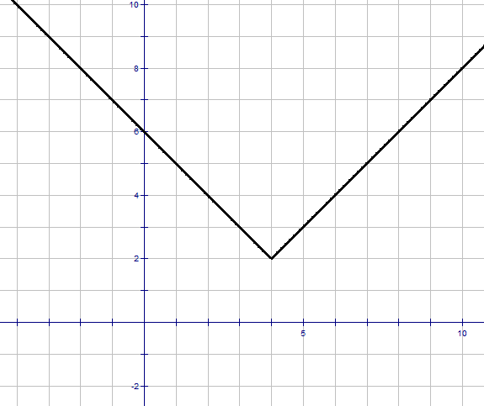

OVER
***NO CALCULATOR***

Calculate the area between the curve and the x-axis over the interval of [0, 4π].
Show your work and/or explain your reasoning.

