Math 4 Honors Name ___________________________

Lesson 1-1: *Families of Functions Review* Date _________________________

Learning Goals:

|  |
| --- |
| * *I can find the domain and range of various function families.* * *I can use and apply properties of linear, exponential, power, logarithmic and inverse variation functions.* |
| * *I can use the parameters of functions to predict the shape and end behavior of function families.* * *I can understand limit notation and its relationship to end behavior.* |



Use the following function to answer the questions below:

1. Complete the following table of values.

|  |  |  |  |  |  |  |  |  |  |
| --- | --- | --- | --- | --- | --- | --- | --- | --- | --- |
| *x* | -10,000 | -1000 | -100 | -10 | 0 | 10 | 100 | 1000 | 10,000 |
| *f(x)* |  |  |  |  |  |  |  |  |  |

1. As the value of *x* decreases, what value does *f(x)* appear to approach? __________
2. As the value of *x* increases, what value does *f(x)* appear to approach? __________
3. Describe the end behavior using limit notation.
4. What is the domain? (use ***interval notation***) 5. What is the range? (use ***interval notation***)

Important Vocabulary:

A function is **even** if _____________________________________________________________________.

A function is **odd** if ______________________________________________________________________.

6. Draw an example of an even function 7. Draw an example of an odd function.

that is *not* *y = x*2. that is *not* *y = x*3.

Equation: Equation:

OVER 🡪

Page 2

**List the type, characteristics and sketch a graph for the following functions.**

**__________________________ Functions**

8.General Rule: Example:



*f*(*x*) = *bx* + *c*

Domain:

Range:

Symmetries (if any):

Even, Odd, Neither

Asymptotes (if any):

End Behavior:

What happens if the leading coefficient has the opposite sign?

**__________________________ Functions**

9. General Rule: Example:



$f\left(x\right)={-4x}^{2}+7x-19$

Domain:

Range:

Symmetries (if any):

Even, Odd, Neither

Asymptotes (if any):

End Behavior:

What happens if the leading coefficient has the opposite sign?

Page 3

**__________________________ Functions**

10. General Rule: Example:



$f(x)=e^{x}$

Domain:

Range:

Symmetries (if any):

Even, Odd, Neither

Asymptotes (if any):

End Behavior:

The function above is an example of exponential growth. Give an example of a function that represents exponential decay:

**__________________________ Functions**

11**.** General Rule: Example:



$f(x)=ln⁡(x)$

Domain:

Range:

Symmetries (if any):

Even, Odd, Neither

Asymptotes (if any):

End Behavior:

How does the function above relate to $g\left(x\right)=e^{x}?$

OVER 🡪

Page 4

**__________________________ Functions**

12. General Rule: Example:

 *f*(*x*) = 8*x*2

Domain:

Range:

Symmetries (if any):

Even, Odd, Neither

Asymptotes (if any):

End Behavior:

How would the graph change if *r* were an odd integer?

How would the graph change if *k* were negative?

**__________________________ Functions**

13. General Rule: Example:



$f(x)=\frac{6}{x^{2}}$

Domain:

Range:

Symmetries (if any):

Even, Odd, Neither

Asymptotes (if any):

End Behavior:

How would the graph change if *r* were an odd integer?

How would the graph change if *k* were negative?

Page 5

**__________________________ Functions**

14. General Rule: Example:

 

Domain:

Range:

Symmetries (if any):

Even, Odd, Neither

Asymptotes (if any):

End Behavior:

**Practice:**

1. Describe what happens to *f(x)* as |*x*| grows larger and larger in magnitude. In other words, use limit

notation to describe the end behavior of each function. If the limit does not exist, write *d.n.e.*

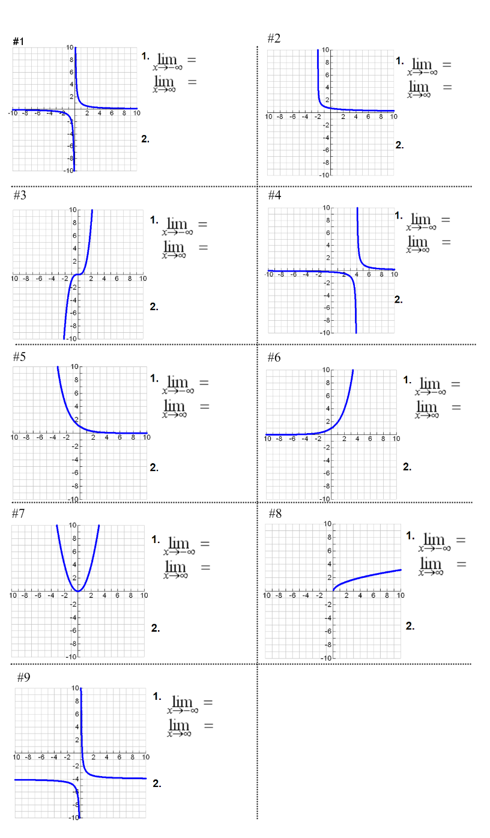2. State whether the function is *even, odd* or *neither*.

OVER 🡪

 Page 6

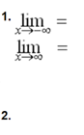

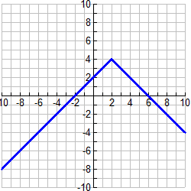

**Math 3 Honors Review**

1. On the axis below, draw an example of an even degree polynomial, with a negative leading coefficient have four real roots and a positive *y*-intercept.

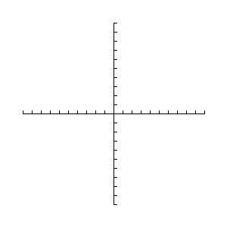

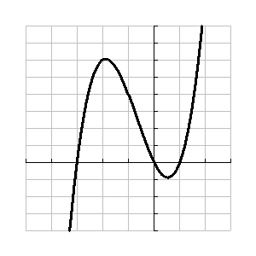

1. Consider the graph of the function to the right.

What are some characteristics of the function?

(Degree, zeros, leading coefficient, *y*-intercept,

possible equation)

*** Describe the end behavior, using the correct limit notation

Page 7

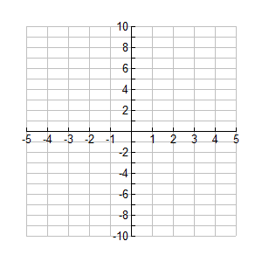3. Sketch a possible graph of *y* = -(*x* – 2)(*x* + 1)(*x* + 3)(*x* – 1) on the axis below (without your calculator).

*** Describe the end behavior, using the correct limit notation.

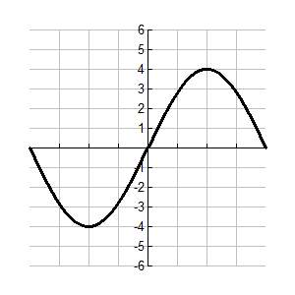4. Find the equation for the graph below.



5. Sample SAT question:



OVER 🡪

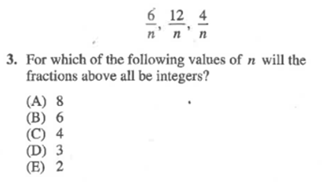 Page 8

6. PSAT Practice

i.

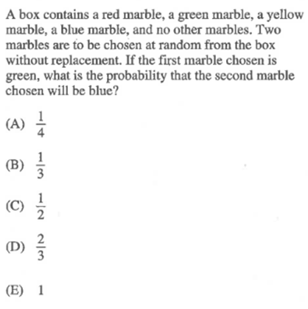

ii.

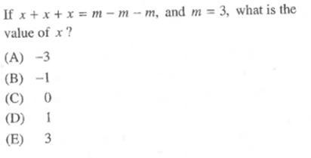

iii.

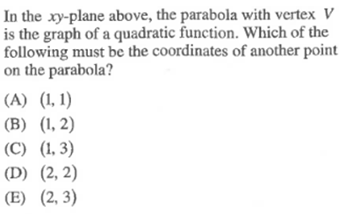

iv. **below**

