Math 4 Honors Name__________________________________

Lesson 1-2: *Composition of Functions* Date _______________________________

Learning Goals:

* *I can use the definitions and important properties of arithmetic operations on functions.*
* *I can combine functions by arithmetic operations.*
* *I can understand function composition and construct rules for composite functions from rules of the component functions.*

I. Algebraic Maintenance: Combining functions using arithmetic operations

Given : 

Evaluate or find a simplified algebraic rule for each combination of *f* and *g*:

*\*\*\*Recall: $\left[f+g\right](-2)$* means $f\left(-2\right)+g(-2)$.

$\left[f+g\right]\left(-2\right)=$ $\left[f+g\right]\left(x\right)=$

State the domain in interval notation:

$\left[f-g\right]\left(5\right)=$ $\left[f-g\right]\left(x\right)=$

_____________

State the domain in interval notation:

$\left[f∙g\right]\left(-4\right)=$ $\left[f∙g\right]\left(x\right)=$

_____________

State the domain in interval notation:

$\left[f÷g\right]\left(7\right)=$ $\left[f÷g\right]\left(x\right)=$

_____________

State the domain in interval notation: _____________

OVER 🡪

Page 2

II. Up to this point in your mathematical career, you have combined functions by using the arithmetic

operations. In this next section, you will learn of another method to combine functions.

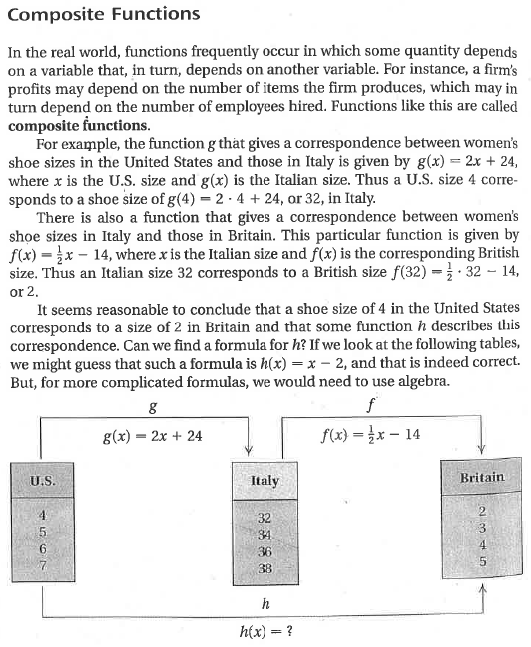

*Explain how the figure above illustrates the idea of* ***composite functions****.*

Page 3

**Based on the shoe-size scenario:**

* Size *x* shoes in the United States correspond to size**shoes in Italy, where.
* Size *n* shoes in Italy correspond to size *f*(*n*) in Britain.

When Italian shoes and British shoes are the same size,  ***Explain why.***

Size **shoes in Italy correspond to size shoes in Britain. ***Explain why.***

Since the *x* in the expressionrepresents a U.S. shoe size, we can find the British shoes size that corresponds to a U.S. size *x* as follows:



*What does the phrase “Usingas an input” mean?*

*Explain the algebraic steps that were taken to simplify*to the expression 

OVER 🡪

Page 4

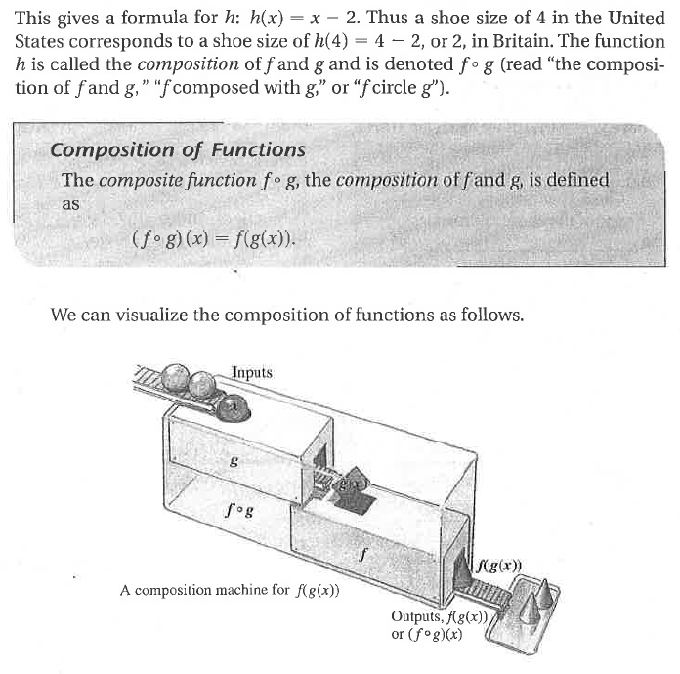

*Explain how the above graphic illustrates function composition.*

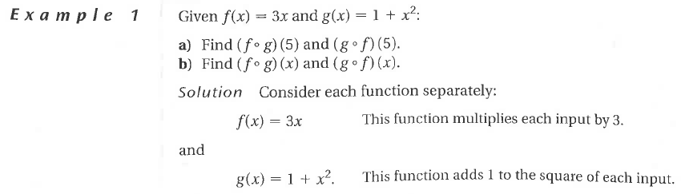

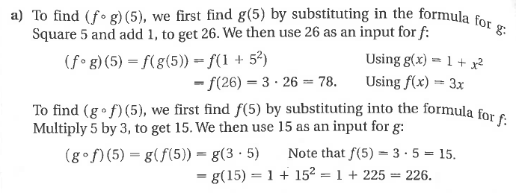 Page 5

*Explain, in your own words, the process for finding *.

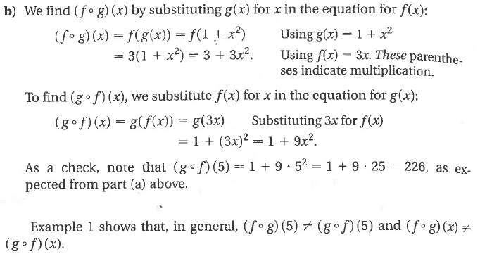

*Explain, in your own words, the process for finding. Also explain how finding*

*differs from finding.*

Example 1 shows that, in general, and

*Explain what the above statement means about function composition. Use mathematical vocabulary.*

OVER 🡪

Page 6

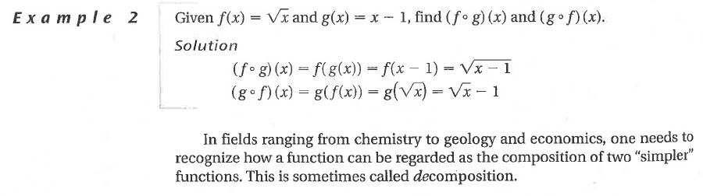

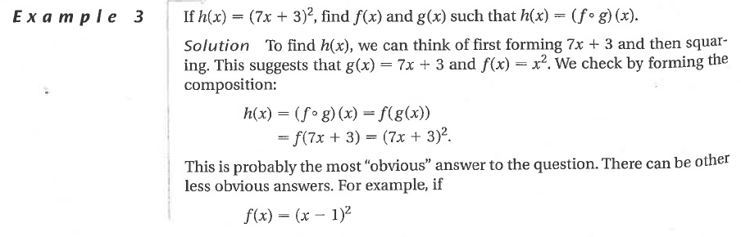

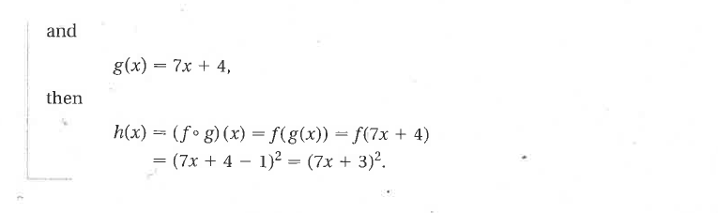

**Homework: Use what you have learned to practice function composition.**

1. 

a. Find  .

b. Find .

c. Find.

Page 7

2. 

a. Find .

b. Find .

c. Find .

3. Do you think the fact that composition of functions is *never* commutative?

Consider this:

 Given . Find 

How are related?

Find another pair of functions that have the same relationship.

4. Find two functions andthat compose to give , where and 

5. Find two functions andthat compose to give , where and 

OVER 🡪

Page 8

6. 



7.

8. Find the inverse of each function. Then prove by composition that that the inverse function is correct.

1. 
2. 