Math 1 Name_______________________________
Lesson 1-3 Independent and Dependent Variables Date________
Learning Goal:
- I can identify the independent and dependent variables and describe their relationship.

What’s an independent variable?
It is a variable that stands alone and isn’t changed by the other variables you are trying to measure. (CAUSE)
What’s a dependent variable?
It is something that depends on other factors.
(EFFECT)

The Independent variable causes a change in the Dependent variable.
OR The dependent variable depends on or is affected by the independent variable.
Example:
Time Spent Studying (independent variable) causes a change in Test Score (dependent variable) and it isn’t possible that Test Score could cause a change in Time Spent Studying.
OR Your test score is affected by the time you spend studying.

In the tables below either an independent or dependent variable is listed. Fill in the other side of the table with several variables that will make the comparison make sense.

Independent Dependent Independent Dependent
Variable Variable Variable Variable

Age of a person A students test score

In numbers 1-6, label each of the variables as independent or dependent variables.
1. Tamara's daughter is a dancer who will be participating in an upcoming recital. For each dance her daughter plans to perform, she will require a different costume.
________________ c = the number of costumes Tamara's daughter will require
________________ d = the number of dances Tamara's daughter plans to perform
2. Yardena is planning her wedding. The number of announcements she orders is determined by the number of guests she wants to invite.
________________ g = the number of guests
________________ a = the number of announcements
3. Spencer goes biking every morning. The farther he bikes, the more calories he burns during the bike ride.
________________ c = the number of calories Spencer burns during the bike ride
________________ d = the distance Spencer bikes

4. A committee is organizing a music festival in Jefferson County. The amount of time that the venue has been reserved for determines the number of bands that will be able to play at the festival.
________________ t = the amount of time that the venue has been reserved for
________________ b = the number of bands that will be able to play
5. Carson is selling lemonade. The number of cups of lemonade he sells determines how much money he earns.
________________ m = the amount of money Carson earns
________________ c = the number of cups of lemonade Carson sells
6. During the winter, a trucking company ships produce from California to Cleveland. The more produce the company needs to ship, the more truckers it will hire.
________________ t = the number of truckers the company will hire
________________ p = the amount of produce the company needs to ship

For numbers 7 and 8, identify the independent and dependent variables in the given situation, graph the data on the coordinate plane and label the axes appropriately.
7. A florist wants to see if the amount of Product X will extend the life of cut flowers so that they last longer.
Independent –
Dependent –
Independent Variable | 0 | 0.2 | 0.4 | 0.6 | 0.8 | 1
Dependent Variable | 2 | 3 | 5 | 7 | 8 | 10

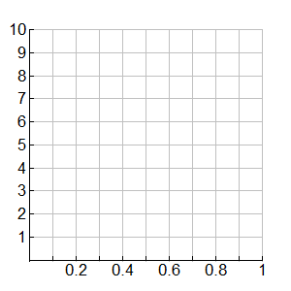

8. A drug company wants to prevent sneezing for people with grass allergies. They test different doses of their new drug.
Independent –
Dependent –
Independent Variable | 0 | 0.5 | 1 | 1.5 | 2 | 3
Dependent Variable | 25 | 21 | 18 | 10 | 8 | 2

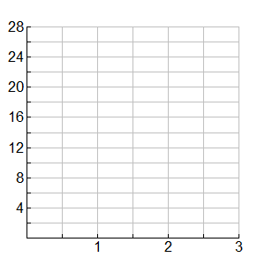

For numbers 9 and 10, read the situation, write an equation to represent the situation and solve the equation for the independent variable.
9. The Mayfield Drama Club is having a three day performance of Tarzan. If the tickets are free they will give away 750 tickets. The math department calculates that for every $1 increase in the cost of a ticket price that 23 less tickets are sold.

a. Using n to represent the number of ticket sold and c to represent the cost of a ticket, identify the independent and dependent variables.

b. Write an equation to represent this situation. Remember, equations usually start with the dependent variable! Check with you teacher before answering the next question.

c. Solve the equation for the independent variable.

d. If 566 tickets are sold, then what was the ticket price?

10. There is a glacier located in Math Valley and it began melting due to global warming. The front of the glacier began at an elevation of 125 feet. The glacier moves up the valley at a rate of 2.25 feet per day.
a. Using E to represent the glacier’s current elevation and d to represent the number of days since the melting began, identify the independent and dependent variables.

b. Write an equation to represent this situation. Check with you teacher before answering the next question.

c. Solve the equation for the independent variable.

d. If the glacier is at an elevation of 149.75 feet, how days have passed since the melting began?

