Math 4 Honors Name ______________________________

Learning Check: Lesson 1-3 Date _____________________________

Score: 0.0 0.5 1.0 1.5 2.0 2.5 3.0 3.5 4.0

In this Learning Check, you are being assessed on the following learning goals:

* *I can write and graph parametric equations.*
* *I can convert parametric equations into rectangular form.*
* *I can solve applications involving parametric equations.*

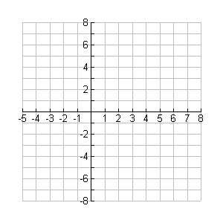1. Graph the curve defined by the following parametric equations over the following interval for *t*: [-3, 3]



*t*  *x*(*t*) *y*(*t*)

2. Eliminate the parameter from the equations in #1.

3. At an archery contest, a large circular target 5 ft in diameter is laid flat on the ground with the bull’s-eye

exactly 540 ft away from the archers. Ralph draws his bow and shoots an arrow at an angle of 25°

above the horizontal with an initial velocity of 150 ft/sec (assume the archers are standing in a depression and the arrow is shot from ground level). *Use your calculator to answer the following questions (T-Step = .01):*

**Round to the nearest 100th.**

1. Write parametric equations to model the motion of the arrow.
2. What is the maximum height of the arrow? At what time does it reach that height?
3. Does the arrow hit the target? Explain.
4. How long was Ralph’s arrow in the air?

OVER 🡪

4. Give a set of parametric equations that would yield the following rectangular equation: *y* = 2(*x* – 5)2 – 1



5. True or false: The Vertical Line Test for functions applies to parametric equations.