Math 4 Honors Name _________________________________

Lesson 1-3: *Parametric Equations*  Date ________________________________

Learning Goals:

* *I can write and graph parametric equations.*
* *I can convert parametric equations into rectangular form.*
* *I can solve applications involving parametric equations.*

**Parametric equations** for a curve are equations in which the *x* and *y* coordinates are both expressed in terms of a single variable, called the parameter, *t.* In “real-life” applications, *t* often represents time.

I. Consider the following scenario:

*A puppy weighs 8 pounds and is 15 inches long at birth. For its first year of life, each month the puppy grows .5 inches and gains 3 pounds.*  Complete the following table:

|  |  |  |  |  |  |  |  |  |  |  |  |  |  |  |
| --- | --- | --- | --- | --- | --- | --- | --- | --- | --- | --- | --- | --- | --- | --- |
| **Time (months)** | **0** | **1** | **2** | **3** | **4** | **5** | **6** | **7** | **8** | **9** | **10** | **11** | **12** | **Rules:** |
| **Height (in.)** |  |  |  |  |  |  |  |  |  |  |  |  |  |  |
| **Weight (lbs.)** |  |  |  |  |  |  |  |  |  |  |  |  |  |  |

1. Sketch the following graphs:

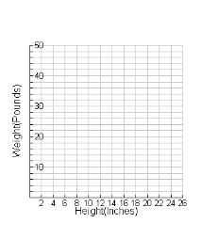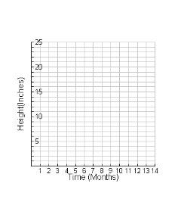 *Time vs. Height Time vs. Weight Height vs. Weight*

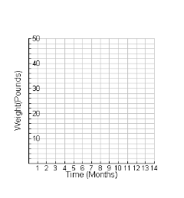



Parametric equations for this scenario:

1. See if you can reproduce your *Height vs. Weight* graph on your calculator. Follow these tips . . . .

Instead of Function mode, you will need to change to Parametric.

Adjust your *window*. Use graph #3’s axes as a guide.

What will you enter for *t* minimum and maximum values?

What about your *tstep*?

Not sure? Experiment . . . .

1. Both parametric equations can be combined into one rectangular equation (in terms of *x* & *y* only.)

This is called **eliminating the parameter, *t.*** To do this, start by solving the *x-*equation for *t.* Substitute the expression for *t* into the *y-*equation & simplify. *Show your work below.* Test your new rectangular equation by graphing it.

OVER 🡪

Page 2

II. Applications:

1. 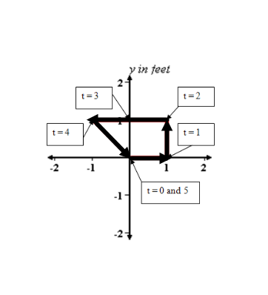 Below is the path of a robot moving in the *xy*-plane between the times t = 0 and t = 5 seconds.
2. Complete the following table:

*t x y*

0

1

2

3 *x in feet*

4

5

b) Is the robot’s *y*-coordinate a function of its *x*-coordinate along the path?

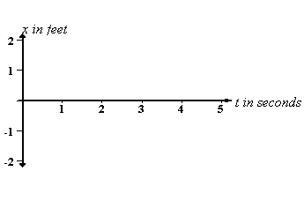c) Make a sketch of the robot’s *x* coordinate versus time *t*.

d) Is the robot’s *x*-coordinate a function of its *t*-coordinate along the path?

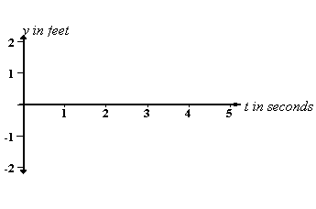e) Make a sketch of the robot’s *y* coordinate versus time *t*.

2. The *x*(*t*) graph above (part c) is given by the piecewise function.



Study the equations & then come up with the piecewise function for *y*(*t*) based on your

graph of *y*(*t*) (part e):

*y(t) =*

We call the functions *x(t)* and *y(t)* the **parametric equations of the robot’s path**. Though the path is not a mathematical function, its parametric equations *x*(*t*) and *y*(*t*) are always functions. Why is this?

Page 3

1. Parametric equations enable us to graph a curve that may double back on itself or cross itself. Such a curve cannot be described by a function *y* = *f*(*x*). The following examples are curves that are not functions in the rectangular system; however, parametrically speaking, it’s a different story…. They will be very familiar to you!
2. Graph the curved defined by the following set of equations *x*(*t*) = *t*2 – 4*t*

over the interval -3 < *t* < 7 in your calculator. Make a table *y*(*t*) = 3*t*

in your calculator. Copy those values onto your paper.

Make a sketch of the graph.

*t x*(*t*) *y*(*t*)

1. Make sure your calculator is in radians. Graph the curve defined by *x*(*t*) = 3cos *t*

the following set of equations over the interval 0 < *t* < 2π. *y*(*t*) = 3sin *t*

Use a *tstep* of π/6. Make a sketch of the graph.

What equations would yield the *unit circle*? What *tstep* would you use?

1. Here is another interesting example. Change the *tmax* to 12 π then graph. Adjust the window so you can see the full curve.



OVER 🡪

Page 4

1. Parametric equations are also useful in modeling motion because in addition to horizontal and

vertical distances, they include a third variable, time. Using these equations, the location of a

projectile can be determined at a specific time during its travel. Basic parametric equations to model projectile motion are as follows...

*x*(*t* ) = *v* ⋅ *t* ⋅ cos(*θ*)

*y*( *t*)= − ½ ⋅ *g* ⋅ *t*2+ *v* ⋅ *t* ⋅ sin (*θ*) + *h*

where *h* is the starting distance from the ground, *g* is the acceleration due to gravity

1. ft/sec² or 9.8 m/sec²), and *v* is the initial velocity.
2. Consider the following scenario:

*A batter at spring training camp hits a baseball with an initial velocity of 90 ft/s at an angle of*

*35° from the horizontal. Assume that the batter hits the ball at 2.5 feet above home plate.*

1. What value of gravity is used for this problem? Explain your reasoning.
2. Write parametric equations to model the motion of the ball.

*x*(*t*) =

*y*(*t*) =

1. Enter your equations in the calculator. Make sure you switch into degrees. Adjust your

window so you can see the path of the ball until it hits the ground. Use a *tstep* of .01. What is the maximum height of the ball? Trace the curve to find out.

1. What is the overall horizontal distance traveled by the ball?
2. How much time elapsed between the ball being hit and landing on the ground?
3. Consider the following scenario:

*A golfer hits a ball with an initial velocity of 41 m/s at an angle of 36° from the horizontal.*

1. What value of gravity is used for this problem? Explain your reasoning.
2. Write parametric equations to model the motion of the ball.

*x*(*t*) =

*y*(*t*) =

1. Enter your equations in the calculator. Adjust your window so you can see the path of the ball until it hits the ground. Use a *tstep* of .01. What is the maximum height of the ball?
2. What is the overall horizontal distance traveled by the ball?
3. How much time elapsed between the ball being hit and landing on the ground?
4. Will the ball clear a 4 meter high fence that is in the path of the ball, 150 meters from the

golfer? *Draw a sketch of the graph to illustrate this situation and explain how you arrived*

*at your answer.*

**Lesson 1-3 Homework**

1. Make a table of values for the curve defined by the following

set of equations over the interval -2 < *t* < 2. *x*(*t*) = *t*2

Sketch a graph of the curve. *y*(*t*) = *t*  − 2

Write the parametric equations below as a single equation in *x* and *y* by eliminating the parameter, *t*. Check your result by showing that its graph and the graph of the parametric equations are the same.

2. *Use your calculator to answer the following questions. Use a tstep of .01*

Make a rough sketch of the scenario

below:

OVER 🡪

3. An NFL kicker at the 30-yard line kicks a football downfield with initial velocity 85 feet per second at an angle of elevation of 56o. (Assume the ball is kicked from the ground.)

a. Write parametric equations to model the motion of the ball.

b. How far downfield will the football first hit the field?

c. What is the “hang time”? (That is, the total time the football is in the air.)

d. Determine the maximum height of the ball above the field.

e. Draw & label a sketch of the scenario.

4. It’s the bottom of the ninth inning, the Indians are behind 6-3 and the bases are loaded. Jason Kipnis is at bat. He swings and makes contact with the ball 3 feet above the plate at an angle of 20° from the horizontal at a velocity of 150 feet per second. He hits straight toward center field where there is a fence 400 feet from home plate and 9 feet high. (Neglect resistance due to wind.)

*Does Kipnis hit a grand slam and win the game?*

* 1. Write parametric equations to model the motion of the ball.
  2. Use your calculator to answer the question. *Use a tstep of .01.*

Explain your reasoning.

* 1. How many seconds will it take for the ball to hit or clear the fence?
  2. Draw & label a sketch of the scenario.

5. Graph the curve defined by the given parametric equations over the specified interval.

Eliminate the parameter and write the equation in rectangular form.

