Math 1 Name_______________________________
Lesson 1-4 Average Rate of Change 1 Date________

Learning Goals:
- I can define and calculate the average rate of change of a function and explain the connection between average rate of change and slope.

- Suppose you take a trip to Columbus to see the Blue Jackets play the Pittsburgh Penguins. The Blue Jackets’ arena is about 150 miles from your house and the trip takes 3 hours. Sketch a graph showing the distance from your house over the number of hours driven.
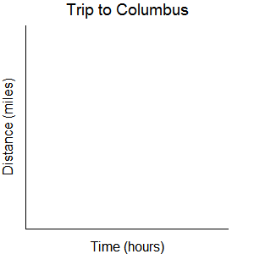

- Describe what your graph tells you about the trip.

The average rate of change over an interval is given by . You probably know this as slope.
- Use the formula above to calculate the average rate of change for your trip to Columbus. Make sure to include units in your answer.

- Would you expect the rest of your classmates to get the same average rate of change for Number 3 regardless of how their graph looks? Why or why not?

- The graph below represents a trip from Mayfield High School to everyone’s favorite theme park, Mathlevania.
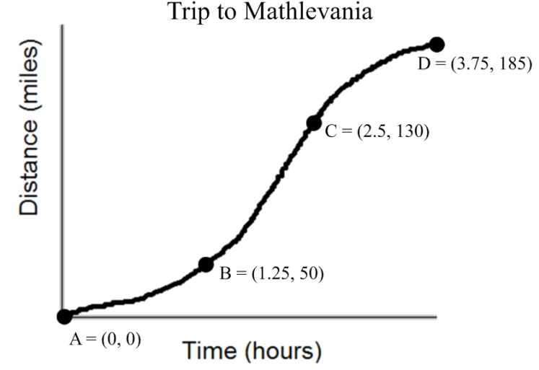
- How far from the high school is Mathlevania?
How long did the trip take?

- How would you describe the trip?

- Calculate the average rate of change from the start of the trip (point A) to Point B. Include units in your answer.

- Calculate the average rate of change from point B to Point C. Include units in your answer.

- Calculate the average rate of change from point C to Point D. Include units in your answer.

- At which interval of your trip were you driving the fastest? How is shown in the graph? How is this shown in your calculations above?

- Calculate the average rate of change from the start of the trip (point A) to the end. Include units in your answer. Compare this answer to your calculations from Parts c-e to explain why we call this the average rate of change.

