Math 1 Name_______________________________
Lesson 1-4 Average Rate of Change 2 Date________

Learning Goals:
- I can define and calculate the average rate of change of a function and explain the connection between average rate of change and slope.
- Use the graph to the right to answer the questions below.
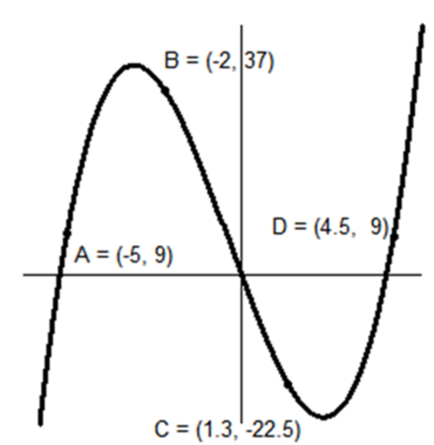
- Describe the pattern of change in the graph between each pair of points. Next, list the overall pattern between the points.

A-B: _____________________________________

Overall:_________________________________

A-C: _____________________________________

Overall:_________________________________

A-D: __________________________________________________________________________

Overall:______________________________________________________________________

- Calculate the average rate of change between the following pairs of points.

A-B: A-C:

A-D:

- How do your answers to Part b help you explain your answers to Part a?

- What relationship exists between the average rate of change and the pattern of the graph between those two points?

- Suppose you found that the average rate of change between two points on a graph was -7. What does this tell you about the pattern of the graph between those two points?
- Sketch a graph that matches the characteristics of the average rates of change given below.
Between points A & B: Negative rate
Between points B & C: Small, positive rate
Between Points C & D: Large, positive rate

- Sketch a graph that matches the characteristics of the average rates of change given below.

Between points Q & R: Large positive rate
Between points R & S: Small, negative rate
Between Points S & T: Small, positive rate
Between points T & U: Large, negative rate

