Math 4 Honors Name _________________________________

Lesson 1-5: *Solving Inequalities with N.L.A*. Date _____________________________

Learning Goal:

* *I can use number line analysis to solve polynomial inequalities.*

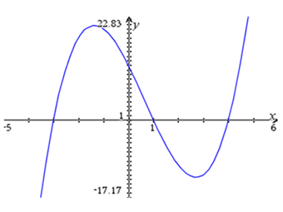

Use the graph of *f*(*x*) to answer the following questions:

1. Identify the values for *x* when *f*(*x*) = 0. *f*(*x*)

1. Identify the interval(s) when *f*(*x*) > 0.
2. Identify the interval(s) when *f*(*x*) < 0.

How can we answer these questions without looking at the graph . . . . . . .?

**Number Line Analysis! (NLA)**

Solve analytically: 

OVER 🡪

Page 2

**Examples: Solve the following inequalities using NLA. Check your solutions graphically.**

1.  2. 

**Homework: Inequality-Solving Extravaganza**

*SHOW ALL WORK ON ANOTHER SHEET OF PAPER*.

Use NLA to solve the following inequalities. Write your final answers in interval notation. *Show all work.*

1. 
2. 
3. 
4. 
5. 
6. 
7. 
8. 

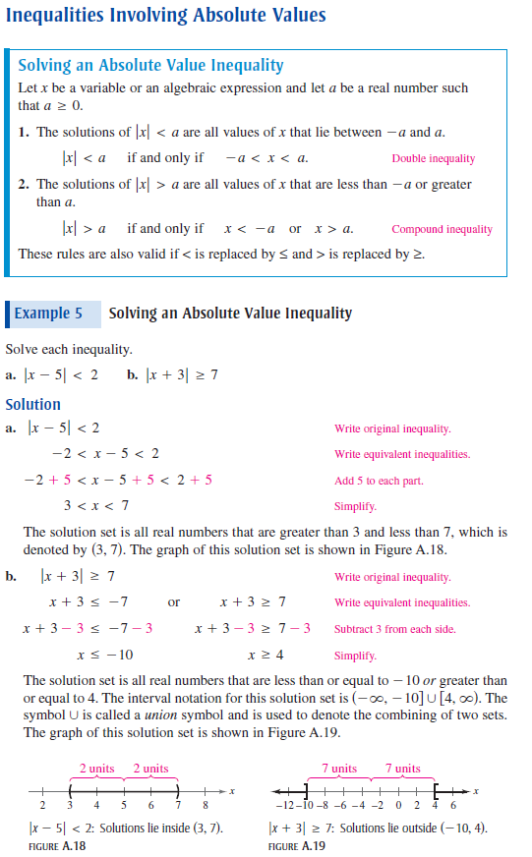 Page 3

OVER 🡪

Page 4

**Application:**

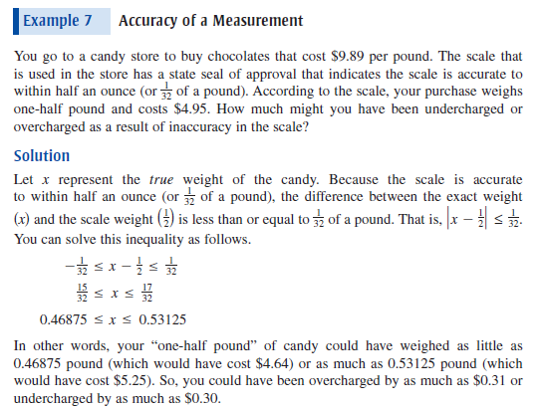

**Absolute Value Practice:**

Solve the following inequalities.

