AP Calculus AB Name_____________________________________

Lesson 2.0: *Introduction to Limits* Date __________________________________

**Learning Goals:**

* *I can develop an intuitive understating of that nature of limits.*
* *I can understand both the power and peril of investigating limits by successively closer evaluation.*

In this investigation we shall study the behavior of a function *f* near a specified point. While this is sometimes a straightforward process, it can also be quite subtle; in many instances in calculus the process for finding a limit must be applied carefully. By gaining an intuitive feel for the notion of limits, you will be laying a solid foundation for success in calculus.

1. Consider the function *f* defined by 

a. By successive evaluation of *f* at what do you think happens to the values of *f* as *x* increases towards 2? (Coming in from the **left**)

b. Do a similar experiment on *f* for values of *x* slightly greater than 2

(). (Coming in from the **right**)

Again, comment on your results.

As shorthand, and anticipating a forthcoming definition, we shall describe what you found in parts (a) and (b) by writing

, or more specifically, 

c. Evaluate . What do you notice?

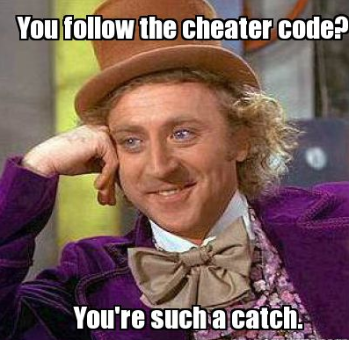

In this case, it seems we could have “cheated” when finding the limit by simply

evaluating the function at the value of interest.

d. Graph *f* on your calculator, using a window of to illustrate

why “cheating” works in this case. Comment below.

OVER 🡪

Page 2

2. Use the same function *f* as above, but this time consider what happens when *x* approaches 1.

|  |  |
| --- | --- |
| **As *x* approaches 1**  **from the right** | |
| ***x*** | ***f*(*x*)** |
|  |  |
|  |  |
|  |  |
|  |  |

a. Study this experimentally as you did in parts (a) and (b) of problem 1. Use the tables below.

What are your conclusions and, in particular, what is 

|  |  |
| --- | --- |
| **As *x* approaches 1**  **from the left** | |
| ***x*** | ***f*(*x*)** |
| 0.8 |  |
| 0.9 |  |
| 0.99 |  |
| 0.999 |  |



b. What happens when you try to “cheat” as was done in part (c) of problem 1?

There are situations in which direct evaluation at the specified point is possible and actually gives a limit (such as in problem 1). These give rise to a concept called **continuity** which we will study more in depth later. There are many situations in calculus where direct substitution does not work (such as in problem 2). Let’s delve into more of those types of situations . . .

3. Using a graph or table, try to determine the values of the following limits. Pay close attention to the value the function is approaching. Remember, the limit is what is happening as the function **approaches** an *x*-value!

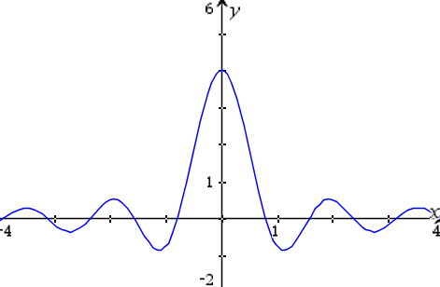

a.  b. 

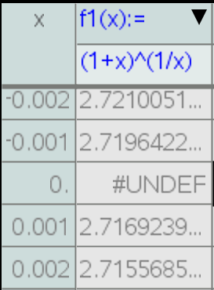

c. Let ; 

**Note:** As far as the existence and value of the limit are concerned,

**the value of has no relevance.**

Page 3

4. It is important to be aware that limits can sometimes fail to exist.

The following expressions are ones whose

limit at a specific *x*-value *does not exist*.

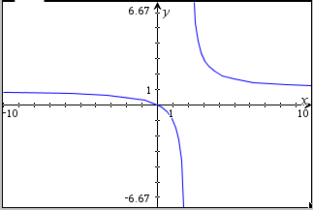a.  b. 

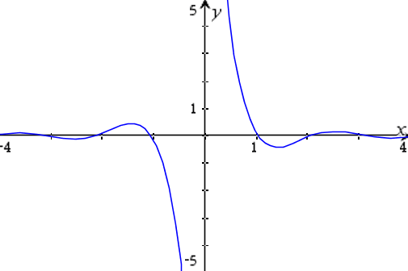

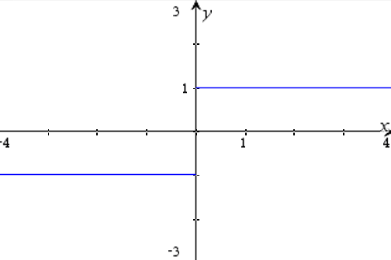c. 

* Where on this graph should there be open circles? Add them to the graph.

Based on these examples, why do the limits *not exist* at the specified *x*-values?

5. Even today, not everything in mathematics is settled. For instance, is the definition of a trapezoid a polygon with *exactly* one pair of parallel sides or a polygon with *at least* one pair or parallel side? Depends on the textbook you use as a source. Calculus-wise, there is currently a nerd war going on about problems such as the following:



What do you think is the value of this limit? Since there is a nerd war going on about this answer, there must be another possible answer. What do you think it is?

OVER 🡪

Page 4

**Examples:**

1. In our study of calculus, we will encounter many piece-wise functions such as the one below.

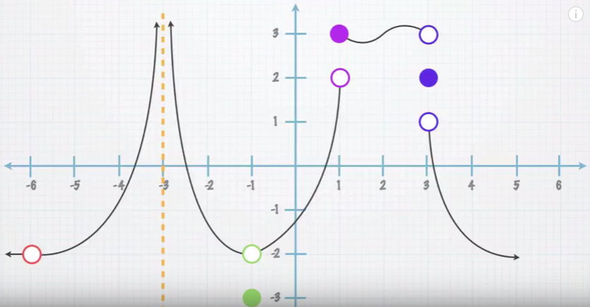

Determine if each of the statements is true or false.

If a statement is false, correct the statement to make it true.

1.  _____________
2.  _____________
3.  _____________
4.  _____________
5.  _____________

2. It’s never too early to start working on AP Test problems! Here we go!



