Math 4 Honors Name_______________________________

Lesson 2-1: *Introduction to Matrices* Date______________________________

Learning Goals:

* *I can construct and use a matrix to organize, display, and analyze information.*
* *I can interpret and operate on a matrix to help understand and analyze data.*
* *I can determine the dimensions of a matrix.*
* *I can add and subtract matrices.*
* *I can perform scalar multiplication.*

1. A survey of what brand of shoes all the students in a physical education class was taken. The results are summarized below in a **matrix**. A matrix is *a rectangular array of numbers*, as shown below. This particular matrix has ***3 rows and 2 columns***.

Answer the following questions:

1. How many men in the class wear Reeboks?
2. How many women in class wear Nike?
3. How many women in class wear Converse?
4. How many total students are in the class?



*Converse*

*Nike*

*Reebok*

2. The **size of a matrix** or **order** is written as *m* x *n*, where *m* is the number of *rows* and *n* is the number of *columns.* Thus, the sample matrix above is 3 X 2 (read “three by two”)

1. Identify the order for each of the following matrices (the plural of matrix).

  

Order:________ Order:________ Order:________

 

Order:________ Order:________

1. There are special types of matrices – Row, column and square

* Identify the “row” matrix in part a.
* Identify the “column” matrix in part a.
* Identify the “square” matrix in part a.
* Make up your own square matrix that has a different order than that from part a.

OVER 🡪

Page 2

3. Suppose another physical education class took a survey and found the following data: 7 men wore Nike, 3 men wore Converse, 9 men wore Reebok; 5 women wore Converse, 6 women wore Nike, 2 women wore Reebok. Organize this data into a matrix like that of part 1.

4. The two classes wanted to combine their data together. Fill in the two blank matrices below with the matrices from number (1) and number (3), then combine the data into one matrix. *Be sure to label the rows and columns of ALL the matrices.*



***Describe the method you used to add the two matrices.

5. Use your method from number (4) to add the below matrices (*if possible*).

a.  b. 

c. 

6. Suppose there are 8 total physical education classes. Instead of counting how many people wear each type of shoe in every class, they want to use the combined matrix from number (4) to *estimate* how many students wear each type of shoe. How would you use the matrix from number (4) to do this? Write a new matrix that shows the estimation. Label the rows and columns of the answer matrix.



Page 3

7. What you did in number (6) is called **scalar multiplication** of a matrix. Use the same method to perform the below scalar multiplication.

1.  b. 

c.  d. 

8. Suppose you are a manager of a local shoe store. Data on monthly sales of Converse, Nike, and Reebok shoes are shown in the matrix below. Each entry represents the number of pairs of shoes sold.

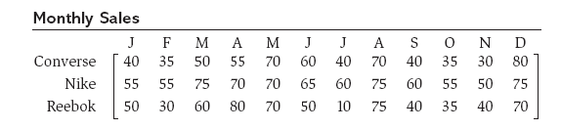

a. What is the order of this matrix?

b. How many pairs of Nikes were sold in July?

c. How many pairs of Converse were sold in May?

1. How many total pairs of Nikes were sold throughout the entire year?

e. How many total pairs of shoes were sold in April?

OVER 🡪

Page 4

Additional Information and Notation:

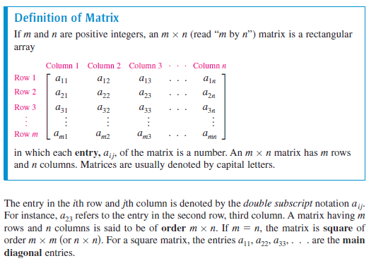

**Homework:**

1. Matrix  is a ____ by ____matrix. Entry is _______. Entry is _______.

***For the remaining problems, do your work on another sheet of paper.***

2. Find *A* + *B*, *A* – *B*, 3*A*, 3*A* – 2*B*

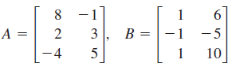



a. b.

3. Solve for *x* and *y*.

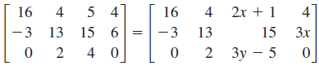

a.

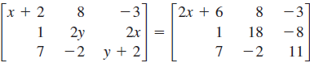

b.