Math 2 Name___________________________

Lesson 2-1: *Pumpkins in Flight (Intro to Quadratics)* Date __________________________

Learning Goals for this lesson:

* *I can identify a quadratic expression, ax2+bx+c and compare its properties to that of a linear or exponential model.*
* *I can write and solve a quadratic equation that best models the problem and interpret the solution(s) in the context of the problem.*
* *I can interpret the components of a quadratic equation with exponents in the context of a problem.*

I. Make sketches of the following scenarios in the boxes below:

1. A sideways view of the wheelchair ramp leading 2. A sideways view of the lift hill of the

up from the cafeteria to the auditorium *Millennium Force* rollercoaster at Cedar

Point

3. A sideways view of the path of a soccer ball 4. A sideways view of a satellite dish

kicked by the goalie (assume the ball hits (like a DIRECTV dish)

the ground)

* What type of functions do your sketches in 1 & 2 represent? Discuss with your group members some key characteristics of these types of functions – both graphically and equation-wise.
* The functions represented by your sketches in 3 & 4 are called **quadratic functions**. What are some differences that you notice between these sketches & those in 1 & 2?

OVER 🡪

Page 2

II. The height of a flying object such as a soccer ball (or football, volleyball, baseball, etc.) can be modeled

by a **quadratic function** of elapsed time.

When an object is **dropped**, its height *h* (in feet), *t* seconds after being dropped, can be modeled by the following equation:

*h*(*t*) = *h0 ­*− ½*gt*2

where *g* is the acceleration of gravity and *h0* is the object’s initial height.

*g =* ___________

* Each year physics students at UCSD Muir College drop a gigantic pumpkin from the roof of one of its dorms. (Evidently physics students all across our country are fascinated with dropping pumpkins from high places!) <https://www.youtube.com/watch?v=Ou1-kNLuA7s>

**In the video, it took 3 seconds for the pumpkin to hit the ground.**

1. Use the formula from above to calculate how high in the feet the roof of the dorm is.
2. How high above the ground was the pumpkin after 2.2 seconds? (Use your findings from #1)
3. How many seconds did it take for the pumpkin to be 26 feet from the ground?
4. Enter your findings from 1 – 3 in 5. Plot the points from your table on the

the table below. Then complete the rest graph below.

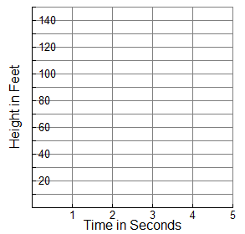of the entries in the table.

|  |  |
| --- | --- |
| Time (sec.)  *t* | Height (ft.)  *h*(*t*) |
| 0 |  |
| 1 |  |
| 1.8 |  |
|  | 45 |
|  | 26 |
|  | 5 |
|  | 0 |

Page 3

III. Believe it or not, some people are not satisfied with just dropping pumpkins from high places. These

folks build cannons to shoot them! Such is the case in Rehobeth Beach, Delaware where they have the Annual Punkin Chunkin World Championships. The event is televised on the Science Channel!

<https://www.youtube.com/watch?v=dmSyrGsqmg8>

* What do you think are some differences in the scenario for dropping a pumpkin versus launching one? Are there any similarities?

When an object is **projected**, its height *h* (in feet), *t* seconds after being projected, can be modeled by the following equation:

*h*(*t*) = *h0 ­+ v0t* − ½*gt*2

where *g* is the acceleration of gravity, *v0* is the initial upward velocity and *h0* is the initial height.

1. Suppose a pumpkin leaves the *Second Amendment* cannon at a point of 24 feet above the ground when *t* = 0. It takes 6 seconds for the pumpkin to hit the ground. Calculate the *initial upward velocity* of the pumpkin.
2. Use the information from #1 to calculate how high the pumpkin is after 3 seconds.
3. Enter your findings from #2 in the 4. Plot the points from your table on the

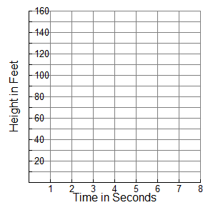table below. Then complete the rest graph below.

of the entries in the table.

|  |  |
| --- | --- |
| Time (sec.)  *t* | Height (ft.)  *h*(*t*) |
| 0 |  |
| 1 |  |
| 2 |  |
| 3 |  |
| 4 |  |
| 5 |  |
|  | 0 |

OVER 🡪

Page 4

**Summarize the Mathematics:**

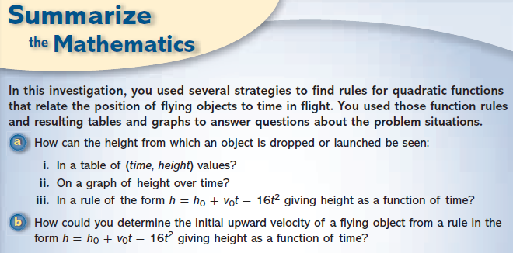

**Practice:** <https://www.youtube.com/watch?v=rz-lyvtuilM>

In Game 3 of the 1970 NBA championship series, the L.A. Lakers were down by two points with three seconds left in the game. The ball was inbounded to Jerry West, whose image is silhouetted in today’s NBA logo. He launched and made a miraculous shot from beyond midcourt, a distance of 60 feet, to send the game into overtime (there was no 3-point line at that time). Through careful analysis of the game tape, one could determine the height at which Jerry West released the ball, as well as the amount of time that elapsed between the time the ball left his havds and the time the ball reached the basket. This information could then be used to write a rule for the ball’s height *h* in feet as a function of time in flight *t* in seconds.

1. Suppose the basketball left West’s hands at a point 8 feet above the ground. What does that information tell about the rule giving *h* as a function of *t*?
2. Suppose also that the basketball reached the basket (at a height of 10 feet) 2.5 seconds after it left West’s hands. Use this information to determine the initial upward velocity of the basketball.
3. Write a rule giving *h* as a function of *t*.

Math 2 Name_______________________________

Lesson 2-1: Homework Date _____________________________

1. When an object is **dropped**, its height *h* (in feet), *t* seconds after being dropped, can be modeled by the following equation: *h*(*t*) = *h0 ­*− ½*gt*2 where *g* is the acceleration of gravity and *h0* is the object’s initial height. Use the fact that acceleration due to gravity is 32 feet per second2.

1. Write an equation to model this situation when the height of the building that the object is being dropped from is 100 feet.
2. Fill in the table below:

|  |  |  |  |  |  |  |  |
| --- | --- | --- | --- | --- | --- | --- | --- |
| *t*  (in sec.) | 0 | .5 | 1 | 1.5 | 2 | 2.5 | 3 |
| *h*(*t*) (in ft.) |  |  |  |  |  |  |  |

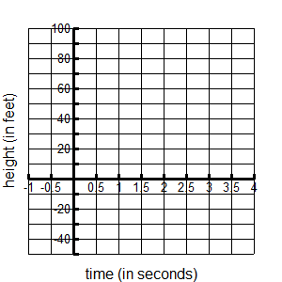

1. Graph:
2. Explain the *y*-intercept in the context of this problem.
3. Explain the point where the graph crosses the *x*-axis in the context of this problem.
4. What is the meaning of *f*(3)’s output?

OVER 🡪

2. A first-time diver was a bit nervous about his first dive at a swimming pool. To ease his worries about hitting the water after a fall of 15 feet, he decided to push a tennis ball off the edge of the platform to see the effect of landing in the water.

1. What rule shows how the ball’s height above the water *h* is related to elapsed time in the dive *t*?
2. Estimate the time it will take the ball to hit the water. *Round to the nearest 1000th.*

3. Math-O, the Magnificent, is shot out of a cannon 16 feet above the ground. Math-O reaches a maximum height of 55 feet after about 1.56 seconds and hits a net that is 9.5 feet off the ground after 3.25 seconds.

Recall: When an object is **projected**, its height *h* (in feet), *t* seconds after being projected, can be modeled by the following equation: *h*(*t*) = *h0 ­ + v0t* − ½*gt*2 where *g* is the acceleration of gravity, *v0* is the initial upward velocity and *h0* is the initial height.

Use this information to answer the following questions. *Hint: Draw a picture of the situation.*

1. Write a rule that relates the daredevil’s height above the ground *h* at a time *t* seconds after the cannon is fired.
2. At what upward velocity is the daredevil shot from the cannon?
3. If, for some unfortunate reason, the net slipped to the ground at the firing of the cannon, when would the daredevil hit the ground?

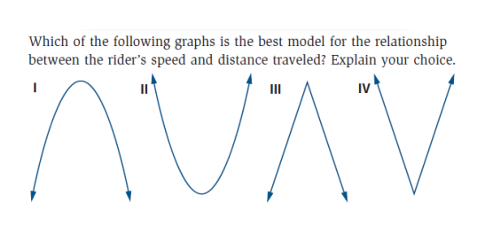4. Suppose that a skateboard rider travels from the top of one side to the top of the other side on a half-pipe ramp. Which of the following graphs is the best model for the relationship between the rider’s speed and distance traveled? *Explain your choice.*

**Spiral Review:**

1. Simplify. 2. Solve for *x.*

***Do not leave negative exponents in answers*.**

1.  a. 
2. 
3.  b. 

1. 
2. 
3. 
4. 
5. 
6. 