AP Calculus AB Name__________________________________

Lesson 2-1: *Rates of Change & Limits* Date ________________________________

**Learning Goals:**

* *I can calculate average and instantaneous speeds.*
* *I can define and calculate limits for function values and apply the properties of limits.*
* *I can use the Sandwich Theorem to find certain limits indirectly.*

**I. Math 2 Flashback!**

Each year physics students at UCSD Muir College drop a gigantic pumpkin from the roof of one of its dorms. (Evidently physics students all across our country are fascinated with dropping pumpkins from high places!) Dense objects such as pumpkins dropped from rest will fall *y* = 16*t*2 feet in the first *t* seconds.

<https://www.youtube.com/watch?v=Ou1-kNLuA7s>

1. What is the average speed of pumpkin during 2. Find the speed of the pumpkin at the

the 3 seconds of the fall? instant it hits the ground.

**II. Evaluating Limits Algebraically**

Many limits can be evaluated by substitution (and some algebra). Check your answer graphically.

3. Find  4. Find 

OVER 🡪

Page 2

**Theorem:** Given real numbers *C* and *L* and some real-valued function, we say



if and only if



* This means for a limit to exist, the limit from the left  must equal the limit from the right .

If you check this condition against problems 3 and 4, you will see that it is true.

**Evaluate the following limits either graphically or by using a table.**

5.**  6. 

**III. Exploring Right- and Left-Handed Limits**

7. Consider the following piece-wise function and its graph:

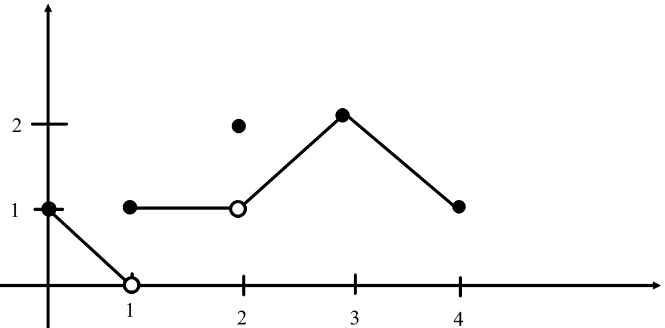



*f(x*) =

All of the following statements about the function are true. Explain why each is true.

At  

At  even though 



 does not exist

At  



 even though 

At  

At  

At noninteger values of *c* between 0 and 4, *f* has a limit as 

Page 3

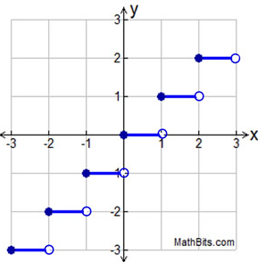8. The **greatest integer function**, or is a piecewise function that is defined to be *the greatest integer .* So . The graph of the greatest integer function is pictured. Given , explain why does not exist.

**IV. Theorem: Properties of Limits**

If *L, , c,* and *k* are real numbers, and ,

**Sum Rule:**

**Difference Rule:**

**Product Rule:**

**Constant Multiple Rule**

**Quotient Rule:**

**Power Rule:**

***Note that without knowing it, we have technically used a few of these properties in problems 3 and 4.

OVER 🡪

Page 4

**Find the following limits using the properties of limits** (and algebra)**. Confirm your answers graphically**

9. Determine  10. Determine 

11. Find 

12. 

a.  b. 

c.  d. 

e. 

**V. Theorem: Sandwich Theorem**

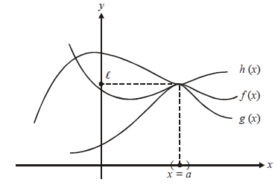If for all in some interval about *a*, and .

Page 5

**VI. Practice (NO CALCULATOR):**

1.  (Sample AP Exam problem)

1. 1 (B)  (C) 3 (D) 

**Evaluate each of the following limits without the aid of a calculator.**

2.  3.  4. 

5.  6.  7. 

8.  9. 

10. 