Math 4 Honors Name _________________________________

Lesson 2-3: *Applications of Matrices* Date ________________________________

Learning Goals:

* *I can use determinants to find whether a matrix is invertible.*
* *I can use matrices to solve systems of linear equations.*
* *I can use matrices to encode and decode messages*.

I. In Lesson 2-2 you learned about properties of matrices. In this lesson we will further develop the idea of the **inverse of a matrix**.

1. If a matrix has an inverse, it is called **invertible** (or **nonsingular**); otherwise, it is called **singular.** Remember**,** only a square matrix can have an inverse. But not all square matrices have inverses. If, however, a matrix does have an inverse, that inverse is unique.
2. To determine if a matrix has an inverse, we can use something called its **determinant**. The determinant of a 2 X 2 matrix is defined as follows:

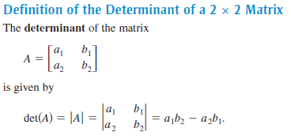

1. Given . Use the above formula to calculate |*A*|.

**\*\*\*If the determinant of matrix ≠ 0, then the matrix has an inverse.**

Based on your computations, does *A* have an inverse? ______________

1. To find the inverse of a 2 X 2 matrix, we use the following formula:



If then,

1. Looking at this formula, explain why it makes sense that a nonsingular matrix must have a nonzero determinant.
2. Use the above formula to find *A*-1 (for #2, part A).
3. Now use your calculator to verify what you found in #2.

OVER 🡪

Page 2

II. Why is the inverse of a matrix so important? You will see in this next section . . . . .

1. Solving a system using the Inverse-Matrix Method:

In previous courses you learned multiple methods of solving a system of equation: graphically,

substitution, and linear combinations. The Inverse-Matrix Method is yet another process.

1. 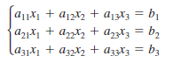The Inverse-Matrix Method Matrix uses matrix multiplication to represent a system of linear equations. Note how the system

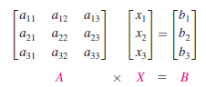can be written as the matrix equation *AX = B* where *A*  is the *coefficient matrix* of the system, and *X* and *B* are column matrices.

1. Solving a system using matrices boils down to setting up and solving a matrix equation. Note the similarity to solving a linear equation to that of a matrix equation:

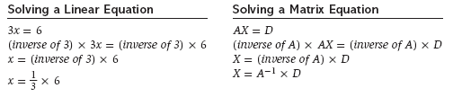

1. Let’s see how this works. Study the following example:

Consider the following system of linear equations.

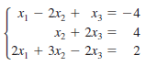

1. Write this system as a **matrix equation**. *AX = B.*

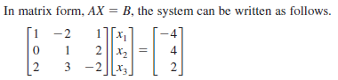

*A ● X = B* **Solution Matrix**

1. Solve the matrix equation for *X*. *X = A-1B.*

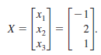 

-1

= ● 

*X = A*-1 *● B*

Page 3

1. Solve the following system using the Inverse-Matrix Method.



* 1. Write the system as a matrix equation.



*A ● X = B*

* 1. Use your calculator to solve the matrix equation for *X*.



Solution Matrix:

1. Cryptography
2. A **cryptogram** is a message written according to a secret code. (The Greek word *kryptos*

means “hidden.”) Matrix multiplication can be used to encode and decode messages. To

begin, you need to assign a number to each letter in the alphabet (with 0 assigned to a

blank space), as follows.

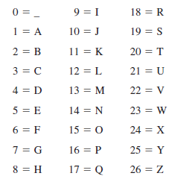

Then the message is converted to numbers and partitioned into **uncoded row matrices,**

each having *n* entries.

OVER 🡪

Page 4

1. Study the example below to see how to **encode** a message.

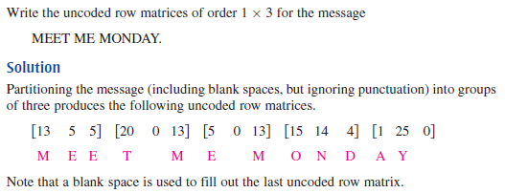

To encode a matrix, create an *n* X *n* invertible matrix, such as matrix A below.

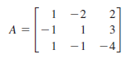

Multiply the uncoded row matrices by to obtain **coded row matrices.**

Here is an example:

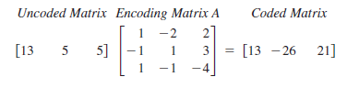

*** M E E encoded!

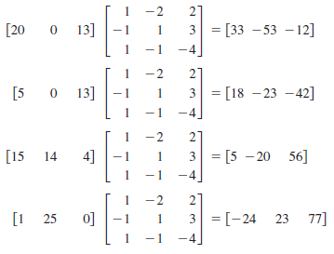 Here’s the rest:

So, the sequence of coded row matrices is:



Finally, removing the matrix notation produces the following cryptogram.



M E E T M E M O N D A Y _

Page 5

3. What do you think is involved to **decode** the message? How would you reverse the process?

Test out your theory to decode:



*Show your work below.*

4. Your turn . . . . . Message: GO TO HOMECOMING

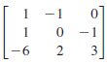A. Write the uncoded 1 X 3 row matrices for the message.

B. Then encode the message using the encoding matrix:

C. Check your encoded message by decoding it.

*Show your work below.*

OVER 🡪

Page 6

**Lesson 2-3 Homework**

*Please show your work on another piece of paper.*

1. Without using a calculator, show that *B* is the inverse of *A.*

**

2. Without using a calculator, find the inverse of each matrix (if it exists).



*A* = *B = C =*

***Use your calculator for the remaining problems.***

3. Use the Inverse-Matrix Method to solve the following systems (if possible).

*You must write the matrix equation as well as your final solution matrix.*

**

a. b.

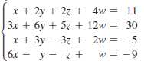

c.  d.

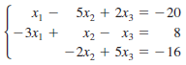

e.  f.

Use the Inverse-Matrix Method to solve the following problems 4 – 6.

4. A serving of roast beef has 17 grams of protein and 11 milligrams of calcium. A serving of mashed potatoes has 2 grams of protein and 25 milligrams of calcium. How many servings of each are needed to get 40 grams of protein and 97 milligrams of calcium?

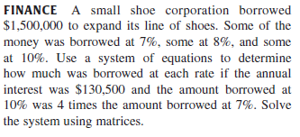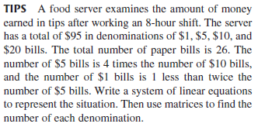

5. 6.

7. Write a cryptogram for the message below using 8. Use *A*-1 to decode the following cryptogram.

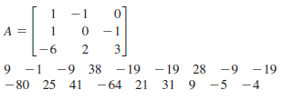 the matrix *A*.

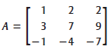

LANDING SUCCESSFUL