AP Calculus AB Name__________________________________

Lesson 2-3: *Continuity and the IVT* Date ________________________________

**Learning Goals:**

* *I can identify the intervals upon which a given function is continuous and understand the meaning of a continuous function.*
* *I can apply the Intermediate Value Theorem (IVT) and the properties of algebraic combinations and composites of continuous functions.*

When we collect data over a certain time period and plot the values, we often connect the plotted points with an unbroken curve to show what the functions values would have been at times that we did not measure. In doing so, we are assuming that we are working with a **continuous function**, a function whose outputs vary continuously with the inputs and do not jump from one value to another without taking on the values in between.

Any function  whose graph can be sketched in one continuous motion without lifting the pencil is an example of a continuous function.

Of the function families that we know, which are continuous and which are not continuous?

*Continuous* *Not Continuous*

**Limits and Continuity Desmos Activity**

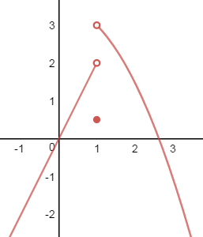In this activity, you will consider left and right limits—as well as function values—in order to develop an informal and introductory understanding of continuity.

Is this function continuous at *x* = 1? Explain.

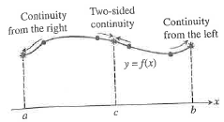Definition: **Continuity at a Point**

*Interior Point:*

A function is continuous at an interior point *c* of

its domain if .

*Endpoint:*

A functionis continuous at a left endpoint *a* or right endpoint *b* of its domain if



If a function *f* is not continuous at point *c*, we say that *f* is **discontinuous** at *c* and *c* is a **point of discontinuity** of *f*. Note that *c* need not be in the domain of *f.* OVER 🡪

Page 2

Which **one** of the following graphs is continuous? ***when *x = c*.

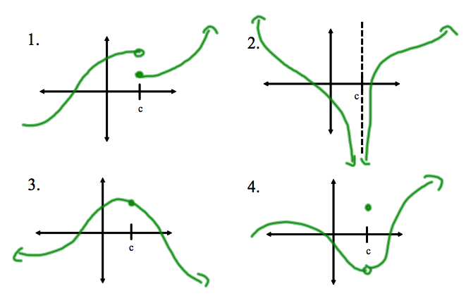

**Continuity Checklist:**

A function *f* is said to be continuous at *x = a* if:

***Now go to the website: <http://webspace.ship.edu/msrenault/GeoGebraCalculus/continuity_at_a_point.html> and try examples 2, 4, 5, and 7.

**Types of Discontinuities**

Consider the functions below. Which one is continuous at *x* = 0? The remaining graphs have different types of discontinuities *x* = 0: **infinite, jump, oscillating,** and **removable**.

Identify the discontinuityfor each graph.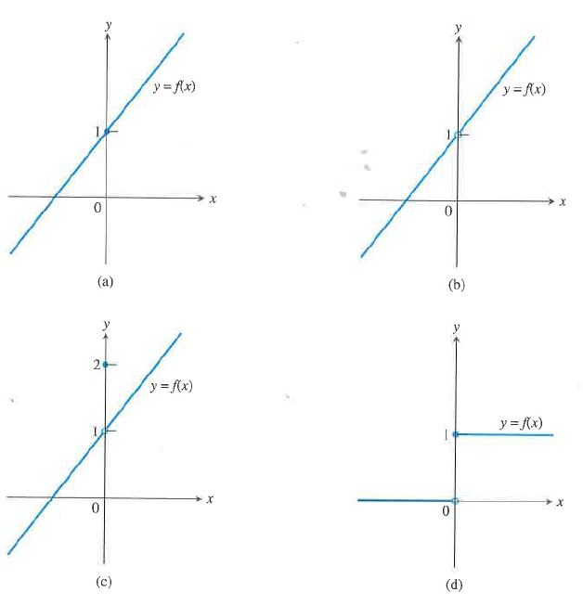

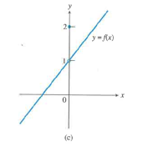

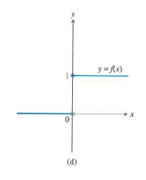

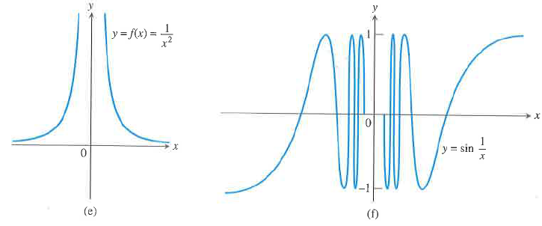

Page 3

Note that a function is **continuous on an interval** if and only if it is continuous at every point of the interval. So for example,is not continuous on the interval . However, the function is considered a **continuous function** because it is *continuous at every point of its domain.* Note the technical difference – so a continuous function need not be continuous on every interval. It may not be continuous at a certain value, but that value is excluded from the domain. Therefore, it is possible for a continuous function to have a discontinuity.

**Practice #1**

Identify the point and type of discontinuity of the function . Sketch the graph.

**Practice #2**

What value of *k* will make the below function continuous everywhere?



**Practice #3**

Find all discontinuities of the function .

Theorem: **Properties of Continuous Functions**

If the functions *f* and *g* are continuous at , then the following combinations are continuous at 

1. Sums: 

2. Differences: 

3.Products: 

4.Constant Multiples: , for any number *k*

5.Quotients: , provided 

OVER 🡪

Page 4

Theorem: **Composites of Continuous Functions**

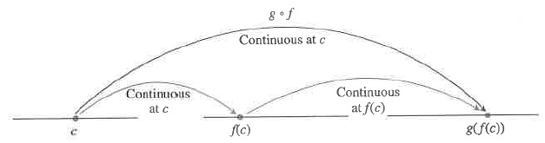If *f* is continuous at *c* and *g* is continuous at *f(c)*, then the composite of $g∘f$ is continuous at *c*

**Practice #4**

Without graphing, explain why the function is continuous.

Theorem: **Intermediate Value Theorem for Continuous Functions (IVT)**

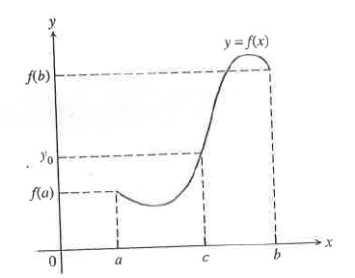A function that is continuous on a closed interval $\left[a,b\right]$ takes on every value between $f(a)$ and $f(b)$. In other words, if $y_{0}$ is between $f(a)$ and $f(b)$, then $y_{0}=f(c)$ for some $c$ between $a$ and $b$.

**Practice #5** (This question was one part of a 2014 AP Calculus AB Free Response Question.)

|  |  |  |  |  |  |
| --- | --- | --- | --- | --- | --- |
| t | 0 | 2 | 5 | 8 | 12 |
| $v_{A}(t)$ | 0 | 100 | 40 | $$-120$$ | $-150$ |

Train A runs back and forth on an east-west section of railroad track. Train A’s velocity, measured in meters per minute, is given by a continuous function $v_{A}(t)$, where time *t* is measured in minutes. Selected values for $v_{A}(t)$ are given in the table above.

Do the data in the table support the conclusion that train A’s velocity is -100 meters per minute at some time *t* ? Give a reason for your answer.