AP Calculus AB Name__________________________________

Lesson 2-3 Learning Check Date _____________________________

**NO CALCULATOR!**

**Learning Goals**:

* *I can identify the intervals upon which a given function is continuous and understand the meaning of a continuous function*
* *I can apply the Intermediate Value Theorem (IVT) and the properties of algebraic combinations and composites of continuous functions*

1. Suppose  _________

Then is continuous _________________.

1. except at  (B) except at  (C) except at 

(D) except at  (E) at each real number

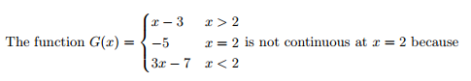

2. _________

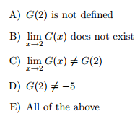

3. Explain why the function must have a zero on the interval 