Math 4 Honors Name________________________________
Lesson 2-4: Constructing Polynomial Function Models Date ______________________________

Learning Goal:
- I can fit polynomial function models to data and graph patterns using problem conditions, statistical regression, and the method of undetermined coefficients (which is an application of matrices).

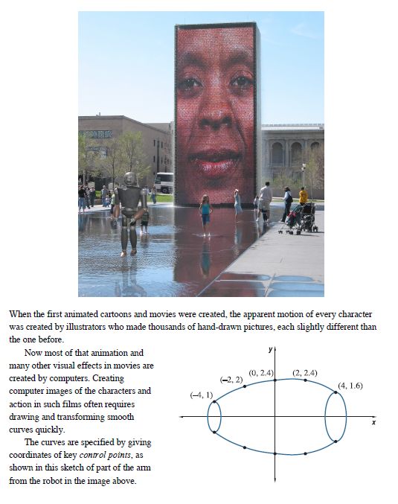

OVER
Page 2
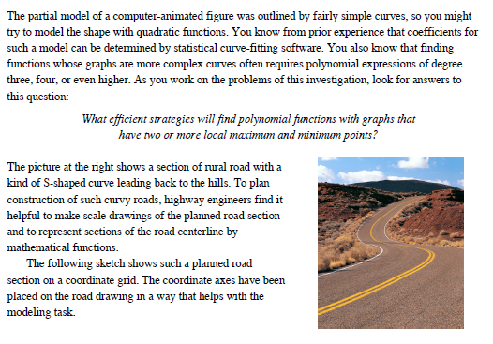

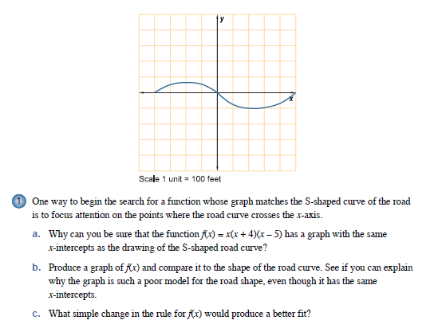

Page 3
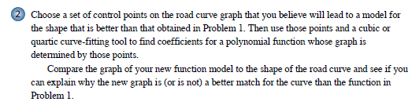

You will need to use at least 4 control points. Enter your points into a spreadsheet on your calculator. Run a regression . . .

The points $\left( \right), \left( \right), \left( \right) and \left( \right)$ give the equation

$y=$ _____________________________________________________

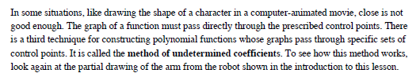

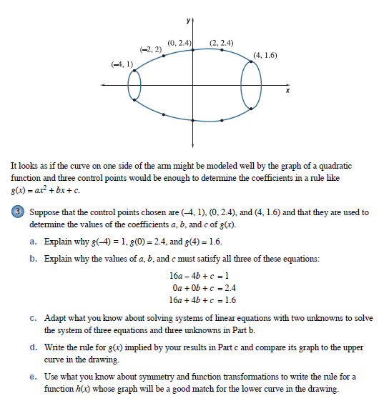

OVER
Page 4

Solve the system using substitution.

d. What would the matrix equation look like to solve the system in 3b? Solve the system using the
inverse-matrix method to verify what you found in part c.

e.

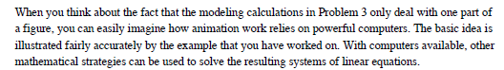

Page 5
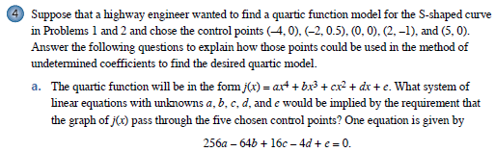

$$256a-64b+16c-4d+e=0$$

____________________________

____________________________

____________________________

____________________________

b. Translate the system from part a into a matrix equation. Write the matrix equation below.

c. Use the inverse-matrix method to solve the system. Write your solution matrix below.

d. $j\left(x\right)=$ _________________________________________________________________

5. If you had to use the method of undetermined coefficients to find the equation of a 5th degree polynomial, what would be the minimum number of control points you would need? _________
- How many equations would make up the system you would have to solve? _________
- What key points might you choose for your control points?
OVER
Lesson 2-4 Homework Page 6
Show all work on another sheet of paper.
1. Use a system of equations to find the quadratic function that satisfies the quadratic function
f(x) = ax² + bx + c that satisfies the given equations. Use matrices to solve the system.

f(x) = _____________________________________

2. Use a system of equations to find the cubic function that satisfies the cubic function
f(x) = ax³ + bx² + cx + d that satisfies the given equations. Use matrices to solve the system.

f(x) = _____________________________________

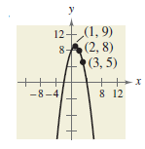
3. Use a system of equations to find the equation of the parabola y = ax² + bx + c that passes through the points. Use matrices to solve the system. Graph the equation in your calculator to verify your results.

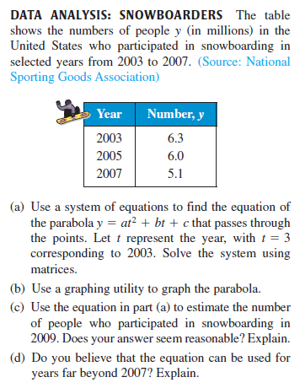
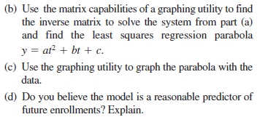
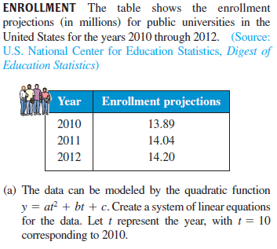
4. 5.

