AP Calculus AB Name ________________________________

Lesson 2-4 Learning Check Date _______________________________

**NO CALCULATOR** Result (circle one): P or NP

**SHOW ALL WORK** (even for multiple choice)

**Learning Goals:**

* *I can calculate average rates of change ( $A_{RoC})$ and instantaneous rates of change ($I_{RoC})$.*
* *can find equations of tangent lines and normal lines to a curve at a given point.*

1. Which of the following values is the average rate of change for  1. ________

over the interval ?

1.  (B)  (C)  (D) 

2. Which of the following is an equation for the tangent line to? 2. ________

**Use the definition and show your work!!**

1.  (B)  (C)  (D) 

OVER 🡪

Page 2

3. Is  continuous at ? Justify using the definition of continuity

4. Let . The equation to the tangent line at passes through .

Find the equation of the tangent line to at 

**REVIEW – The following two questions are from the 2003 AP Calculus AB Exam**

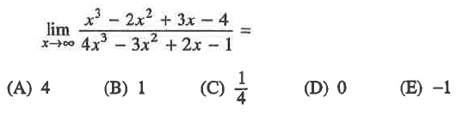

5. 5. ________

6. For , the horizontal lineis an asymptote for the graph of function 6. ________

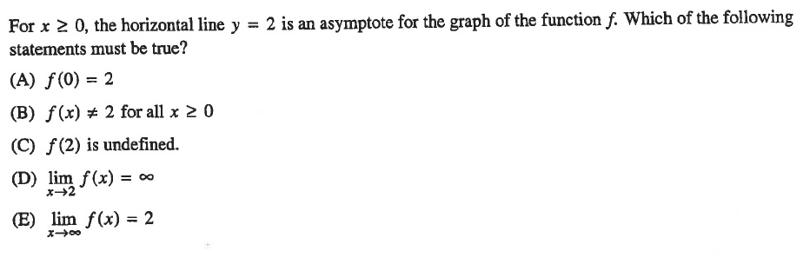 Which of the following statements must be true?