AP Calculus AB Name__________________________________

Lesson 3-1: *Derivative of a Function* Date _______________________________

**Learning Goals:**

* *I can calculate the derivative of a function using the definition of a derivative (at least once) and the alternative definition of a derivative (at least once).*
* *I can use the power rule (when appropriate) to find derivatives of functions.*

At the end of Chapter 2, we discussed how to find the slope of a curve at any point using limits.

When it exists, this limit is called **the derivative of *f* at *a*.**

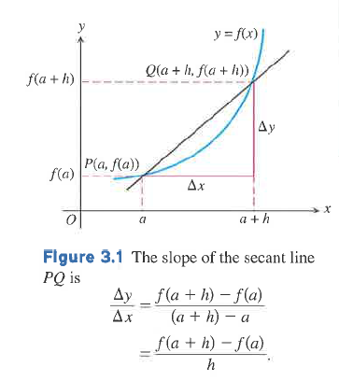**Definition:**: The **derivative** of the function *f* with respect to the variable *x* is the function 

whose value at *x* is

**

provided the limit exists.

*** ”*h*” is Δ*x.*

If exists, we say that *f* is **differentiable** at *x*. A function that is differentiable at every point of its domain is a **differentiable function**.

**Notation**

There are many ways to denote the derivative of a function . Besides , the most common notations are these:

**Notation Say it like this Notes**

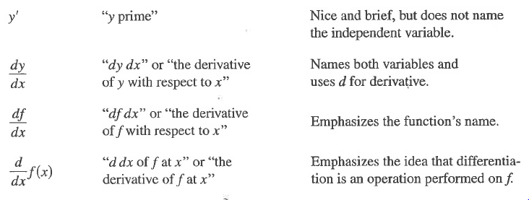

For those of you that did not learn the “ultimate shortcut” for derivatives, here is the grand unveiling:

**Power Rule:**

 (*** “*n*” must be a number.)

* Remember also that, like limits, the derivative of a sum is the sum of the derivatives.
* What is the derivative of any linear function?
* What is the derivative of a constant?

OVER 🡪

Page 2

**Practice #1**

Let .

1. Use the power rule to find.
2. Find the slope of the tangent line at .
3. Find the equation of the tangent line.

**I’m not allergic to fractions. Fractions are our friends. . . .**

**Practice #2**

Let 

1. Find the slope of the tangent line at .
2. Find the equation of the tangent line at .

**Practice #3**

Let 

1. Find the slope of the tangent line at .
2. Find the equation of the tangent line at .

Page 3

While using the power rule is obviously much more efficient than using the definition, the AP Exam will make sure that you know the definition of a derivative through some well-worded multiple choice questions. Along with the standard definition given on the previous page, if the drawing is relabeled as shown below, we then have an *alternate definition for a derivative at a point*.

**Alternate Definition:** The **derivative** of the function ***f* at point *x = a*** is the limit

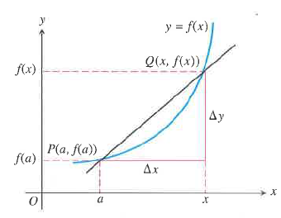



provided the limit exists.

**Practice #4**

Use the definition of a derivative or the alternative definition of a derivative to evaluate the following limits.

Use the power rule to make the work more efficient.

**These are similar to multiple choice questions on the AP Exam!**

a. Find 

b. Find 

OVER 🡪

Page 4

c. Find 

d. 

**One-Sided Derivatives**

**Definition:** A function is **differentiable on a closed interval ** if it has a derivative at every interior point of the interval, and if the limits



exist at the endpoints.

The usual relationship between one-sided and two-sided limits holds for derivatives. A function has a (two-sided) derivative at a point if and only if the function’s right-handed and left-handed derivatives are defined and equal at that point.

The important take-away here are

1. that on a closed interval, you ARE allowed to take derivatives of the endpoints; and
2. Just as with limits, for piecewise functions, you may need to make sure that the left-handed and right-handed derivatives are the same.

Page 5

**Practice #5**

For the function  show that :

1. is continuous as *x* = 0 .
2. has a left-handed derivative at *x =* 0*.*
3. has a right-handed derivative at *x =* 0.
4. the derivative does not exist at *x* = 0*.*

OVER 🡪

Page 6

**Practice #6**

Let

1. Find the left-handed derivative of *f* at *x =* 1 if it exists.
2. Find the right-handed derivative of *f* at *x =* 1 if it exists.
3. Does exist? Explain.