Math 1 Name ________________________

**Lesson 3-1 Learn Check** Date________

The following equations represent the percent of males and females in the armed forces since 1920.



Use the following graph to answer the questions 1-6 below:

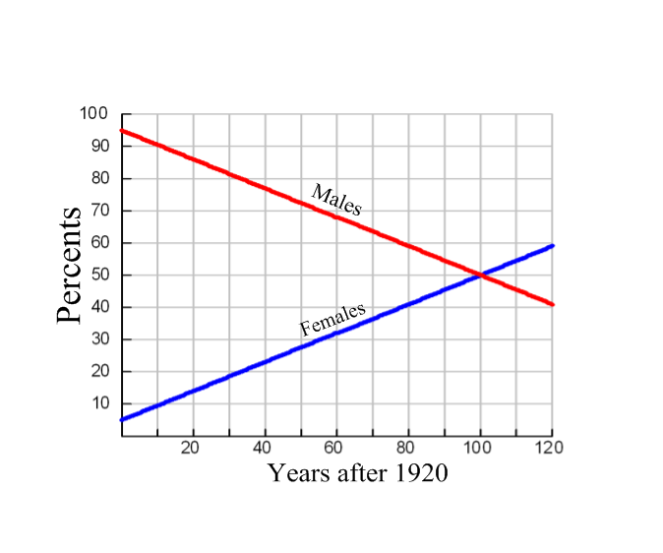

1. Are males or females represented by ?

2. In what year will the percent of males fall

to 60%

3. What will the percent of females in the

armed forces be in the year 1940?

4. When will the percent of females in the armed

forces be greater than the percent of males?

5. Which question below is represented by the following equation? 

a. When will the percent of females be 70%?

b. When will the percent of males be 70%?

c. What will be the percent of males in the year 1990?

d. What will be the percent of females in the year 1990?

e. What will be the percent of males in the year 1970?

6. Which question below is represented by the following equation? 

a. When will the percent of females be 28%?

b. When will the percent of males be 28%?

c. What will be the percent of males in the year 1948?

d. What will be the percent of females in the year 1948?

e. What will be the percent of males in the year 1928?

7. Using algebra, solve the following equation by hand. 

a. 

b. 

c. 

d. 

e. 