AP Calculus AB Name__________________________________

Lesson 3-1 Learning Check Date _______________________________

**NO CALCULATOR**

1. Find the equation of the tangent line to the graph of at 

2. If , then 

1.  (B)  (C) 

(D)  (E) 

3. If , then which of the following will find the value of 

1. 
2. 
3. 
4. I only (B) II only (C) I and II (D) I, II, and III (E) III only

OVER 🡪

Over the weekend, The Heinl was developing derivative practice problems while watching the Browns’ game. While she was working, the Browns actually scored a touchdown. In her excitement, The Heinl tossed her nachos supreme on her paper, thus making it unreadable. The only legible items left are below:

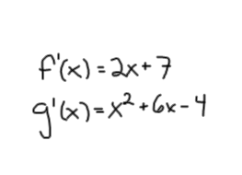

She just cannot seem to remember what his original functions were!

Please help!! Can you figure out what andwere??