Math 4 Honors Name ______________________________

Lesson 3-1: *Limits of Polynomial & Rational Functions* Date ___________________________

Learning Goal:

* *I can use direct substitution to evaluate the limits of polynomial and rational functions.*

**Limits** are a fundamental concept in calculus. Your experience with limits thus far has been with end behavior. For example: 

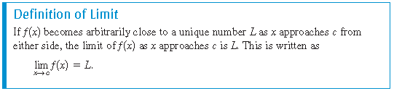In this lesson, you will be evaluating limits of polynomial and rational functions *x* is approaching a specific value for *c*.

I. Limits can be determined graphically, numerically, and algebraically. We will focus on the algebraic technique of **direct substitution**. That is,

 ***Substitute *c* for *x* then evaluate.

The results of using direct substitution to evaluate limits of polynomial and rational functions are summarized as follows:

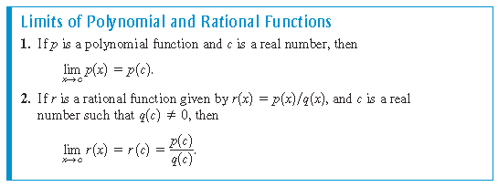

Study the examples below and their solutions.

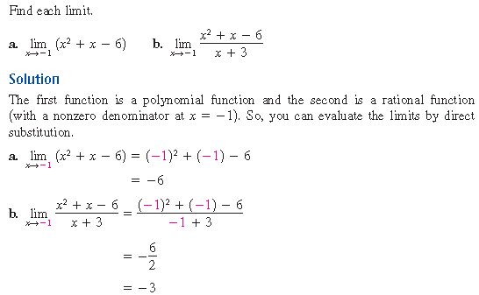

OVER 🡪

Page 2

**Practice:**

Find each limit.

1. 2.

II. Sometimes the direct substitution technique fails when evaluating limits of rational functions. Let’s

revisit the example from the front of this page. Notice how *c* now equals -3.

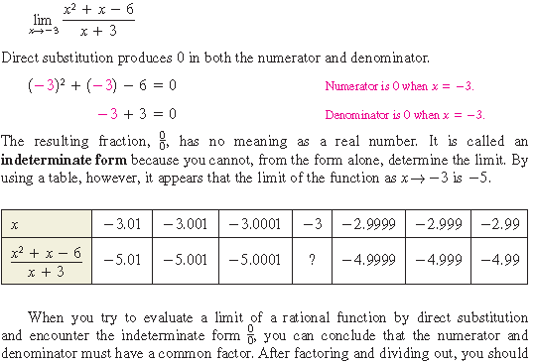





Try it out:

Does your answer fit the pattern in the table above?

The process you just used is called the **dividing out technique**.

Page 3

III. Another way to find the limits of some functions is first to *rationalize the numerator* of the function.

This is called the **rationalizing technique**. Recall that rationalizing the numerator means multiplying the numerator and denominator by the *conjugate* of the numerator. This will eliminate the irrational expression from the numerator.

Examples of conjugates:  and 

 and 

Study the following example of this technique:

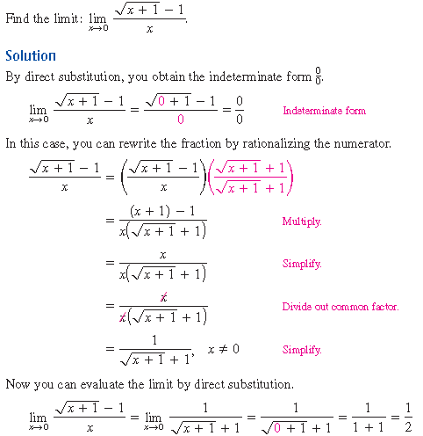

Now you try:

Find the limit:

OVER 🡪

Page 4

**Lesson 3-1 Homework**

*Show all work on another sheet of paper.*

Use direct substitution to find each limit.

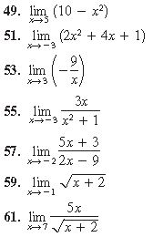

Use either the **dividing out technique** or the **rationalizing technique** to find each limit.

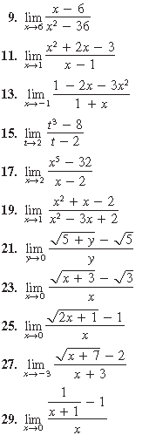



**Challenge:**