Math 4 Honors Name_______________________________

Lesson 3-2 Learning Check Date __________________________

Score: 0.0 0.5 1.0 1.5 2.0 2.5 3.0 3.5 4

In this learning check, you are being assessed on the following learning goals:

|  |
| --- |
| * *I can write expressions for rules of rational functions that model patterns in experimental data, geometric curves, and problem conditions.* |

Many common food items are packaged in cylindrical cans. Designing the size and shape of those cans requires consideration of visual appeal, ease of handling, durability, and manufacturing cost. Suppose that a new product is to be sold in cans that hold 355 milliliters (approximately equal to 12 ounces).

1. What information is given in the following formula? 

2. What information is given in the following formula? 

3. Use the information in problem (1) to express the ***height*** (in cm) of the can in terms of the radius.

4. Use the information in problems (2) and (3) to express the ***surface area*** (in cm2)of the can as a function

of the radius alone. *Write your function rule as a single algebraic fraction*.

5. Use the result of problem (4) (and your calculator) to estimate the radius that will produce minimum

surface area and the height corresponding to that radius. Make an accurate sketchofthe graph below.

Label the axes.

What do your computations mean in the context of the scenario? Write a sentence (or two).

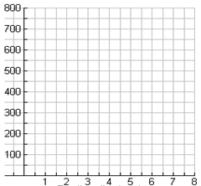

6. What is the equation of the vertical asymptote for your function #4? What does this mean in the context of the scenario?