Math 4 Honors Name______________________________

Lesson 3-2: *Rational Function Models* Date _____________________________

**Learning Goal:**

* *I can write expressions for rules of rational functions that model patterns in experimental data, geometric curves, and problem conditions.*

I. **Coffee and Cream Anyone?**

A typical coffee mug will hold around 300 cubic centimeters (cc) of coffee. This will leave space for cream. The coffee situation is this: what percent of a coffee and cream mixture is coffee? This is sometimes called the strength of the coffee. Many restaurants provide cream in small containers. Since the containers are usually not full, an estimation of the amount of cream in one container is 6 cc. Suppose you put one container of cream in your coffee, the strength has changed from 100% to something lower. The strength can be found by dividing the amount of coffee by the amount of mixture; thus the mixture now has a strength of , or 98% coffee. If you add two containers of cream, the strength has changed to , or 96.2% coffee.

1. Write a formula that will give you the strength of the coffee for *x* number of creams.



2. If you have not done so in question (1), simplify your formula by factoring out a common term.



3. Graph your function from question (2) in your calculator. Sketch it using both windows shown below.

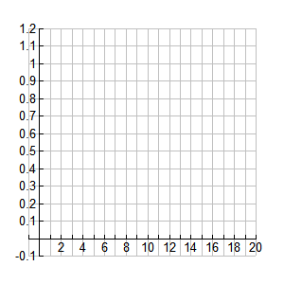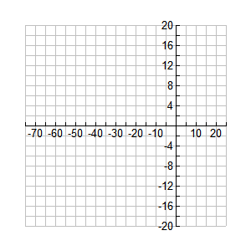

OVER 🡪

Page 2

4. Which graph is the more practical graph, given the context of the problem? Explain.

5. What happens to the function when ? Explain both in terms of the graph and the equation.

6. State the theoretical domain and range of the function.

7. State the theoretical end behavior of the function.

8. What is the parent function for ?

II. **The Refrigerator: How much does it really cost?**

On the web site <http://www.duke-energy.com/pdfs/appliance_opcost_list_duke_v8.06.pdf> there is a list of yearly costs for electricity for common household appliances.

|  |  |
| --- | --- |
| **Appliance** | **Average Cost/year for electricity** |
| Home Computer | $3.84 |
| Television | $26.52 |
| Dishwasher | $4.08 |
| Clothes Dryer | $81.72 |
| Washing Machine | 11.76 |
| Refrigerator (medium-sized) | $72.00 |

1. A brand new medium-sized Maytag refrigerator at Home Depot costs $565, determine the total annual cost for a refrigerator that lasts for 15 years. Assume the only costs associated with the refrigerator are the purchase price and the electricity.

Page 3

1. Develop a function that gives the annual cost of a refrigerator as a function of the number of years you own the refrigerator.
2. Sketch a graph of the function. Label important parts of the function.
3. What are the asymptotes of this function?
4. Explain the meaning of the horizontal asymptote in terms of the refrigerator.
5. If a company offers a refrigerator that costs $1000, but says that it will last at least twenty years, is the refrigerator worth the difference in cost? (Assume same electrical use & cost) Explain.

OVER 🡪

**Lesson 3-2 Homework**

1. Buffy and Ralph are graphing functions at the chalk board. Buffy is graphing  and Ralph is graphing .
2. The teacher asks both students to first write the domain of each of the functions. What should Buffy say? What should Ralph say?
3. Because these are both rational functions, the teacher asks both students to identify the asymptotes for each of the functions. What should each person say?
4. Enter the graphs of each function and check on the graphing calculator.
5. Surprised? Write an explanation of why these functions produce the same graph and then point out the easy information that comes from each form.

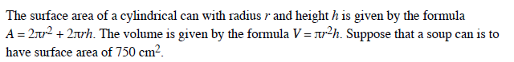

2.

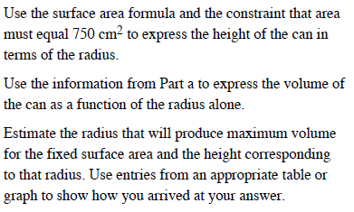

a)

b)

c)

3. It is common to see data patterns that have close to an L-shape as in the plot below. In such situations, you might consider modeling the data with a rational function

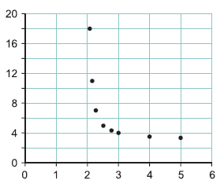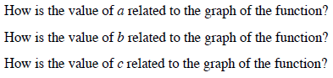

c)

a)

b)