Math 4 Honors Name________________________________

Lesson 3-3: *Properties of Rational Functions* Date ______________________________

**Learning Goals**

|  |  |
| --- | --- |
| * *I can identify asymptotes (horizontal, vertical, and oblique) for graphs of rational functions.* * *I can analyze rational functions.* | |
|  |

I. Analyzing Local and Global Behavior of Rational Functions:

1. Introduction to **Local Behavior** and **Jump Discontinuity**:

* When we observe the **local behavior** of a function  around a specific value , we look to see if  approaches a particular value as *x* approaches  from two directions − the left and the right.

Consider the graph of the function  shown below.

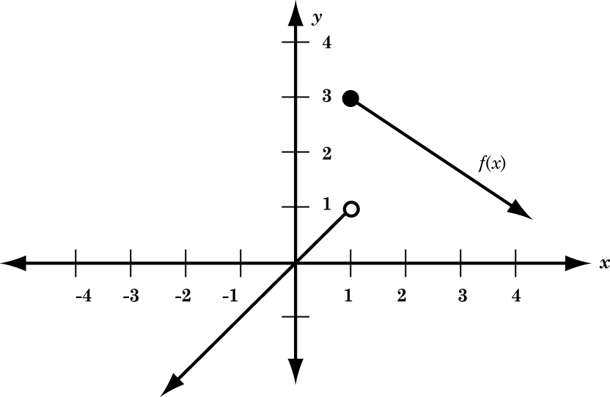

* Let’s examine the local behavior of the function  around the value .
* *x* approaches 1 from the left (Notation: *x* → 1- )

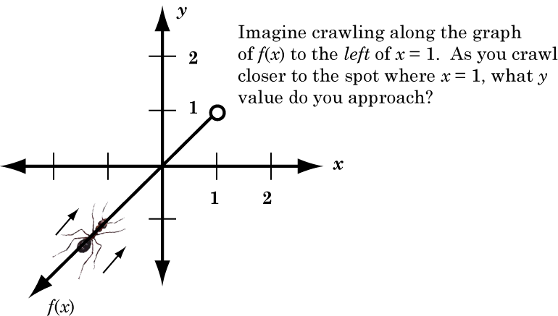

Complete:



OVER 🡪

Page 2

* *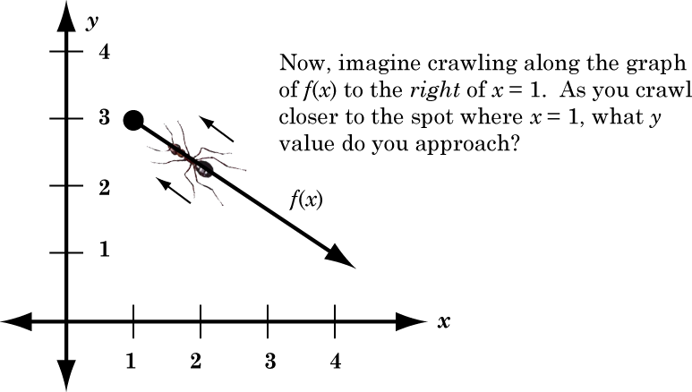x* approaches 1 from the right (Notation: *x* → 1+ )

Complete:



***Since the function doesn't approach the same value from both sides of , we say that

 has a **jump discontinuity** at .

1. Local Behavior of Rational Functions

In this section, you will use your graphing calculator to explore **rational functions** - functions of the form , with  and polynomials.

The table below contains several **rational functions**. Complete the missing values of the table by analyzing the **local behavior** of each function at the location *p* specified in the table. The first one has been done for you.

***Possible ways to do this: Make a *table* (ctrl T) of values; Make a graph and use the *trace*

function to manually enter values around the *p*-value

|  |  |  |  |
| --- | --- | --- | --- |
| Rational Function |  | Behavior of  as  (from left) | Behavior of  as  (from right) |
|  | 3 |  |  |
|  | 3 |  |  |
|  | 3 |  |  |
|  | 3 |  |  |
|  |  |  |  |
|  |  |  |  |

Page 3

C. **Practice**

1. Based on the information you compiled in the table, what (if any) generalizations can you make about rational functions of the form .

2. Make a prediction about the local behavior of the rational function  near the value

. Use your graphing calculator to check your predictions.

1. Consider the graph of a rational function of the form  where . Use the graph to predict the values of **, ** and ** .



Check your prediction using graphing features of your calculator.

1. Construct your own rational function such that  satisfies all 3 of the following properties:
   1. As , 
   2. As , 
   3. 

OVER 🡪

Page 4

II. Removable Discontinuities

A. In the previous section, you focused much of your attention on **rational functions** with a constant

numerator. **Rational functions** of the form  have **jump**

**discontinuities** at  (i.e. the roots of the denominator).

In this section, we'll examine **rational functions** with linear factors in both the numerator and denominator. As you will see, rational functions such as these may or may not have **jump discontinuities**.

* Consider the **rational function** . Simplify the algebraic expression.

What does this suggest about the graph of ?

With your graphing calculator, construct a graph of  (prior to simplifying). Your graph should resemble that of the linear function , *with one small difference*. Complete the following statements to learn more about the rational function .

1. As , 

1. As , 
2. Does  have a **jump discontinuity** at ? Why or why not?
3. 

As you probably discovered, the graph of the **rational function** doesn't "jump" at . Since the same *y*-value is approached from both sides, the function doesn't "jump".

However, since evaluating the function at  results in *division by zero* the function itself is *undefined* at . (Make a table in your calculator and notice what happens when *x* = 5.)

Because the graph breaks at , we still say that the function is **discontinuous** at . The graph highlights an example of a **removable discontinuity** (some find it helpful to think of "removable" discontinuities as values of *x* where "holes" occur in the graph of the function).

Page 5

B. **Practice:**

1. Consider the rational function  .

a. Factor the numerator and denominator of the function. At what values of *x* will the function have a removable discontinuity?

1. Using the factored form of the numerator and denominator, simplify the function by "cancelling out" like factors. The resulting function should be in the form  with .

***Think about it.***  You can use the "long division algorithm" to write the simplified form of the function in a way that clearly illustrates locations of jump discontinuities. Here's an example using the rational function .

  there's a jump at *x* = 2.

Note that graph of  is actually the graph of  translated to the

right 2 units and translated up 1 unit.

1. Complete similar steps to find the jump discontinuity of the function you wrote in part (b).

OVER 🡪

Page 6

1. Consider the graph below. An equation for the function that generates the graph may be written in the form  where  (with values not necessarily distinct).

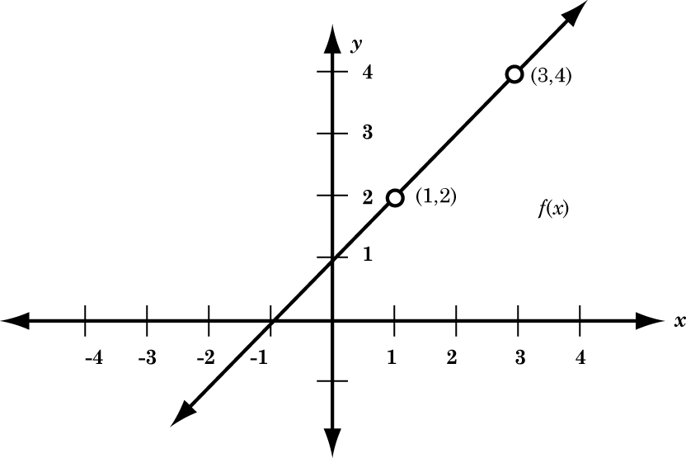

Find values of  that generate the graph. Check your prediction using graphing features of your calculator. *Make a table of values. Do you see where the holes occur?*

1. Construct your own rational function such that  satisfies the following 3 properties:

a. As , 

1. As , 
2. A **removable discontinuity** exists at .

*Challenge*: Modify your rational function to satisfy the above three properties **and** the additional property listed below:



*Make a table of values. Do you see where the hole occurs? Does* ?

Page 7

III. **Essential Discontinuities**

Up to this point we have addressed jump and removable discontinuities. There is one more type of discontinuity when it comes to rational functions . . . . **Essential**!

1. Dig back into your Math 3 Honors archives . . . What is another term for an **essential discontinuity**?
   * Explain what the source of an essential discontinuity is.
   * Is it possible for a rational function to have multiple essential discontinuities? Explain by giving an example.
   * Is it possible for a rational function to zero essential discontinuities? Explain by giving an example.
2. Refer to the function from part B, question 1 on page 5 of this packet.
   * 1. How many essential discontinuities? _______
     2. Write the equation(s) of it(them): _______________________________
     3. Describe the local behavior around the vertical asymptote using the correct notation.

IV. Horizontal and Oblique Asymptotes

A rational function will have either a horizontal or oblique asymptote.

1. Recall the coffee & cream function from the previous investigation: 

What is the equation of its horizontal asymptote?

What is the theoretical end behavior of the asymptote?

What is the theoretical end behavior of the function?

Page 8

1. Recall the refrigerator function from the previous investigation: 

What is the equation of its horizontal asymptote?

What is the theoretical end behavior of the asymptote?

What is the theoretical end behavior of the function?

C. Graph the following function: 

What type of asymptote?

What is the equation of the asymptote?

What is the end behavior of the asymptote?

What is the end behavior of the function?

D. Graph the following function: 

What type of asymptote?

What is the equation of the asymptote?

What is the end behavior of the asymptote?

What is the end behavior of the function?

Page 9

**Summary of Horizontal and Oblique Asymptotes:**

WITHOUT graphing, how can you predict if a rational function has . . . .

*\*\*\*Hint: Think degrees of the numerator and denominator.*

1. The *x*-axis for its horizontal asymptote?

1. A constant function for its horizontal asymptote?

How do you find the constant value?

1. An oblique asymptote?

How do you find the equation of the oblique asymptote?

**True or false. *If false, explain why (you can use a counterexample if you like).***

1. A rational function can have both a horizontal and oblique asymptote at the same time. ___________
2. A horizontal asymptote can be intersected by its function. ___________
3. All rational functions must have either a horizontal or vertical asymptote. ___________
4. A rational function can have multiple vertical asymptotes. ___________
5. Horizontal and oblique asymptotes determine the end behavior of rational functions. ___________
6. The same value for *x* can be the source of a hole and a vertical asymptote for a rational function.

_____________

OVER 🡪

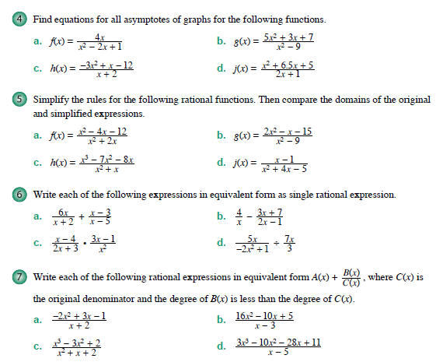**Lesson 3-3 Homework: *Please* *show all work on another piece of paper.***

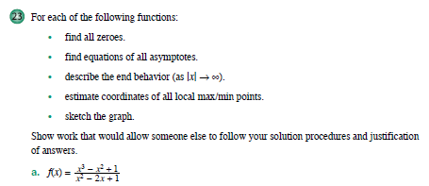

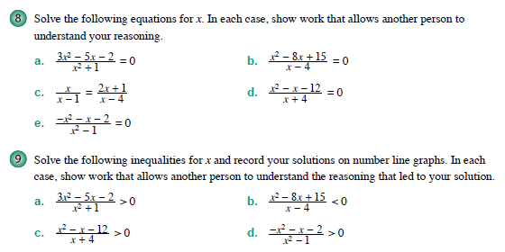







For the functions below, find the following:

* The zero(es)
* The *y*-intercept
* Removable discontinuities (if any)
* Essential discontinuities (if any)
* The equations of all asymptotes
* Local behavior around the vertical asymptotes
* End behavior

a.  b. 