Math 4 Honors Name ______________________________

Lesson 3-4: *Partial Fraction Decomposition* Date ___________________________

**Learning Goal:**

* *I can find the partial fraction decomposition of a rational expression.*

In Calculus, there are several procedures that are much easier if we can take a large fraction and break it up into pieces. The procedure that can decompose larger fractions is called Partial Fraction Decomposition. We will proceed as if we are working backwards through an addition of fractions with LCD.

**Example 1:** For our first example we will work an LCD problem frontwards and backwards. Use an LCD to complete the following addition.



Now let’s work this problem backwards . . . .



Find the *partial fraction decomposition* for .

As we saw above that the denominator factors as (*x* + 2)(*x* – 1). We want to find numbers *A* and *B* so that:



Study the process below and describe what was done in each step of the process.



If the left side and the right side are going to be equal then:

*A* + *B* = 8 and –*A* + 2*B* = 7. Why?

2 equations; 2 variables; time to solve a system! Show your work below:

What is significant about the solution to the system? Take a look at what we started with!

OVER 🡪

Page 2

**Example 2:** The previous example had an LCD comprised of two linear factors. This next example has a denominator with one linear factor and one quadratic factor.



Find the partial fraction decomposition for

First factor the denominator. Use the factor by grouping technique:



Because one of the factors in the denominator is quadratic, it is quite possible that its numerator could have an *x* term and a constant term—thus the use of *Ax* + *B* in the numerator.



So,

Describe what was done in each step:



Now there are three variables, so it is necessary to set up a system of three equations. Write the equations below and solve the system.

Use your solution to complete the partial fractions.



* How can you check verify that you have found the correct partial fractions?

Call The Heinl over for verification of your work and solutions. *Heinl Approval:*

Page 3

**Example 3:** Let’s see what happens when one of the factors in the denominator is raised to a power. Consider the following for partial fraction decomposition:



The following set up considers that the second fraction could have come from two pieces.



Describe what was done in each step:



Again, there are three variables, so it is necessary to set up a system of three equations. Write the equations below and solve the system.

Use your solution to complete the partial fractions:

Call The Heinl over for verification of your work and solutions. *Heinl Approval:*

OVER 🡪

Page 4



**Example 4:** Find the partial fraction decomposition for .

Notice how this is an improper fraction. Before starting the process, we must divide the numerator by the denominator and then decompose the remainder.





So,

Now it’s your turn. Decompose the remainder.



Complete:

Call The Heinl over for verification of your work and solutions. *Heinl Approval:*

**Summarize the process of *Partial Fraction Decomposition:***

**Lesson 3-4 Homework**

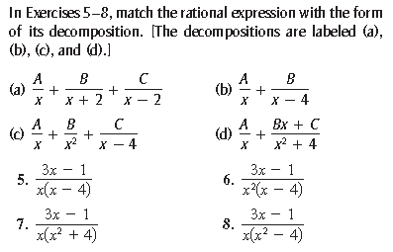

*Show all work on another sheet of paper.*

Write the partial fraction decomposition of each rational expression.

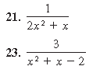

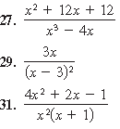

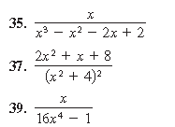

OVER 🡪

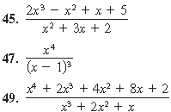



**Review:**

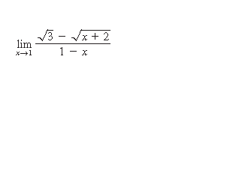

1.  Evaluate:
2.  Solve for *x*:



1. Completely analyze the following function: