AP Calculus AB Name____________________________

Lessons 3-4 Learning Check **NO CALCULATOR!** Date ____________________________

**In questions 1-4, the position of a particle moving along a straight line is given by** .

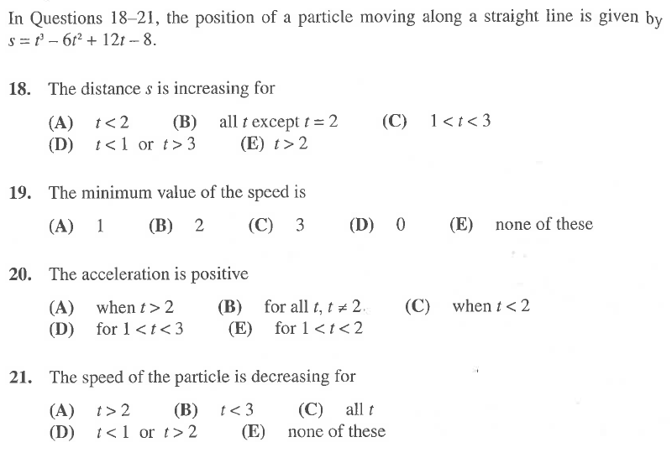

1.



2.



3.



4.

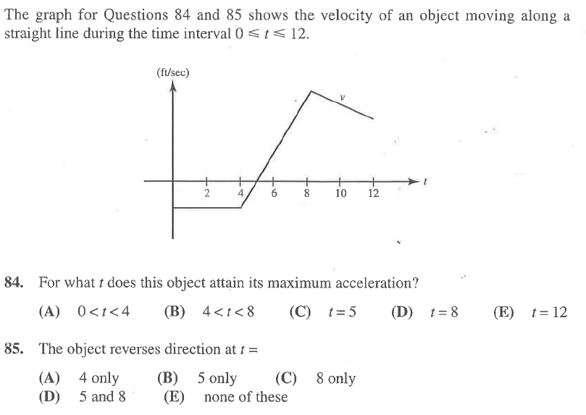**The graph for questions 5 and 6 shows the velocity of an object moving along a straight line for .**

5.

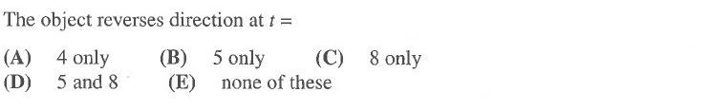

6.