AP Calculus AB Name__________________________________

Lesson 3-4: *Velocity and Other Rates of Change* Date _________________________________

**Learning Goal:**

* *I can use derivatives to analyze straight line motion and solve other problems involving rates of change.*

The below graph models the height over time of a pumpkin that was launched straight up into the air.

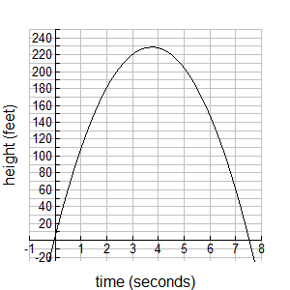The equation for the graph is .

1. Find . Label your answer with units.

What does your answer mean in the context of the problem?



*Which means . . .*

2. Find . Label your answer with units.

What does your answer mean in the context of the problem?





*Which means . . .*

3. Find . Label your answer with units. What does your answer mean in the context of the problem?





*Which means . . .*

**Notes:**

OVER 🡪

Page 2

**Important Vocabulary:**

**Displacement** - the amount of movement of an object measured in a particular direction

**Average Velocity - ;** graphically represented by a *secant* line; note that when we simply say

“velocity”, the assumption is we are referring to *instantaneous* velocity.

**Speed –** absolute value of velocity

**Jerk –** derivative of acceleration; third derivative of position (jerk is what makes you spill your drink when

a car accelerates suddenly).

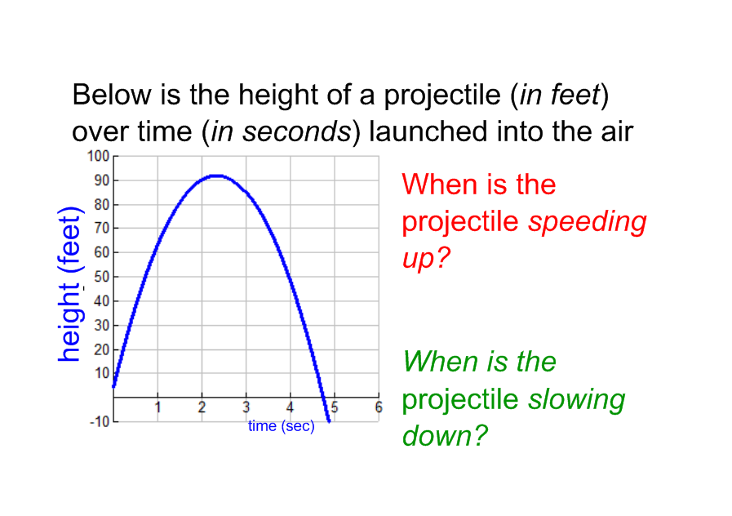

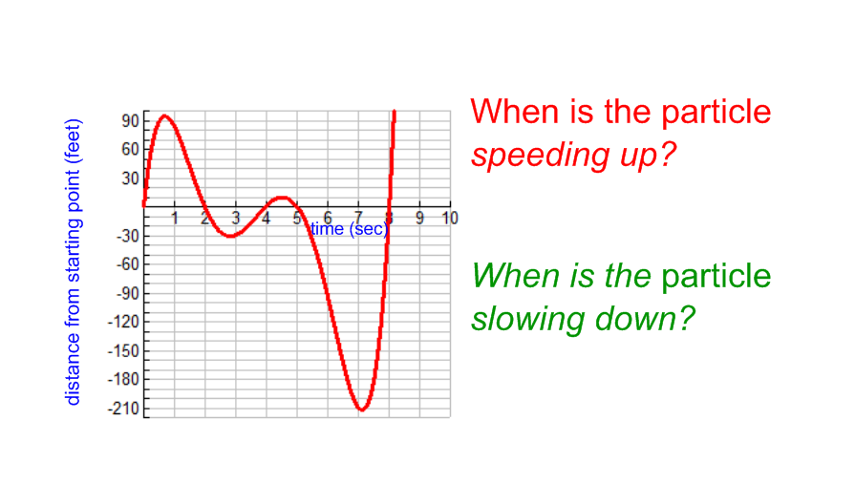

If an object is traveling at a velocity of , what does the negative sign imply?

If the object’s velocity gets “more negative”, what does that mean about the object?

If the object’s velocity gets “less negative”, what does that mean about the object?

Page 3

**Example 1 –** *Calculator active but explain your answers!*

A dynamite blast propels a heavy rock straight up into the air. Its velocity is modeled by the function reaches a height of ft/sec after *t* seconds.

(a) When will the rock reach its maximum height?

(b) What is the acceleration of the rock at any time *t* during its flight (after the blast)?

(c) At , is the rock speeding up or slowing down?

(d) When does the rock hit the ground? Explain how you know.

OVER 🡪

Page 4

**Example 2 – Particle Motion** *– NO CALCULATOR*

A particle is moving along the horizontal axis in such a way that its position at time *t* is

given by the following function:



(a) Determine a formula for the velocity of the particle.

(b) Determine a formula for the acceleration of the particle.

(c) For what values of *t* is the particle at rest? *Hint: What is its velocity when it’s at rest?*

(d) When is the particle moving to the right? To the left? *Hint: NUMBER LINE ANALYSIS!*

(e) What is the velocity of the particle when the acceleration is zero?

(f) At *t =* 4 seconds is the particle speeding up or slowing down? *Think about the relationship*

*between velocity and acceleration.*

(g) What is the displacement of the particle at 

(h) When *t* = 3, what is the total distance traveled by the particle. *Refer back to your NLA analysis!*

Page 5

**STOP, DROP, AND AP!**

**Answer the following AP multiple choice questions:**

*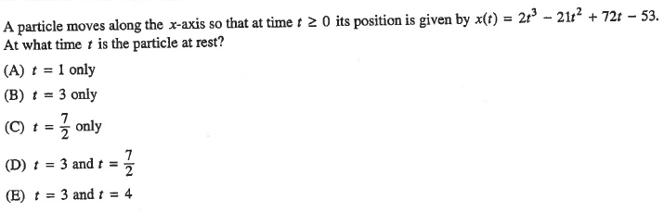NO CALCULATOR*

*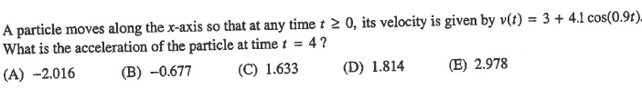CALCULATOR*

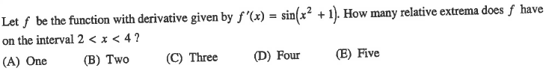

**2016 Exam**

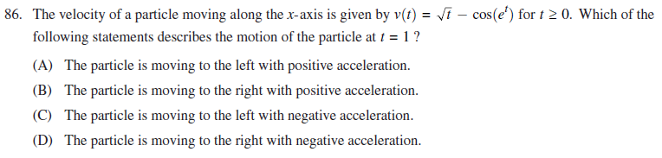

OVER 🡪

Page 6

Below is an actual free response question from the 2013 AP Calculus Exam. This question was calculator active. Complete the below problem, then see The Heinl for an answer key. Skip part (b) as we have not done any integrals yet (however note how material from much later in the school year will be used in a problem that we are learning at this point in the school year).

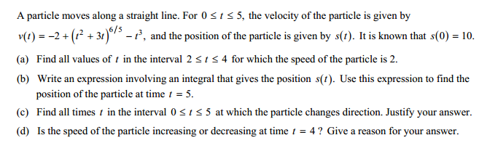

[skip part b.]

**AP Calculus Free Response Question Rubric**

