AP Calculus AB Name__________________________________

Lesson 4-1 Chain Rule Practice #1 Date __________________________________

**Calculate the derivatives of the below functions.**



1. 2.



3. 4.



5. 6.

OVER 🡪

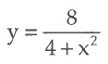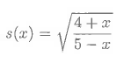7. 8.

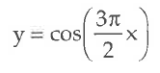



9. 10.

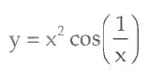

11. 12. Find the slope of the tangent line at 

if .

13. The derivative of a function is . Find .