AP Calculus AB Name__________________________________

Lesson 4-1 Chain Rule Practice #2 Date _________________________________

**In problems 1-6, find the first derivative of the given function.**



1. 2.

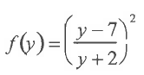



3. 4.

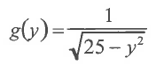



5. 6.

OVER 🡪

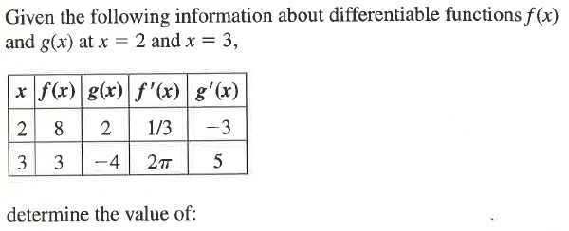7.

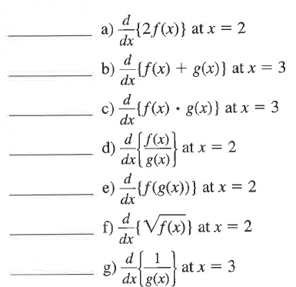

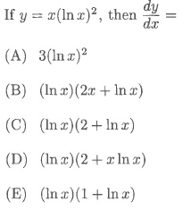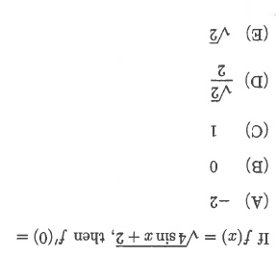

8. 9.

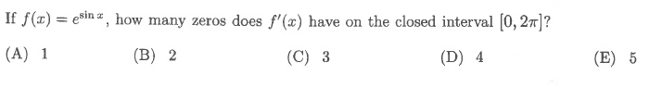

10.

11. Find if  12. Find *y* if 