AP Calculus AB Name__________________________________

Lesson 4-1 Chain Rule Practice #3 Date ________________________________

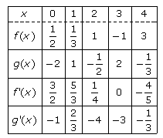

Two functions are differentiable for all values. Some values of the functions and derivatives are given above. Use the table to answer the following questions.

*Write out the general rule for the derivative before attempting to evaluate it!*

1. Find . 2. .

3. . 4. .

5. . 6. .

OVER 🡪



7. . 8. .

9. . 10. .

