AP Calculus AB Name__________________________________
Lesson 4-1 Learning Check Date _________________________________

All of these questions are from released AP Exams.
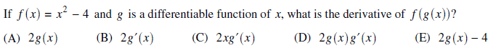
1.

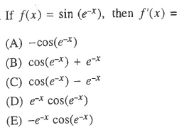
2.

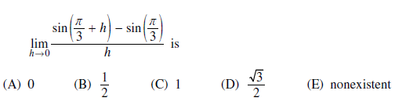

3.

OVER
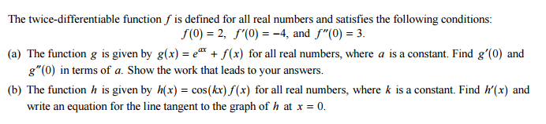
4.

