AP Calculus AB Name__________________________________

Lesson 4-2: *Implicit Differentiation* Date ________________________________

**Learning Goal:**

* *I can find derivatives using implicit differentiation.*

**Implicit**: Implied though not plainly expressed; In mathematics - A function or relation in which the

dependent variable is not isolated on one side of the equation.

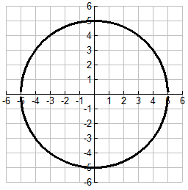

I. Recall that the equation of a circle with radius 5 is .

Sketch tangent lines to the circle at .

* How would you use the equation of the circle to find

the exact slope of each of the tangent lines? What makes

this more challenging than what we have seen so far?

Discuss these questions with the people at your table.

While the work to solve the problem above is not terribly difficult, what if the function we started with were a bit more complicated? Say we wanted to find the tangent line to at . In this equation, it is not very efficient to try to isolate *y* in order to take the derivative. So how are we going to differentiate the function if we cannot isolate *y*? That answer is **implicit differentiation**.

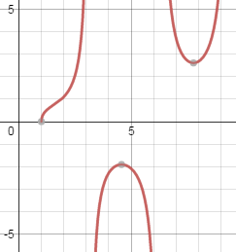**Explicitly defined functions** are functions that are expressed only in terms of the independent variable.

For example, .

**Implicitly defined functions** are relations that actually have two or more functions hidden (hence implicit) inside the equation. For example:

1. The inverse of is ; this can only be written explicitly as the **two** functions

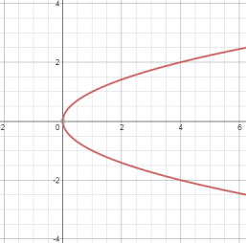.

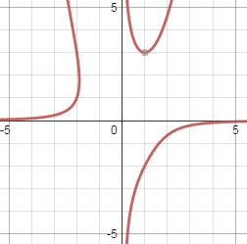b) ; this function cannot (easily) be written explicitly, but from the graph clearly has two functions hidden within itself.

OVER 🡪

Page 2

To understand how to find implicitly, you must realize that differentiation is taking place ***with respect to x***.This means that when you differentiate terms involving *x* alone, you can differentiate as usual. However, when you differentiate terms involving *y*, you must apply the Chain Rule – because you are assuming that *y* is defined implicitly as a differentiable function of *x*.

**Example 1**

a. Find 

b. Find 

c. Find 

d. Find 

e. Find 

II. Let’s go back to the circle problem:

* Find the slope of the tangent lines to the circle  at. This time use implicit differentiation.

**Example 2**

Show that the formula for is defined at every point on the graph of 

Page 3

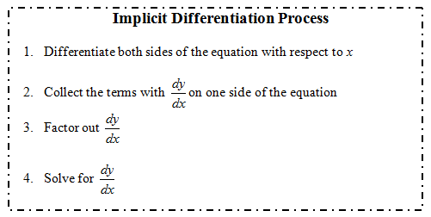

**Practice #1**

1. Find  if 

2. Find the tangent and normal lines to the ellipse at the point 

OVER 🡪

Page 4

III. Finding the 2nd Derivative Implicitly

**Example 3**

Find if 

**Practice #2**

Use implicit differentiation to find for the equation .

**Algebra Challenge:** Your answer should simplify to. Give it a try!

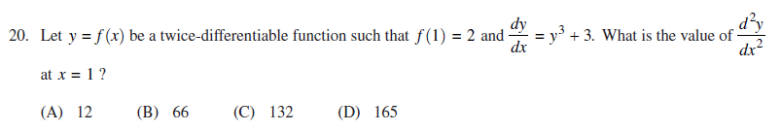**2016 A.P. Exam Problem**