AP Calculus AB Name__________________________________

Lesson 4-2 Learning Check Date ________________________________

**NO CALCULATOR**

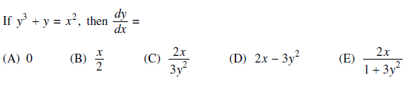

1.

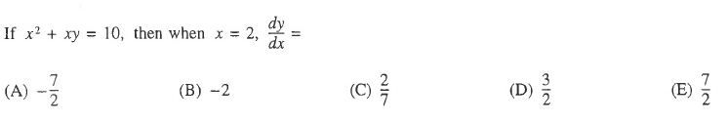

2.



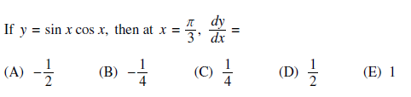

3.

|  |  |  |  |
| --- | --- | --- | --- |
| ***x*** | 0 | 1 | 2 |
| ***f(x)*** | 1 | *k* | 2 |

4. The function *f* is continuous on the closed interval and has values that are given in the table above.

The equation  must have at least two solutions in the interval if 

(A) 0 (B)  (C) 1 (D) 2 (E) 3

OVER 🡪

5. Find .

6. Find the slope of .