Math 4 Honors Name _______________________________

Lesson 4-2: *Proving Trigonometric Identities* Date _____________________________

Learning Goals:

* *I can use the fundamental trigonometric identities to simplify expressions and verify equivalences.*
* *I can solve trigonometric equations algebraically, including equations that involve factoring.*

**Graph the following equations in your calculator. What do you notice?**



***Prove algebraically:***

**Tips for Verifying Trig Identities**

1. **Start with the MORE COMPLICATED side and work VERTICALLY just on that side to make it look like the other side. SHOW ALL WORK.**

***Note: We cannot assume that the equation is true, so properties of equality cannot be applied.***

1. **Look to factor, add/subtract fractions, square binomials, distribute, multiply by a conjugate, etc.**
2. **Look for opportunities to use the fundamental identities. *These must be memorized!***
3. **Try converting to all sines & cosines.**

**Fundamental Identities:**



OVER 🡪

Page 2

**Examples: Prove the following.**



1. 2.



3.

**Inverse Trigonometric Functions**

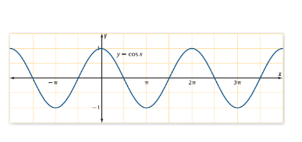

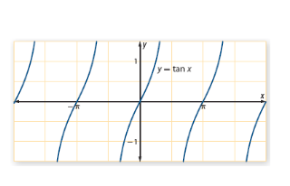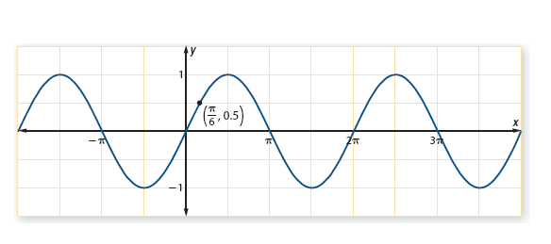

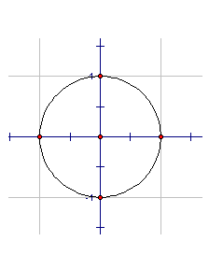

Notation: Notation: Notation:

Domain: Domain: Domain:

Range: Range: Range:

Page 3

**Solving Trig Equations**

***Principal Solutions: General Solutions: Primary Values:***

**Examples: Solve for the primary values.**



1.)



2.)



3.)

Math 4 Honors Name __________________________

Trigonometric Identities #1 Date _______________________

*You must show all work on another piece of paper.*

**Verify the following identities.**

**\*\*\*Remember:****Start with the MORE COMPLICATED side and work VERTICALLY just on**

**that side to make it look like the other side.**



Math 4 Honors Name __________________________

Trigonometric Identities #2 Date _______________________

*You must show all work on another piece of paper.*

**Verify the following identities.**



**Solve for the primary values. *Exact values only.***



*Hint: Chunk!*

Math 4 Honors Name __________________________

Trigonometric Identities #3 Date _______________________

*You must show all work on another piece of paper.*

**Verify the following identities.**



**Solve for the primary values. *Exact values only.***

