AP Calculus AB Name_________________________________

Lesson 4-3: *Derivatives of Inverse Functions, Part 1* Date _________________________________

**Learning Goal**:

* *I can calculate the numeric derivative of an inverse function*

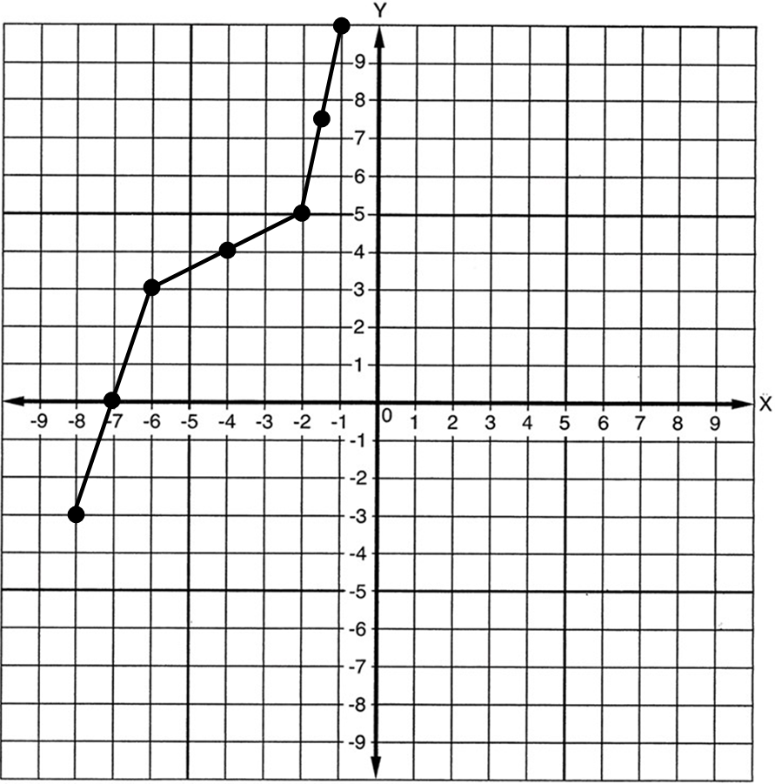

***f***

I. Function  is graphed above. Please do the following:

1. Graph  .
2. Complete the table below:

|  |  |  |  |  |
| --- | --- | --- | --- | --- |
|  |  |  |  |  |
| -7 |  |  |  |  |
| -4 |  |  |  |  |
| -1.5 |  |  |  |  |
| 0 |  |  |  |  |
| 4 |  |  |  |  |
| 7.5 |  |  |  |  |

1. What are some observations you can make from the numbers in the table?

OVER 🡪

Page 2

**Theorem:** *Derivatives of Inverse Functions*

If  is differentiable at every point on an interval *I* and is never zero on *I*, then has an inverse, and is differentiable at every point of the interval .

If , then ________________________________.

**Example 1**

Let , and let  denote the inverse of . Given that  is on the graph of *f*,

find 

**Practice #1**

Let 

(a) Find and .

(b) Find and .

Page 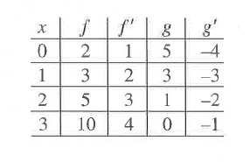3

**Practice #2**

Differentiable functions *f* and *g* have values as shown in the table.

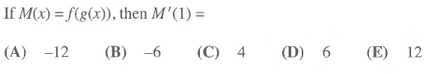

a.

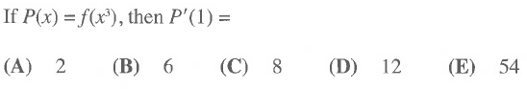

b.

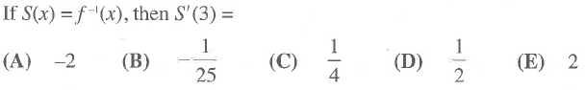c.

AP Calculus AB Name__________________________________

Lesson 4-3, Part 1 Homework Date _________________________________

For the below problems:

1. Verify that the functions have inverses
2. Evaluate the derivative of the inverse at the given value

1. 

2. 

3. 

4. 

OVER🡪

5. Let *f* be the function defined by . If and , what is the value of

?

(A)  (B)  (C)  (D) 4 (E) 13

6. Let *f* be a function such that . Which of the following must be true?

I. *f* is continuous at 

II. *f* is differentiable at 

III. The derivative of *f* is differentiable at 

(A) I only (B) II only (C) I and II only (D) I and III only (E) II and III only