AP Calculus AB Name_________________________________

Lesson 4-3: *Derivatives of Inverse Functions, Part 2* Date ________________________________

**Learning Goal:**

* *I can calculate the derivative of an inverse trigonometric function.*

Let’s take a trip down our trigonometric memory lane . . . . .

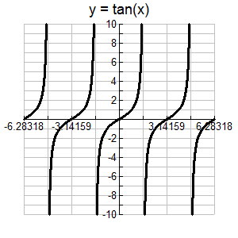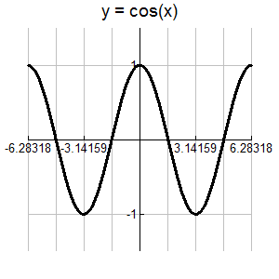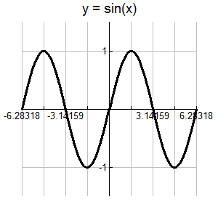

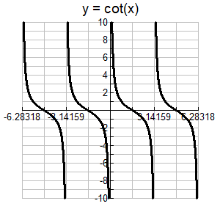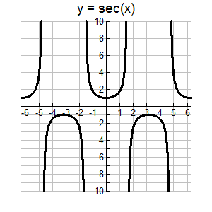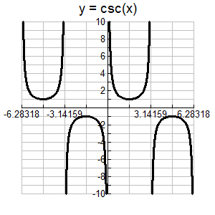

  

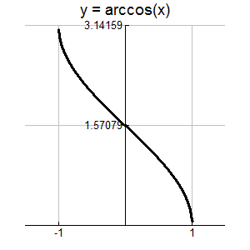

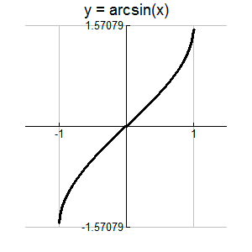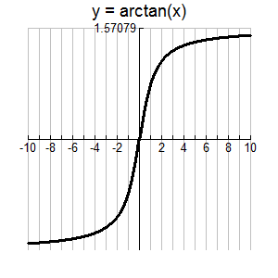

Look at the graph of on the open interval  . The sine function is one-to-one on this interval and hence it has inverse . We know from the previous lesson that we are assured that the inverse functionis differentiable throughout the interval  (it is not differentiable at because the tangent lines are vertical at these points).

OVER 🡪

Page 2

We find the derivative of as follows:



**Example 1**

Find 

Page 3

Without going through the pain of proving all of the other formulas, here they are:

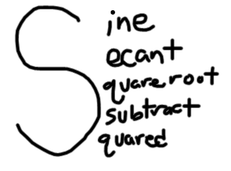 

 

 

**Let’s have some fun . . . and practice our inverse trigonometric derivatives!!**

Differentiate the following functions:

1. 

2. 

3. 

OVER 🡪

AP Exam Mixed Practice Page 4

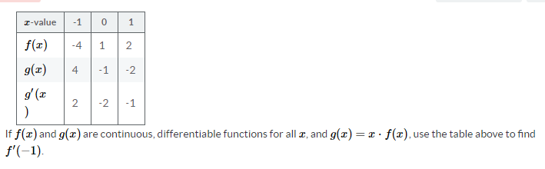

1.

A. -6 B. -2 C. -1/2 D. 2

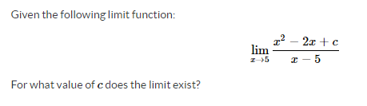

2.

A. -5 B. -15 C. 0 D. 3



3.

A. *y =* π B. *y =* 3 C. *y =* π + 3 D. *y = x −* π + 3



4.

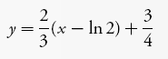

A. B.





C. D.

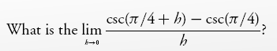

5.



A. B.



C. 0 D.