Math 4 Honors Name _______________________­­­­­­­­­________

Lesson 4-3: *Sum & Difference Formulas for Cosine* Date _____________________________

Learning Goal:

* *I can, without a calculator, use trigonometric identities such as angle addition/subtraction and double angle formulas, to express values of trigonometric functions in terms of rational numbers and radicals.*

I. **Evaluate the following with your calculator to 4 decimal places:** cos 105° ≈ __________

The problem is that this is not an exact value because **cos 105°** is an irrational number.

The following formulas will enable you to calculate the exact value of **cos 105°**.

**Sum and Difference Formulas for Cosine:**

*Note:* are angle measures in either degrees or radians.



Here’s how they’re used . . .

1. Think of **cos 105°** as **cos(45° + 60°)**. What is ____ What is ____

2. Use: 

3. Substitute: 

4. Now it’s *Happy Unit Circle Time* . . . . Evaluate and simplify. Combine into one fraction.

DO NOT TOUCH YOUR CALCULATOR.



5. *Now use your calculator*. Enter your final fraction from step 4 into your calculator and evaluate. What do you get? _______________

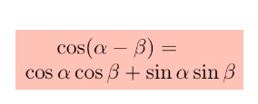

*Where do the formulas come from?* **:**

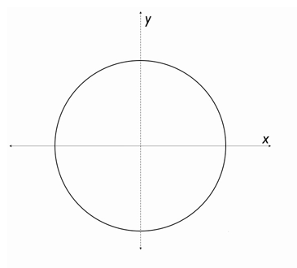

OVER 🡪

Page 2

 . . . to using the formulas: For values, you must use those from the  families.



**II.** **Examples:** *No Calculator!!!!*

**Find the exact values for the following.**

**1.  2.**



**3. Given: Remember: SOH-CAH-TOA**

**Pythagorean Thm.**

**Find:**



**Verify the following. *Hint: Use the formulas and Unit Circle. Only work on the left side.***

**4.  5. **

Math 4 Honors Name ________________________

Homework: Sum & Difference Formulas for Cosine Date _______________________

*SHOW ALL WORK. EXACT VALUES ONLY. NO CALCULATOR!!!!*

Simplify the following:

1. = 2. =

3. = 4. 

5.  6. 

7. 



8. Given:

Find: 

OVER 🡪

9. Verify:  10. Verify: 

11. Verify: 



12. a. Using the diagram and information at the right, what

is the radius of the circle?

b. Find an expression for *PQ.*

*\*\*\*Hint: d =* 

*This is challenging. Show off your algebra skills! ☺*