Math 4 Honors Name ___________________________

Lesson 4-6: *Trigonometric Form of Complex Numbers* Date _________________________

Learning Goals:

* *Given a complex number in standard form or rectangular form, I can re-express it in trigonometric or polar form and vice versa.*
* *I can find the product and quotient of two complex numbers expressed in trigonometric form.*

I. We cannot graph complex numbers in the rectangular system; so instead, they are graphed in the *complex plane*.

Notice the labels of the axes. The complex number -7 + 2*i* has been plotted on the graph. Use this example to

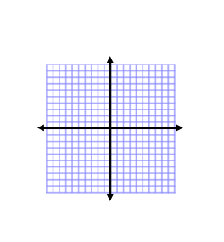 plot and label the numbers listed below.

*Imaginary*

* 1. 4+ 3*i*
  2. 5
  3. 7*i*
  4. -9 – 5*i* -7 + 2*i =* (-7, 2)
  5. 2*i* – 6
  6. -8 + 7*i Real*
  7. 0
  8. *-*3
  9. -5*i* + 5
  10. -10*i*

II. The complex number *a* + *bi* shown at the right, can be

represented by a position vector. The **magnitude**

(length) of the vector is *r*, and its **direction angle** is *θ*. = **[*r, θ*]**

A complex number also can be represented

by its magnitude and angle. In symbols,

it looks like this: **[*r, θ*]**

and is called **polar form.**

The length *r* of the position vector is also

called the **absolute value** or **modulus** of

*a* + *bi* and is denoted |*a* + *bi*|.

Develop a formula to calculate the *r-*value in terms of *a* & *b.* Hint: *Think Pythagorean Theorem.*

*r =* ___________________

There are 4 ways of representing a complex number. So far you have learned the following:

**Standard form**: *a* + *bi* **Rectangular form**: (*a, b*) **Polar form**: [*r, θ*]

You are about to derive the 4th one, **Trigonometric form**:

1. Write an equation for *a* in terms of *r* and *θ.*  Then write an equation for *b* in terms of *r* and *θ.*

Hint: *Think SOH-CAH-TOA!*

1. Substitute your expressions from step 1 into the standard form and then do a little factoring.

**Trigonometric form**:

*\*\*\*\*Call the Heinl over to verify your formulas before you move on.* OVER 🡪

Page 2

Summary of forms & formulas:

|  |  |  |  |
| --- | --- | --- | --- |
| **Standard** | **Rectangular** | **Polar** | **Trigonometric** |
|  |  |  |  |

*a = b= r =* tan *θ =*

*Use this equation to help*

*you calculate θ.*

**\*\*\*If a point lies in quadrants II or III, adjustments to tan-1** *θ* **will have to be made. Why . . . . ?**

III. Express each of the following complex numbers in **trigonometric form**.

*Use exact values when possible. If you have to round, round to the nearest 100th.*

*When calculating θ, follow these restrictions:* 0° < *θ <* 360° or 0 < *θ <* 2π

1. 4 + 4*i* 2. –3*i*

Final answer: ( cos + *i* sin )

3. -2 + 3*i* 4. 3 – 4*i*



*θ* -56.31°

IV. Express each complex number in **standard form***, a* + *bi*. *Use exact values when possible. If you have*

* to round, round to the nearest 100th.*

1. 2(cos 60° + *i* sin 60°) 2.

 Page 3

3. 4.



5.

V. READ THROUGH THE FOLLOWING EXAMPLE. DO NOT WRITE ANYTHING DOWN.

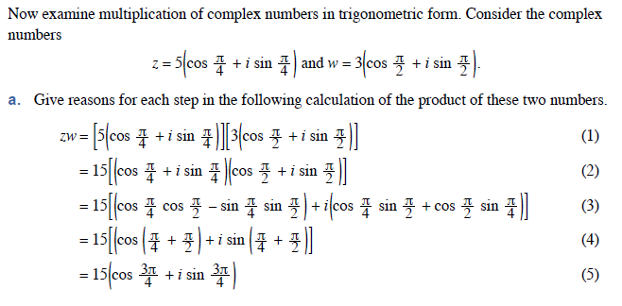



b. Find the product *vw* in trigonometric form.

Use the example above as your guide.

OVER 🡪

Page 4

c. What’s the pattern?

Generalize your results:

If *z* = *r*(cos α + *i* sin α) and *w* = *s*(cos β + *i* sin β), then

*z · w =* ____________________________________________

6. READ THROUGH THE PROOF. DO NOT WRITE ANYTHING DOWN.

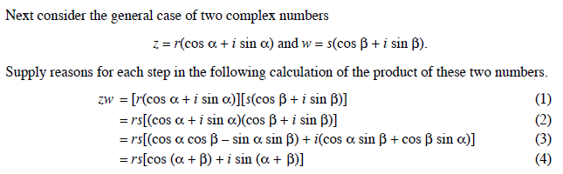

How might you adjust your formula in 5c to calculate ?

If *z* = *r*(cos α + *i* sin α) and *w* = *s*(cos β + *i* sin β), then



= __________________________________________

*\*\*\*\*Call the Heinl over to verify your formulas before you move on.*



 *Imaginary*

e. Plot and label *z*1, *z*2, *w* and *z* on the complex plane.

*Real*

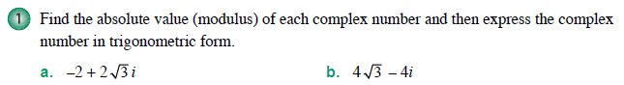**Lesson 4-6 Homework**

**

**

**

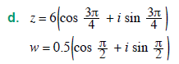



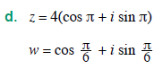

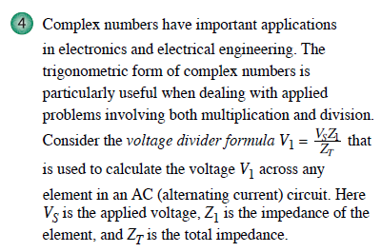

OVER 🡪

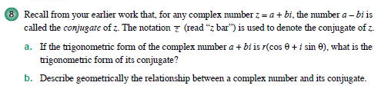



**Review: Solve for primary values.**

