AP Calculus AB Name_________________________________

Lesson 5-4: *Modeling and Optimization* Date ________________________________

**Learning Goal:**

* *I can solve application problems involving optimization.*

One of the classic application of differential calculus are optimization problems (also known as max-min problems). Technically, the calculus is fairly straightforward – find a function that models the problem and then use derivatives (or a calculator) to find the maximum or minimum (whichever is appropriate) of the problem. A more specific strategy follows:

1. Determine whether it is a maximum or minimum problem.

2. Determine what has to be maximized or minimized.

3. Select variables to represent unknowns & write the equation of a function to represent the problem.

4. Use the first derivative of the function to find the critical points. INCLUDE ENDPOINTS!

5. Justify why your solution is the maximum or a minimum.

6. Use the critical point(s) to answer the question.

**A note about the AP Exam** – From my understanding, if the equations/models are complicated to figure out then they will be given to you (since the purpose of the exam is to test your knowledge of calculus). However, as you have seen with some of the expected algebra, what the test writers consider “complicated” and what you consider complicated might not agree . . .

**Example 1** – *NO CALCULATOR*

What is the smallest perimeter possible for a rectangle whose area is, and what are its dimensions?

OVER 🡪

Page 2

**Example 2** – *CALCULATOR ACTIVE*

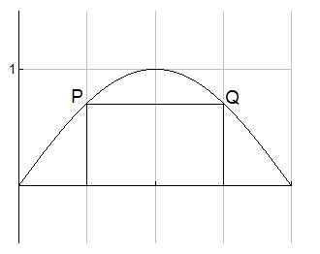A rectangle is to be inscribed under one arch of the sine curve (see below). What is the largest area the rectangle can have, and what dimensions give it that area?

*y*

*x*

**Practice:** *NO CALCULATOR!*

1. The square of a number is to be added to twice the number. What number will give the smallest sum?
2. Find two numbers whose difference is 10 and whose product is the minimum possible.

Page 3

1. On the graph *y* = *x*3 take a point *P*(*x*, *y*) subject to the condition 0  *x*  6. Join point *P* to the point (6, 0) by a straight line and drop a perpendicular from *P* to the *x*-axis. These two lines and the *x*-axis form a right triangle. Find the value of *x* for which the area of the triangle is a maximum.
2. You have been asked to design a one-liter (1000 cm3) oil can shaped like a right, circular cylinder. What dimensions will use the least material? [use a calculator ONLY for computations].

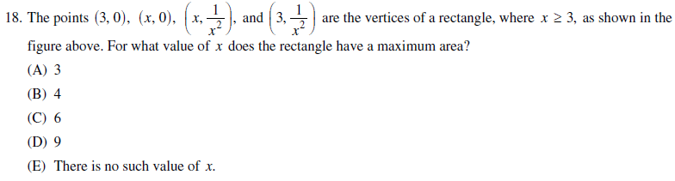

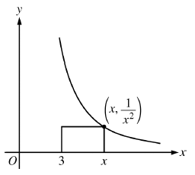

OVER 🡪

Page 4

**Mixed AP Exam Review**

*No Calculator*

