AP Calculus AB Name_________________________________

Lesson 5-5: *Linearization & Differentials*, Part 1 Date ________________________________

**Learning Goal:**

* *I can find the linearization of a function at .*

Early in our study of derivatives, we made a statement that if a function is differentiable at a point, then it is “locally linear” at that point. We explored this fact a bit by zooming in on two graphs that looked similar. The two functions were and . The graph ofhad a corner no matter how far you zoomed in, and the graph of eventually looked linear when zoomed in. In this section, we are going to explore the idea of local linearity a bit more.

**Exploration – Appreciating Local Linearity**

1. Graph the function in “Zoom Decimal” mode. What appears to be the

behavior of the function at ? What could this behavior mean?

2. If you use the definition of a derivative, you can prove that is in fact differentiable at the point . Since *f* is differentiable, let’s find the derivative where there appears to be a corner, at . By hand (just for practice) find below.

3. What is the equation of the tangent line to *f* at . Remember, to find the equation of a tangent line you need the slope of the tangent line (problem 2) and a point on the graph (also in problem 2). Then find the equation (point-slope form is the easiest).

4. Graph the tangent line in the same window as the graph of *f*. Does the tangent line appear to approximate the graph of *f* at ?

5. Zoom in repeatedly, centered at . You will probably need to zoom in at least 10-20 times. What happens to the graph and the tangent line?

OVER 🡪

Page 2

**DEFINITION – Linearization**

If *f* is differentiable at , then the equation of the tangent line



Defines the **linearization approximation of *f* at *a*.** The point is the **center** of the approximation.

* *Note that this is just the equation of the tangent line to f at a. It is just point slope form rewritten with the*

*y-value on the other side of the equation!*

**Example**

Find the linear approximation of at , and use it to approximate without a

calculator. Check the accuracy of your estimate on your calculator.

(note that in general, for , for function in the form , )

**Practice**:

1. Find the linear approximation of at and use it to approximate without a calculator. **Explain what the value ofmeans in the context of this problem**.

2. Find the linear approximation of at .Explain what your answer tells you about the function.

OVER 🡪

Page 3

**Practice (continued)**

3. Find the linear approximation of . Use the closest perfect square to 68 for your point of tangency.

4. *NO CALCULATOR*  
The best linear approximation for near is

(A)  (B)  (C) 

(D)  (E) 

5. *CALCULATOR ACTIVE*

The approximate value of at , obtained from the tangent to the graph at is

(A) 2.00 (B) 2.03 (C) 2.06 (D) 2.12 (E) 2.24

OVER 🡪

AP Calculus AB Name_________________________________

Lesson 5-5: *Linearization & Differentials*, Part 2 Date _________________________________

**Learning Goal:**

* *I can find and evaluate a differential.*

**Differentials**

**DEFINITION:** Let be a differentiable function. The **differential *dx*** is an independent variable. The **differential *dy* is**



Unlike the independent variable *dx*, the variable *dy* is always a dependent variable.

It depends on both *x* and *dx.*

As you can see below, the linearization of a function *f* at can sometimes underestimate the change (concave up) and other times overestimate the change (concave down) in the function *f.*

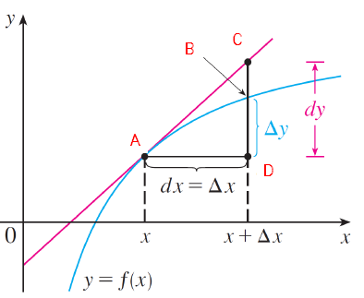

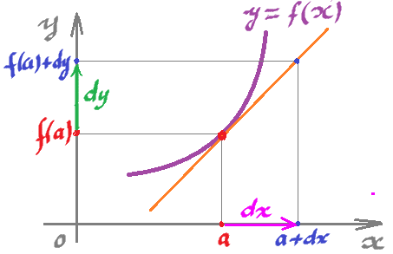

**Example**

If , find the differential *dy* and evaluate *dy* when and 

Page 5

**Practice**

In the following practice problems, find the differential *dy* and evaluate *dy* at the given value when

(1) ; when and 

(2) ; when and 

**Mixed AP Practice – *No Calculator***

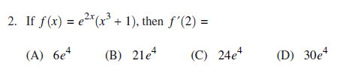

OVER 🡪

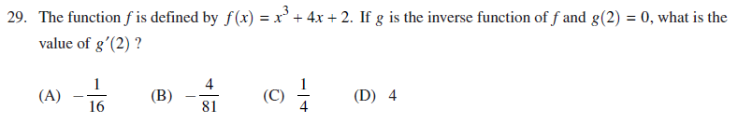 Page 6

