AP Calculus AB Name__________________________________

Lesson 5-6: *Related Rates* Date ________________________________

**Learning Goal:**

* *I can solve related rate problems.*

**Review:** Find the equation of the tangent line to the graph of at the point .

**Related Rates**

Suppose that you and a friend, using a closed loop of yarn, make a rectangle by holding two corners as shown in the picture below. Let’s say that you start with your fingers together so that the length, *l*, is close to zero (but you still have a rectangle) then you move your hands apart at a constant rate.

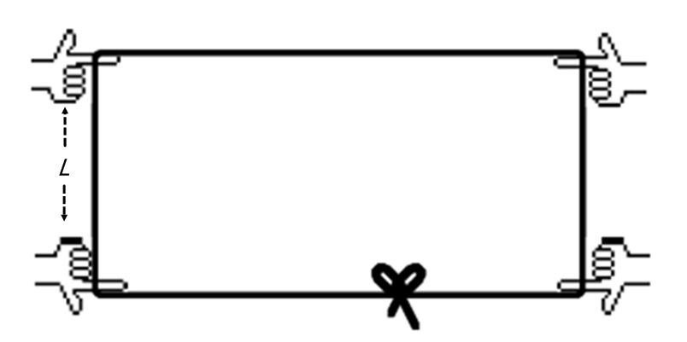

1 a. As the length increases at a constant rate,

how does the width change?

b. If is the rate the width is changing and is the rate the length is changing, write an equation relating these two rates. Think, if the length gains an inch, what must happen to the width?

c. As the length increases, how does the perimeter, *P*, change? That is, what is ?

d. As the length increases, what happens to the area?

OVER 🡪

Page 2

2. In each expression below, use the following variable definitions:

 

Translate the rates below into a complete sentence, and determine whether the rates are constant,

positive, negative, or some combination. For example, represents the rate at which your age changes

over time, and the rate of change is (unfortunately at my age) always positive.

a.  b. 

c.  d. 

3. The amount of gas a car uses each hour depends on how fast the car is traveling. If *x* represents the distance a car travels and *g* represents the number of gallons of gas the car has consumed, analyze these related rates.

a. What do and represent?

b. Assume a car uses about 12 gallons of gas to travel 360 miles. What is when the car is traveling at a of 60mph? Of 30 mph? Of 10mph?

c. Notice that  varies directly with . Write an equation relating and for the car described in (3b) above.

Page 3

Often, when something changes, several other measures change accordingly, causing their rates to be related. For instance, in the problem at the beginning of the packet about the yarn loop, changes in length and width also affect other measurements such as the area and perimeter of the rectangle. These rates are not independent since they depend on the rate of the changing dimensions. We call these types of problems (not surprisingly) **related rate** problems.

What has always distinguished calculus from algebra is its ability to deal with variables that change over time. A strategy for solving related rate problems (from your text book), similar to the strategy we introduced for optimization problems, is below.

**Strategy for Solving Related Rate Problems**

**1. Understand the problem.** In particular, identify the variable whose rate of change you *seek* and the variable (or variables) whose rate of change you *know*.

**2. Develop a mathematical model of the problem.** Draw a picture and label the parts that are important to the problem. *Be sure to distinguish constant quantities from variables that change over time.* Only constant quantities can be assigned numerical values at the start.

**3. Write an equation relating the variable whose rate of change you see with the variables(s) whose rate of change you know.** The formula is often, but not always, geometric (area/volume, Pythagorean Theorem, trig, etc.)

**4. Differentiate both sides of the equation implicitly with respect to time *t*.** Be sure to follow all differentiation rules!!! The Chain Rule especially, as you will be differentiating with respect to parameter *t*, which may not even appear in the formula!

**5. Substitute values for any quantities that depend on time.** Notice that it is only safe to do this *after* the differentiation step. Substituting too soon “freezes the picture” and makes changeable variables behave like constants with zero derivatives.

**6. Interpret the solution.** Translate your mathematical result into the context of the problem, with units! Decide if the result makes sense.

**Example 1**

(a) Assume that the radius *r* of a sphere is a differentiable function of *t* and let *V* be the volume of the sphere. Find an equation that relates .

(b) Assume that the radius *r* and height *h* of a cone are differentiable functions of *t* and let *V* be the volume of the cone. Find an equation that relates .

OVER 🡪

Page 4

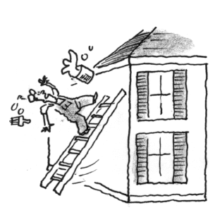**Example 2**

Mr. Legan decides one day that his house needs painting. He is standing near the top of a 20-foot ladder when he feels the base of the ladder starting to slide away from the house.

Draw a *mathematical* diagram of the situation if *h* is the height of the ladder and *x* is the horizontal distance the ladder is from the base of the wall.

Explain why the rate of the ladder sliding down the wall must be related to the rate that the base of the ladder is sliding along the ground.

Let *h* be the height of the ladder at any time *t.* If the base of the ladder slides at 1.5 ft/sec, find the rate at which the height of the ladder is changing over time when the ladder is 10 feet from the base of the house.

What do you notice about the sign of the rate? Why does this make sense?

Page 5

**Example 3**

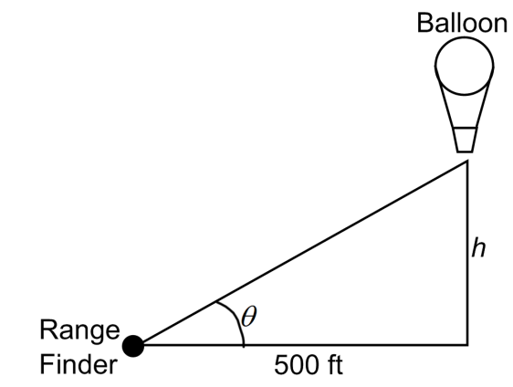A hot air balloon rising straight up from a level playing field is tracked by a range finder 500 feet from the lift-off point. At the moment the range finder’s elevation angle is , the angle is increasing at the rate of 0.14 radians per minute. How fast is the balloon rising at that moment?

**Example 4**

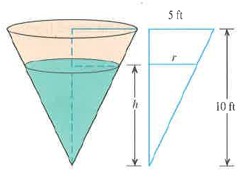Water runs into a conical tank at the rate of 9 ft3/min. The tank stands point down and has a height of 10 feet and a base radius of 5 feet. How fast is the water level rising when the water is 6 feet deep?

OVER 🡪

Page 6

**Group Practice 1**

While working with a loop of yarn as described on the first page of this packet, Ms. Heinl caused the length *l* of the rectangle to *increase* at a rate of 3 cm/sec. At the moment when and :

(a) Find the rate of change of the perimeter of the rectangle.

(b) Find the rate of change of the area of the rectangle.

(c) Find the rate of change of the length of a diagonal of the rectangle.

**Group Practice 2**

Oil spilling from a ruptured tanker spreads in a circle on the surface of the ocean. The area of the spill increases at a rate of . How fast is the radius of the spill increasing when the radius is 10m?

Page 7

**Group Practice 3**

Ralph is walking away from a lamppost.

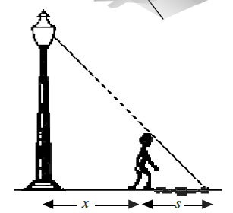

(a) If *s* is the length of his shadow and *x* is the distance between Ralph and the lamppost, generally speaking what do we know about and ?

(b) Find an equation relating  and .

*Hint: let* h *be the height of Ralph and l be the height of the lamp; then use similar triangles!*

(c) If Ralph is 5.75 feet tall and walks away from the 16-foot pole at a rate of 4 ft/sec, at what rate is the length of his shadow increasing when he is 30 feet away from the lamppost?

**Group Practice 4**

You and your friends have just finished your first semester of college and are driving south on your way to the beaches in Florida in order to celebrate. Being so happy, your friend who is driving does not pay much attention to the speedometer of your car. Hovering 1000 feet directly over the highway in a helicopter is the state patrol. The officer in the helicopter fires the radar at your car. At the moment of the firing of the radar the car was 2000 feet from the helicopter and moving away at 85 feet per second. The officer flags you down and gives your friend a ticket for speeding.

Your friend (who understands arithmetic but is not as well versed in calculus as you) does not understand – the speed limit was 65 mph, and 65 mph is about 95 feet per second. Your friend wants to challenge the ticket. Explain, using calculus, why the ticket is justified. Use the diagram below to help.

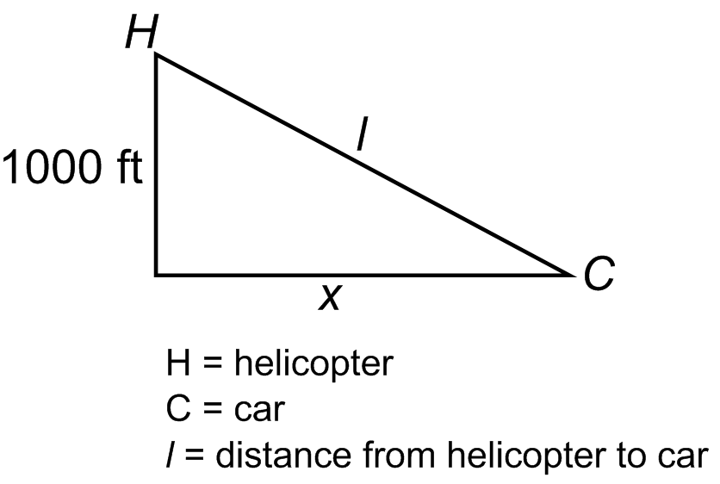

OVER 🡪

Page 8

**Individual Practice – Exam Questions**

**Try these problems individually –a released free response question.**

Note that: (1) 1 point was given for using correct units throughout this problem, so label your answers!

(2) In part (c) (which is a bit of a ridiculous question), remember that “directly proportional”

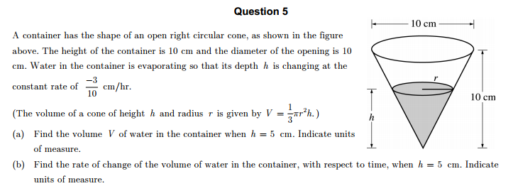means that the equation can be written in the form , where *k* is the constant of proportionality.



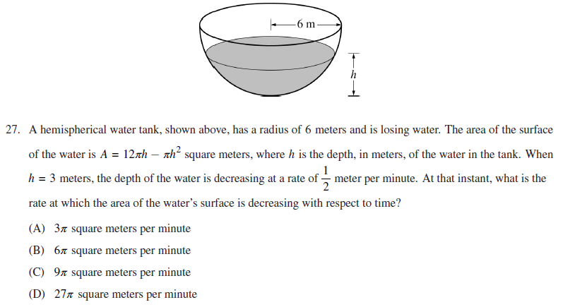

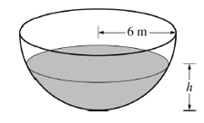

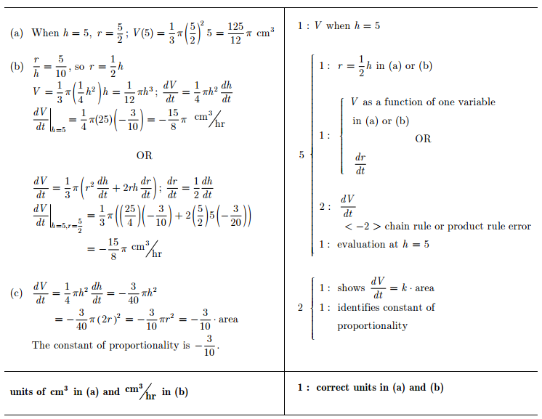**FREE RESPONSE ANSWER KEY**