Math 4 Honors Name ______________________________

Lesson 6-1: *Difference Quotients & Rates of Change* Date _____________________________

**Learning Goals:**

* *I can compute average rates of change in functions.*
* *I can find the formula for the difference quotient of a function and use it to solve problems.*
* *I can use secant lines to determine the average rates of change in graphs of functions.*

VIDEOS: “**What is Calculus?”** <http://www.youtube.com/watch?v=ismnD_QHKkQ>

**“A Brief Introduction to Calculus”** <http://www.youtube.com/watch?v=6gvtr_H1h90>

Answer the questions based off of the videos:

1. What is calculus?
2. What is a difference between algebra & calculus?
3. Since what year has calculus been around?
4. Who is credited with founding calculus?
5. What is Leibniz credited with?
6. What was the main problem Newton & Leibniz were concerned about solving?
7. “Climbing down the ladder” – what tool in calculus? What is happening to the powers?
8. “Climbing up the ladder” – what tool in calculus? What is happening to the powers?
9. The two components of calculus are: _______________________ & _________________________

Please meet with your group members & discuss your answers.

OVER 🡪

Page 2

II. In this portion of the lesson, you will investigate **rates of change**. Plot the following data points on the

graph below. Then answer the questions.

|  |  |  |  |  |  |  |  |  |  |  |  |  |
| --- | --- | --- | --- | --- | --- | --- | --- | --- | --- | --- | --- | --- |
| Month | Jan. | Feb. | Mar. | Apr. | May | June | July | Aug. | Sept. | Oct. | Nov. | Dec. |
| Average High Temp. in ° F | 34 | 37 | 46 | 56 | 68 | 77 | 81 | 80 | 74 | 63 | 51 | 40 |

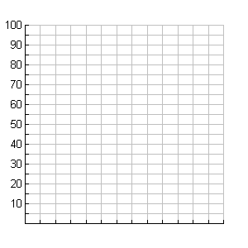

0 1 2 3 4 5 6 7 8 9 10 11 12 13

**Month**

1. To calculate *change*, what operation is used? _________________
2. What Greek letter is used to represent change? ______

In symbols, change in month *x*1to month *x*2 = __________ = Δ*x*

In symbols, change in temp *y*1to temp *y*2 = ____________ = (or in function notation)____________ = Δ*y*

1. The *average* *rate of change* is found by dividing the changes.

In symbols: **Average Rate of Change** (ARoC) =  =  = (or in function notation):

4. Calculate the following (use the correct units): : :

Page 3

The Geometric Definition of **Average Rate of Change:**

The slope of the line through  and .

***If we connect the two points, we end up with what is called a **secant line** for the graph of the function.

 = 

*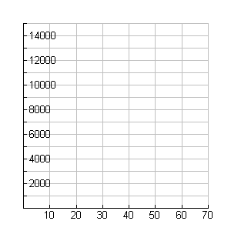****Example:*** A projectile follows along a path given by the formula .

1. Complete the table of values & then graph the path of the object.

*t h(t)*

0

5

10

15

**(feet)** 20

25

30

35

40

45

50

55

**Time (seconds)** 60

B. Use the formula from above to calculate **ARoC** over the following intervals (use the correct units):

1.)  2.) 

3.)  4.) 

1. What do your computations in part B tell you about the projectile?

D. Use a ruler to draw the secant lines going through the pairs of points. Do the direction of the lines confirm the signs of your computations in part B?

OVER 🡪

Page 4

**Average Velocity** over an interval – the average rate of change of *directed* distance

If average velocity > 0 🡺 The projectile is going ________________.

If average velocity < 0 🡺 The projectile is going ________________.

If average velocity = 0 🡺 The projectile is ­­­­­_________________________________.

III. The concept of **ARoC** is an important one in mathematics. When many **ARoC**s have to be calculated for a particular function, *f*, it helps to have a general formula called the **Difference Quotient**. Below you will derive a general formula to help write the difference quotient for any function, *f.*

*Recall:*   = 

Solve the equation for *x*2. Substitute your expression for *x*2 into the formula above.

Write your new formula here: The **Difference Quotient** =

Geometrically, here is how the Difference Quotient is illustrated:



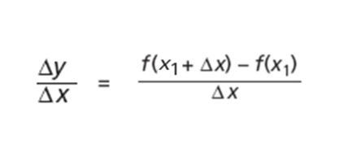

Page 5

***Example:***Refer to the projectile example, where . Find a formula for the difference quotient given the average rate of change of *h* for each interval *t* to *t + Δt.*

*\*\*\*Note: Δt is one variable!*



=

1. Use the results from above and *t =* 5to find the average velocity when *Δt* = . . .

a.) *Δt* = 1 b.) *Δt* = .5 c.) *Δt* = .1 d.) *Δt* = .01

1. What is happening to the *Δt* values in part A? What value does the average velocity appear to be approaching?

Complete:  = __________________

Math 4 Honors Name _____________________________

HW: Lesson 6-1: The Difference Quotient Date ___________________________

*Show your work on another sheet of paper.*





***Find the formula for the difference quotient. Use the formula to calculate the following:***







***Find the formula for the difference quotient. Use the formula to calculate the following:***



