AP Calculus AB Name_________________________________

Lesson 6-1: *Estimating with Finite Sums* Date _________________________________

**Learning Goals:**

* *I can approximate the area under the graph of a nonnegative continuous function by using rectangle approximation methods.*
* *I can interpret the area under a graph as a net accumulation of a rate of change.*

Congratulations on being finished with the *differential calculus* portion of our course! Remember, differential calculus gives us a method to describe how functions change at any given instant. Now that we have mastered differential calculus, let’s begin our exploration of *integral calculus*. Eventually (later in this chapter) we will explore what is the most historically important discovery/proof in mathematics – the connection between these two branches of calculus.

**Exploration: The Great Gorilla Jump**

|  |  |
| --- | --- |
| **Time (sec)** | **Velocity (ft/sec)** |
| 0 | 0 |
| 0.5 | 5 |
| 1 | 7 |
| 1.5 | 8 |
| 2 | 11 |
| 2.5 | 11.5 |
| 3 | 12 |
| 3.5 | 13 |
| 4 | 15.5 |
| 4.5 | 18 |
| 5 | 19 |

1. A gorilla (wearing a parachute of course) jumped off the top of a building. We were able to record the velocity of the gorilla with respect to time twice each second. The data is shown to the right. Note that the gorilla touched the ground just after 5 seconds.

2. Discuss in your groups a method to *approximate* how far the gorilla fell during each

half-second interval. Use the agreed upon method to fill in the table below.

|  |  |
| --- | --- |
| **Time Interval (sec)** | **Approximate Distance Traveled** |
|  |  |
|  |  |
|  |  |
|  |  |
|  |  |
|  |  |
|  |  |
|  |  |
|  |  |
|  |  |

OVER 🡪

Page 2

3. What is the approximate the total distance that the gorilla fell?

4. Is your approximation for the distance fallen an overestimate or an underestimate? Why? *Think about the method you used to find the distance fallen for each interval.*

5. Is there a way you could give a lower bound and an upper bound on the distance that the gorilla fell?

6. If this experiment were done again (measuring the velocity of the gorilla at multiple times during the jump), what could be changed in order to get a more accurate measure for the total distance fallen?

Page 3

**Relating Velocity and Distance Traveled**

Consider the following problem that is seen in typical elementary school textbooks:

*A train travels along a track at a steady rate of 75 mph from 7:00 AM to 9:00 AM. What is the total distance traveled by the train?*

Being as mathematically sophisticated as we are, we know that *distance = rate x time* and can easily solve this problem 🡪  . So how does this relate to calculus?

Take a look at the below graph of the velocity of a truck over time from 8:00 AM to 4:00 PM (the truck driver drove non-stop for 8 hours . . .)

*Assume all non-lattice point intersections are half-hours.*

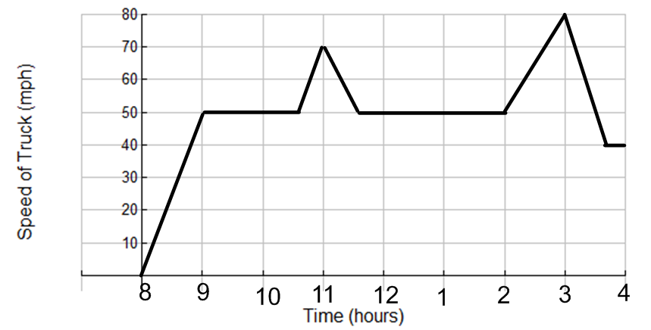

1. How far did the truck travel between 11:30AM and 2PM?

2. You may have find your answer algebraically (using ). How can you use the graph to find your answer *geometrically?* **Spend a few minutes being sure you understand how to find the answer geometrically – this is a BIG deal!!**

3. Use the method you developed in problem (2) to find the total distance traveled by the truck from 8 AM to 9AM.

OVER 🡪

Page 4

4. Find the total distance traveled from 8AM to 11:30AM

5. Find the total distance traveled from 8AM to 4PM

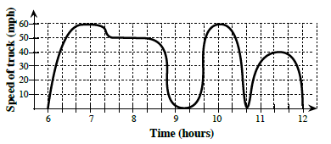Realistically, the change in velocity over time for trucks moving in the real world is not as linear as the pieces in the above graph. Below is a more realistic graph for the velocity over time by a truck from 6AM to 12PM.

6. Find (estimate) the distance traveled by the truck from 6AM to 9AM. Show your work on the above graph.

7. Find (estimate) the total distance traveled by the truck from 6AM to 12PM.

**Notes:**

Page 5

Does the area of an irregular region still give the total distance traveled over a time interval? Newton and Leibniz (and others before them) thought it would and that is why they were interested in a calculus for finding areas under curves. They imagined the time interval being partitioned into many tiny subintervals, each one so small that the velocity over it would essentially be constant. Geometrically, this was equivalent to slicing the irregular region into narrow strips, each of which would be nearly indistinguishable from a narrow rectangle.

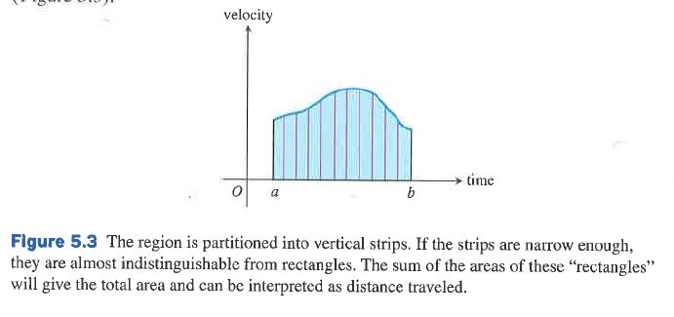

The region to the right is partitioned into vertical strips that, if narrow enough, are almost indistinguishable from rectangles. Newton and Leibniz argued that, just as the total area could be found by summing the areas of the (essentially rectangular) strips, the total distance traveled could be found by summing the small distances traveled over the tiny intervals.

**Example**

A particle starts at and moves along the *x*-axis with velocity for time . Where is the particle at ?

We know that velocity is the derivative of position. To find where the particle is at , we either need to find the position function (which we cannot do specifically with the given information) , or as we discovered above we can find the area under the velocity curve

[since and , position is the same thing as distance traveled]

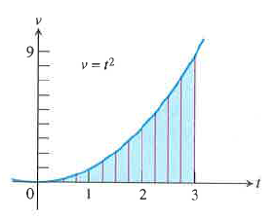To find the area under the velocity curve, we need to partition the region into vertical strips. In the diagram at the right, notice that the region under the curve is partitioned into thin strips with bases of length and *curved* tops that slope upward from left to right. Unfortunately, we do not know how to find the area of such a shape. However, we can get a good approximation of it by finding the area of a suitable rectangle.

So how do we find a suitable rectangle? Let’s find out.

OVER 🡪

Page 6

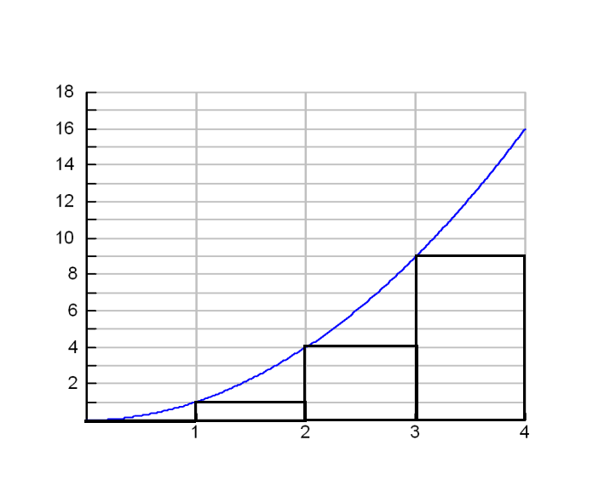Using the Left Rectangular Approximation Method (LRAM) to find the area under , we let the height of our rectangles be the upper-left vertex of our rectangle. In the diagram at the right, the area from is partitioned using rectangles of base length 1. A length of 1 is not ideal (we would like it to be much smaller), but 1 will be easier for the purpose of our example.

Find the approximation of the area under the curve using the LRAM and the rectangles in the diagram to the right. If represents velocity (in meters/sec), what is the position of the particle at ? What do you think of the accuracy of your estimation?

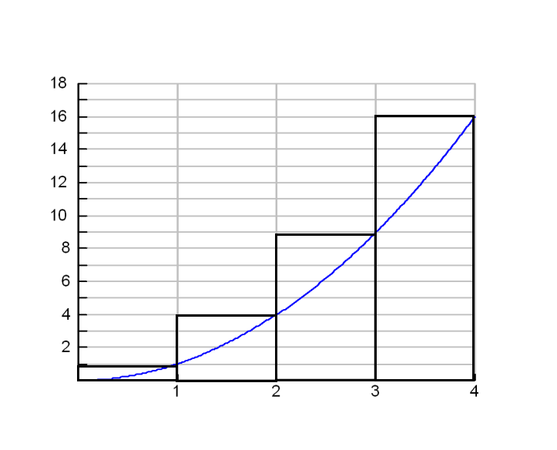

To the right is an approximation of the area under the Right Rectangular Approximation Method (RRAM) to approximate the area under from . Find an approximation of the area using the RRAM. If represents velocity (in meters/sec), what is the position of the particle at ? What do you think of the accuracy of your estimation?

In terms of the LRAM and the RRAM, what do you think is the actual area under the curve of from ? We could clearly improve our estimate of area by making more rectangles. How do you think we can find a better approximation while *still* *using the same amount of rectangles*? Draw it below (you do NOT have to find the approximation)

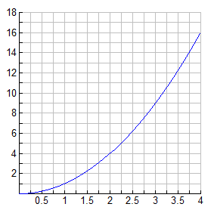

Will your approximation be an overestimate or an underestimate?

Explain, in mathematical terms, when a LRAM and a RRAM will be an overestimate or an underestimate.

Page 7

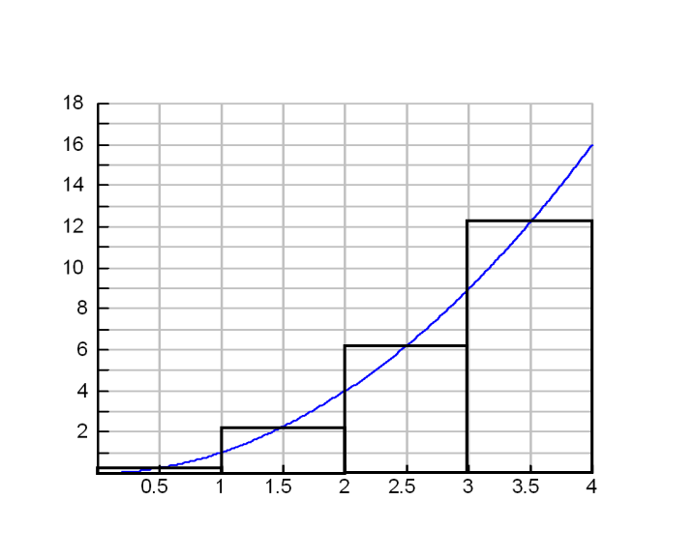The most accurate method for approximating the area under a curve with rectangles is the Midpoint Rectangular Approximation Method (MRAM). Using MRAM, the height of the rectangle is the *midpoint* of the selected intervals.

To the right is an approximation of the area under the MRAM to approximate the area under from . Find an approximation of the area using the MRAM. If represents velocity (in meters/sec), what is the position of the particle at ? What do you think of the accuracy of your estimation?

Note that as the size/number of rectangles grows (goes to infinity), the LRAM, RRAM, and MRAM *all will converge to the same limit* – which is the actual area. Partitioning the area into rectangles in this way is called finding **Riemann sums** – much more on this next section.

**Practice**

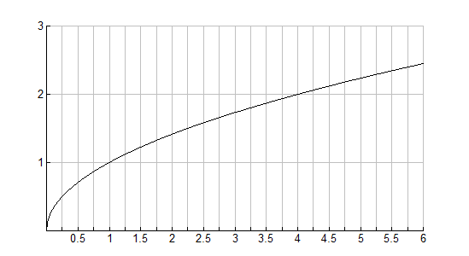1. Estimate the area under the curve of from using the MRAM and

6 rectangles.

OVER 🡪

Page 8

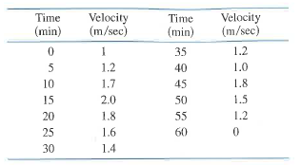

2. You are walking along the bank of a tidal river watching the incoming tide carry a bottle upstream. You record the velocity of the flow every 5 minutes for an hour, with the results shown in the table below. Estimate the distance upstream the bottle travels during that hour? Find the **(a)** LRAM and **(b)** RRAM estimates using 12 subintervals. Explain what your two answers tell you about the distance traveled by the bottle.

**LRAM RRAM**



*Explanation:*