AP Calculus AB Name_________________________________

Lesson 6-1 Learning Check Date ________________________________

1. Estimate the area under the curve of (shown below) using MRAM and 3 subintervals.

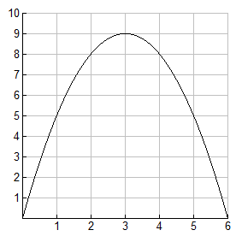

2. Earlier this week, an oil tanker collided with a Coast Guard boat off the California coast. The disabled tanker is spilling oil from its damaged hull. The rate of flow of oil into the Pacific Ocean off the California coast was measured at several different time intervals yesterday. The rates are listed in the table below.

|  |  |  |  |  |  |  |  |  |  |  |  |
| --- | --- | --- | --- | --- | --- | --- | --- | --- | --- | --- | --- |
| **Time** | 9:00 | 10:00 | 11:00 | 12:00 | 1:00 | 2:00 | 3:00 | 4:00 | 5:00 | 6:00 | 7:00 |
| **Rate** | 4.0 | 4.0 | 3.8 | 3.6 | 3.0 | 2.0 | 0.6 | 0.3 | 0.1 | 0.1 | 0.0 |
| (100 gal/hour) |  |  |  |  |  |  |  |  |  |  |  |

a. Estimate the minimum amount of oil that was spilled over the 10-hour time period.

b. Estimate the maximum amount of oil that was spilled over the 10-hour time period.

