AP Calculus AB Name_____________________________________

Lesson 6-2 Learning Check Date __________________________________

***NO CALCULATOR***

1. Evaluate 

2. Use the fact that to evaluate the following integrals:

a.  b. 

***CALCULATOR ACTIVE***

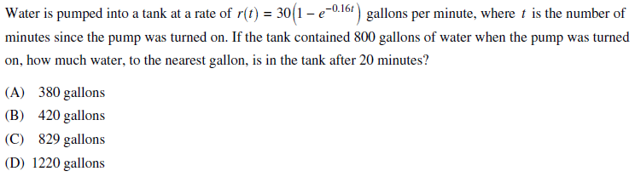

3.

OVER🡪

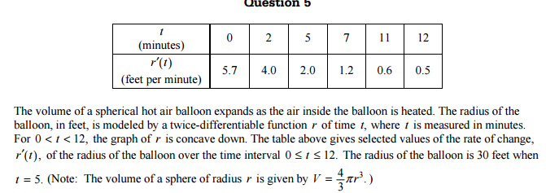4.

