AP Calculus AB Name__________________________________
Lesson 6-4 FTC Released AP Exam Questions Date _________________________________

“**” denotes CALCULATOR ACTIVE PROBLEM
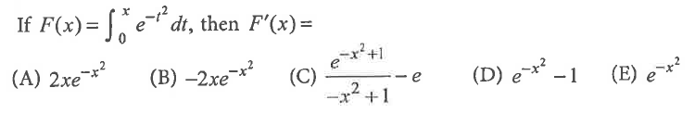
1.

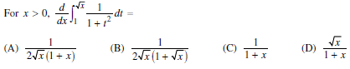
2.

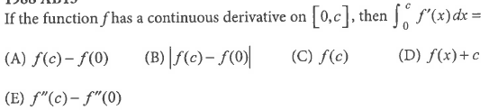
3.

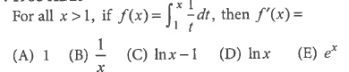
4.

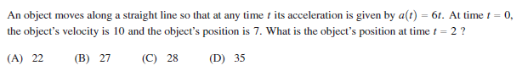
5.

OVER
Page 2

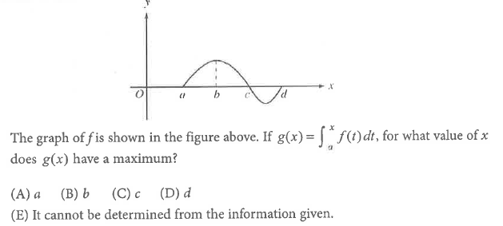

6.

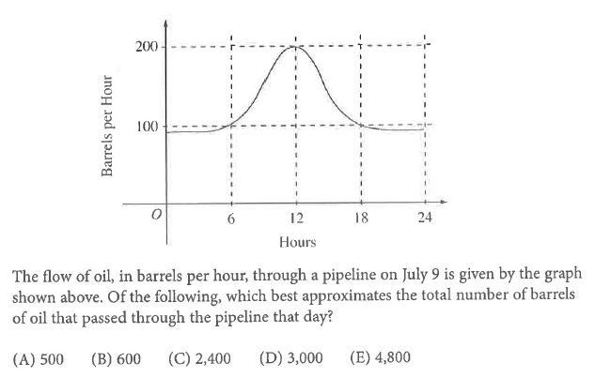

7.

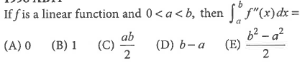
8.

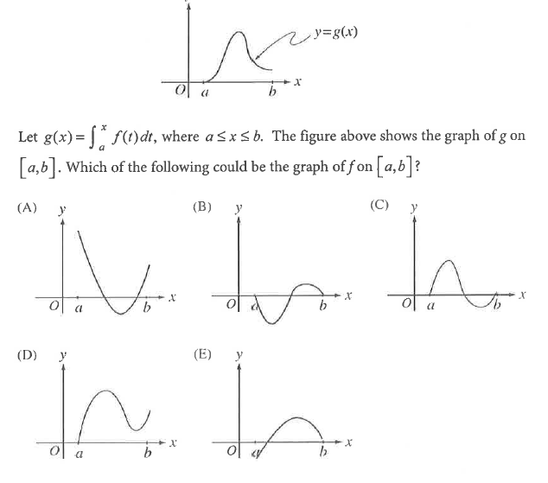
Page 3

9.

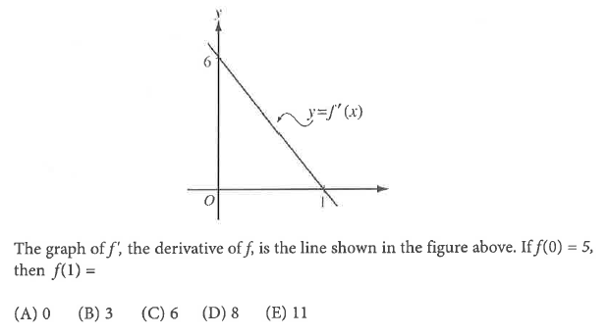

10.

OVER
Page 4
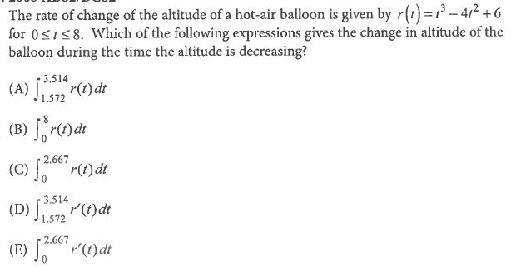
**11.

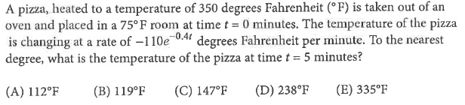
**12.

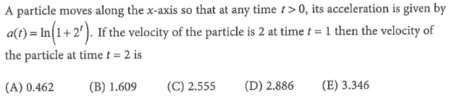
**13.

Page 5

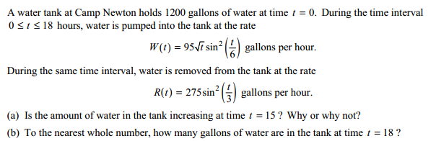
**14.

OVER
Page 6
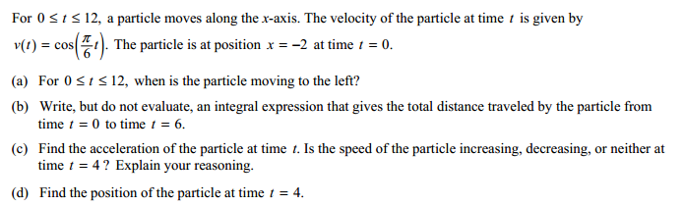
15.

